Responsorial Psalm Ps 27:1, 7-8, 8-9, 13-14 c lent 2

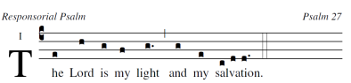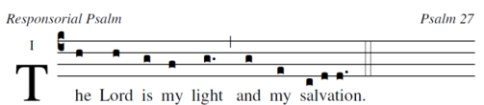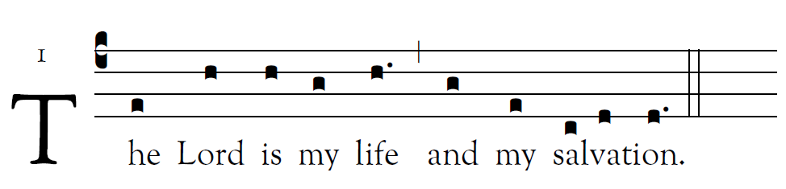
.

R. (1a) The Lord is my light and my salvation.
The LORD is my light and | my salvation;
whom should I fear?
The LORD is my | life’s refuge;
of whom should I | be afraid?
R. The Lord is my light and my salvation.
Hear, O LORD, the sound |of my call;
have pity on me, and | answer me.
Of you my | heart speaks;
you | my glance seeks.
R. The Lord is my light and my salvation.
Your presence, O | LORD, I seek.
Hide not your | face from me;
do not in anger repel | your servant.
You are my helper: cast | me not off.
R. The Lord is my light and my salvation.
I believe that I shall see the bounty |of the LORD
in the land |of the living.
Wait for the LORD | with courage;
be stouthearted, and wait | for the LORD.
R. The Lord is my light and my salvation.

