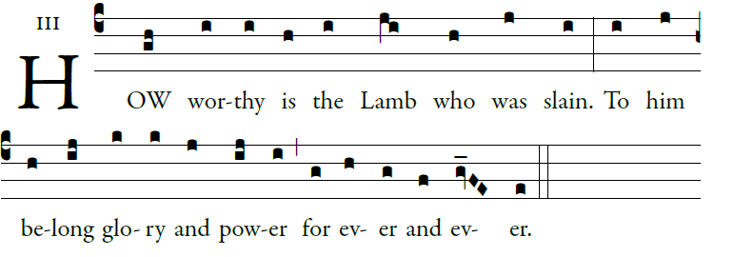
©illuminarepublications.com

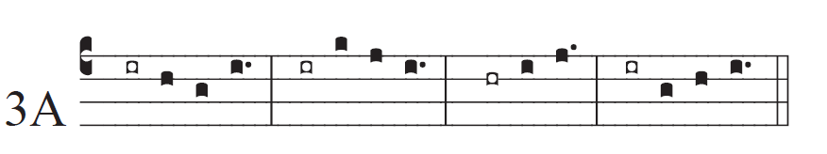
©Saint Meinrad Archabbey
O God, give your judgment to the king,
to a king’s son your justice,
that he may judge your people in justice,
and your poor in right judgment.

1May the mountains bring forth peace for the
people, and the hills justice.
² May he defend the poor of the people,
³ and save the children of the needy,
⁴ and crush the oppressor.

Glory be to the Father…
