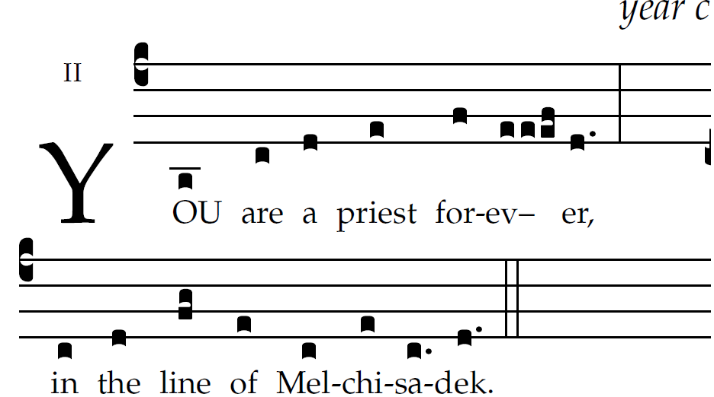

The LORD said to my Lord:
"Sit at my right hand
till I make your enemies your footstool."
The scepter of your power the LORD
will stretch forth from Zion:
"Rule in the midst of your enemies."
"Yours is princely power
in the day of your birth, in holy splendor;
before the daystar, like the dew, I have begotten you."
The LORD has sworn, and he will not repent:
"You are a priest forever,
according to the order of Melchizedek."

