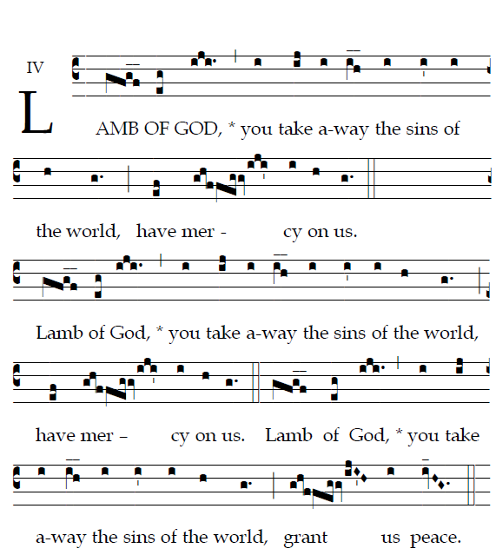
COMMUNION ANTIPHON
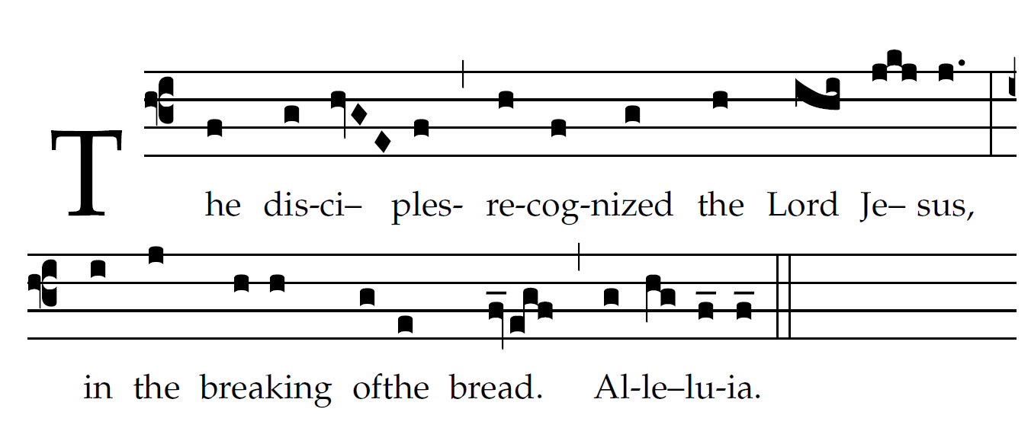
Fr. Columba Kelly ©St Meinrad Archabbey
Give ear, my people, to my teaching;
incline your ear to the words of my mouth.
I will open my mouth in a parable
and utter hidden lessons of the past.

RECESSIONAL HYMN: “Christ the Lord, is Risen Today”

THIRD SUNDAY of EASTER

ENTRANCE ANTIPHON

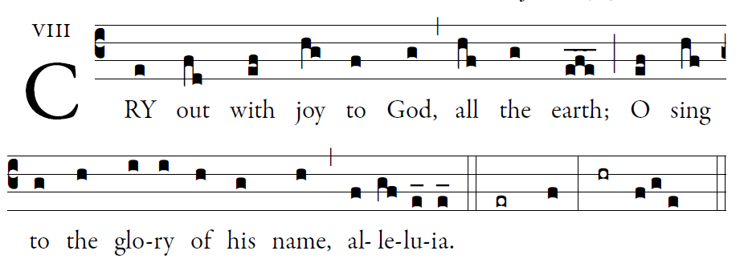
©Illuminare Publications.com

[O render him glorious praise,
alleluia, alleluia.]
2. Say to God, “How awesome your deeds!
Because of the greatness of your strength,
your enemies fawn upon you.     

3. Before you all the earth shall bow down,
shall sing to you, sing to your name!”
4. Come and see the works of God:
awesome his deeds among the children of men.  

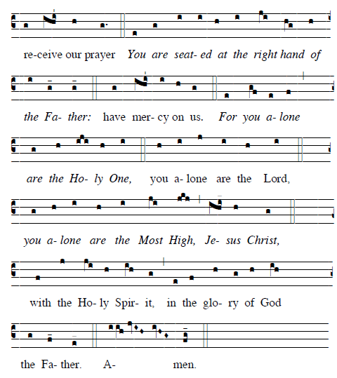

OFFERTROY HYMN: Christ the Lord Is Risen Again

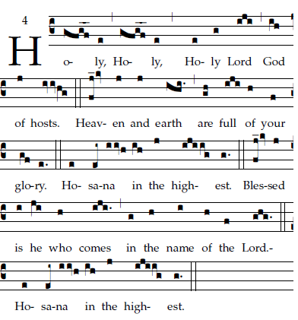

Ordinary of the Masa: Mass I Fr. Columba Kelley.©Saint Meinrad Archabbey

