OFFERTORY HYMN “The King of Love”
Communion Antiphon:

Psalm 23
The LORD is my shepherd;
there is nothing I shall want.
Fresh and green are the pastures
where he gives me repose.
Near restful waters he leads me;
he revives my soul.

He guides me along the right path,
for the sake of his name.
Though I should walk in the valley of the shadow of death,
no evil would I fear, for you are with me.
Your crook and your staff will give me comfort.

You have prepared a table before me
in the sight of my foes.
My head you have anointed with oil;
my cup is overflowing.

Surely goodness and mercy shall follow me
all the days of my life.
In the LORD’s own house shall I dwell
for length of days unending.

RECESSIONAL HYMN
Christ, the Lord, is Risen Today

Fourth Sunday of Easter

ENTRANCE ANTIPHON

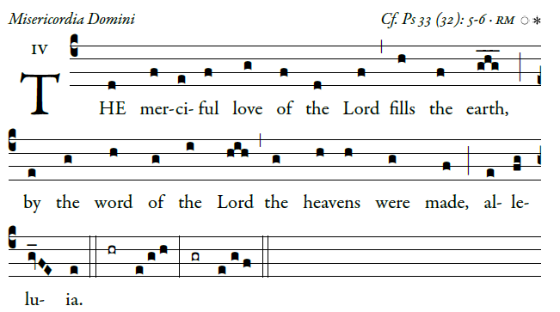
©Illuminare Publications.com
Ring out your joy to the lord, O you just;
for praise is tting for the upright
Give thanks to the lord upon the harp;
with a ten-stringed lute sing him songs. 
O sing him a song that is new;
play skillfully, with shouts of joy.
For the word of the lord is faithful,
and all his works to be trusted.
Let all the earth fear the ord,
all who live in the world revere him. 

Glory be to the Father , 

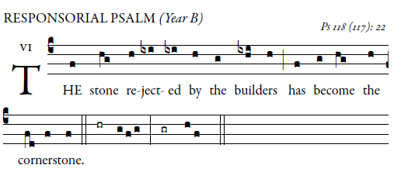

Give thanks to the LORD, for he is good,
for his mercy endures forever.
It is better to take refuge in the LORD
than to trust in man.
It is better to take refuge in the LORD
than to trust in princes.  
I will give thanks to you, for you have answered me
and have been my savior.
The stone which the builders rejected
has become the cornerstone.
By the LORD has this been done;
it is wonderful in our eyes.  
Blessed is he who comes in the name of the LORD;
we bless you from the house of the LORD.
I will give thanks to you, for you have answered me
and have been my savior.
Give thanks to the LORD, for he is good;
for his kindness endures forever.  
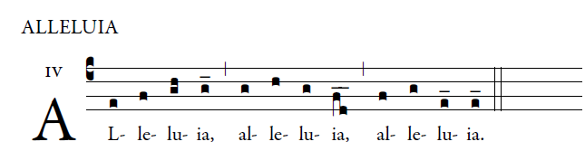
  I am the good shepherd, says the Lord;
I know my sheep and Mine know me.. 

