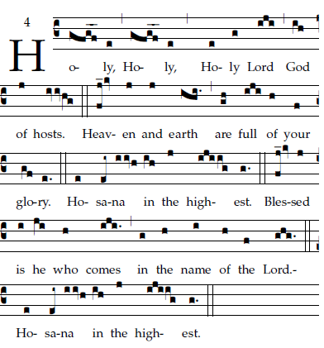

Repeat
Final ending

RECESSIONAL HYMN: “Regina Caeli”
FOURTH SUNDAY of EASTER 2020

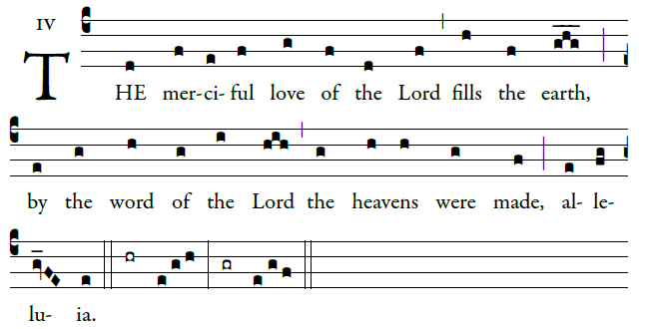
ENTRANCE ANTIPHON

Ring out your joy to the lord, O you just;
for praise is fi tting for the upright
Give thanks to the Lord upon the harp;
with a ten-stringed lute sing him songs. 
©Illuminare Publications.com

Ordinary of the Masa: Mass I Fr. Columba Kelley.©Saint Meinrad Archabbey

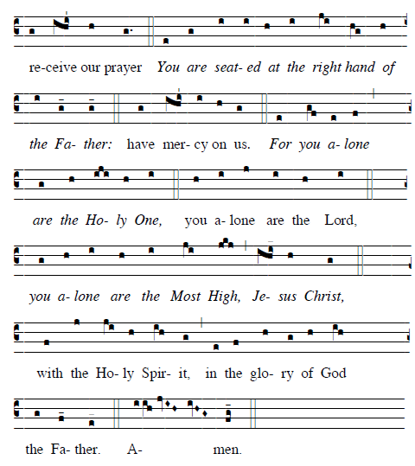

RESPONSORIAL PSALM
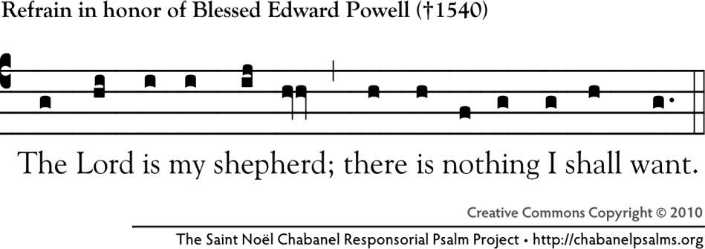

The LORD is my shepherd; I shall not want.
In verdant pastures he gives me repose;
beside restful waters he leads me;
he refreshes my soul.
He guides me in right paths
for his name's sake.
Even though I walk in the dark valley
I fear no evil; for you are at my side.
With your rod and your staff
that give me courage.
You spread the table before me
in the sight of my foes;
you anoint my head with oil;
my cup overflows.
Only goodness and kindness follow me
all the days of my life;
and I shall dwell in the house of the LORD
for years to come.

