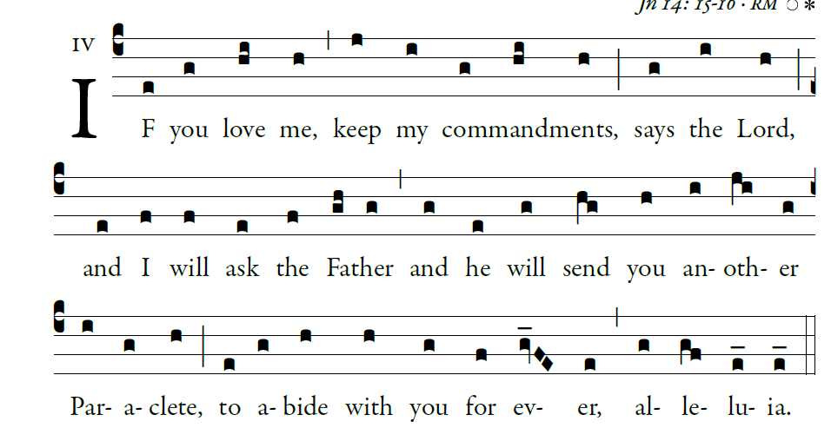

1. To you, O lord, I lift up my soul.
In you, O my God, I have trusted;
let me not be put to shame;
let not my enemies exult over me.
Let none who hope in you be put to shame;
but shamed are those who wantonly break faith.

2. O lord, make me know your ways.
Teach me your paths.
Guide me in your truth, and teach me;
for you are the God of my salvation. *

I have hoped in you all day long.
3. Remember your compassion, O lord,
and your merciful love,
for they are from of old.

4. Do not remember the sins of my youth,
nor my transgressions.
In your merciful love remember me, *
because of your goodness, O lord.

5. Good and upright is the lord;
he shows the way to sinners.
He guides the humble in right judgment;
to the humble he teaches his way.

6. All the lord’s paths are mercy and faithfulness,
for those who keep his covenant and commands.
O lord, for the sake of your name,
forgive my guilt, for it is great.

