Communion Antiphon

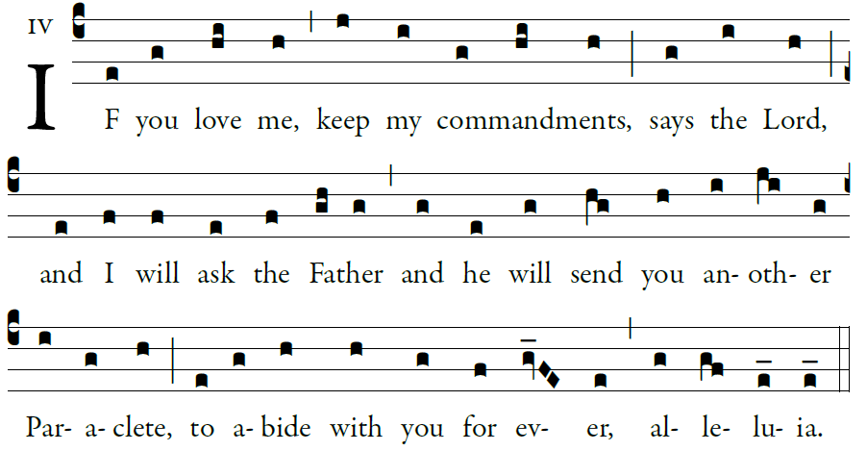

To you, O lord, I lift up my soul.
In you, O my God, I have trusted;
let me not be put to shame;
let not my enemies exult over me.
Let none who hope in you be put to shame;
but shamed are those who wantonly break faith.

2. O lord, make me know your ways.
Teach me your paths.
Guide me in your truth, and teach me;
for you are the God of my salvation. *

I have hoped in you all day long.
3. Remember your compassion, O lord,
and your merciful love,
for they are from of old.

4. Do not remember the sins of my youth,
nor my transgressions.
In your merciful love remember me, *
because of your goodness, O Lord.
.

RECESSIONAL HYMN
“ Christ , he Lord, Is Risen Today”

Sixth Sunday of Easter

ENTRANCE ANTIPHON

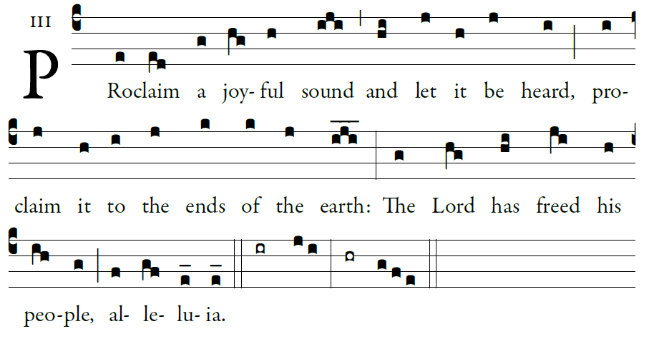

Proclaim it to the ends of the earth,
alleluia, alleluia. Cry out with joy to God, all the earth;
O sing to the glory of his name.

O render him glorious praise.
Say to God, “How awesome your deeds!
Because of the greatness of your strength,
your enemies fawn upon you.

Glory be…

Kyrie and Gloria : MUSIC ISSUE #848 AND #849

OFFERTORY HYMN

“Daily, Daily Sing to Mary” (Ascribed to St Bernard of Cluny, 12th century)

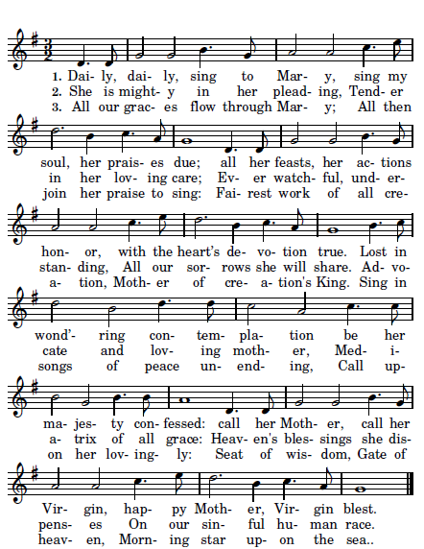

SANCTUS
CHOIR Dominus Deus Sabaoth.Pleni sunt caeli et
terra gloria

ALL SING

CHOIR Benedictus qui venit in nomine Domini

ALL SING

AGNUS DEI
