COMMUNION ANTIPHON

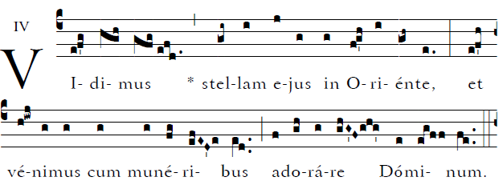

O God, give your judgment to the king,
to a king’s son your justice,
¹The kings of Tarshish and the islands
shall pay him tribute.

The kings of Sheba and Seba
shall bring him gifts.
¹Before him all kings shall fall prostrate,
all nations shall serve him.

COMMUNNION HYMN “ As With Gladness Men of Old”

RECESSIONAL HYMN “We Three Kings”

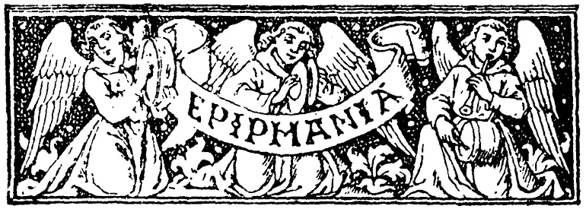

EPIPHANY of the LORD

ENTRANCE ANTIPHON © illuminarepublications.com Adam Bartlett

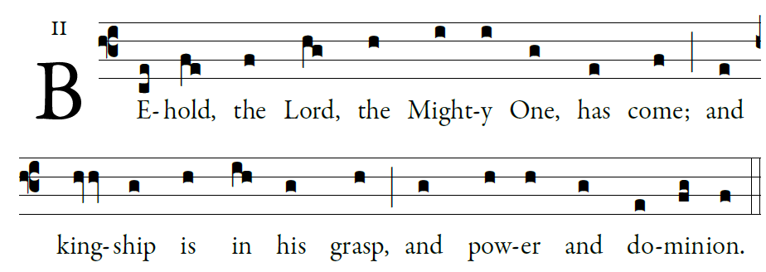  
Psalm 72

O God, give your judgment to the king,
to a king’s son your justice,
¹The kings of Tarshish and the islands
shall pay him tribute.

The kings of Sheba and Seba
shall bring him gifts.
¹Before him all kings shall fall prostrate,
all nations shall serve him.

For he shall save the needy when they cry,
the poor, and those who are helpless.
He will have pity on the weak and the needy,
and save the lives of the needy.

RESPONSORIAL PSALM

© illuminarepublications.com Adam Bartlett
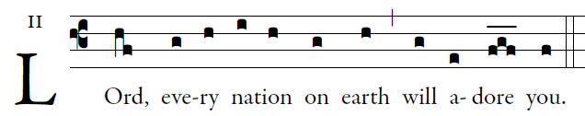

O God, with your judgment endow the king,
and with your justice, the king’s son;
He shall govern your people with justice
and your afflicted ones with judgment. 
Justice shall flower in his days,
and profound peace, till the moon be no more.
May he rule from sea to sea,
and from the River to the ends of the earth. 

The kings of Tarshish and the Isles shall offer gifts;
the kings of Arabia and Seba shall bring tribute.
All kings shall pay him homage,
all nations shall serve him. 
For he shall rescue the poor when he cries out,
and the afflicted when he has no one to help him.
He shall have pity for the lowly and the poor;
the lives of the poor he shall save. 

ALLELUIA
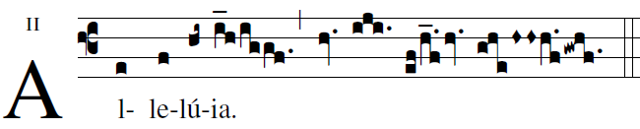

         We Saw his star at its rising and have come to adore the Lord.

OFFERTORY
Narodilse Kristus Pán
Czech Carol
České vánoční koleda
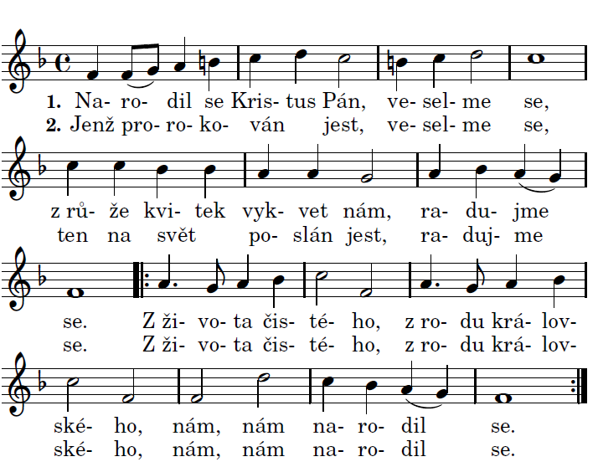

Christ the Lord was born, let us be merry
A flower bloomed from the rose, let us rejoice.
From a Virgin, of the Royal Family,
He was born to us.
Who was prophesied. let us be merry,
That He was sent into the world, let us rejoice.

