COMMUNION ANTIPHON
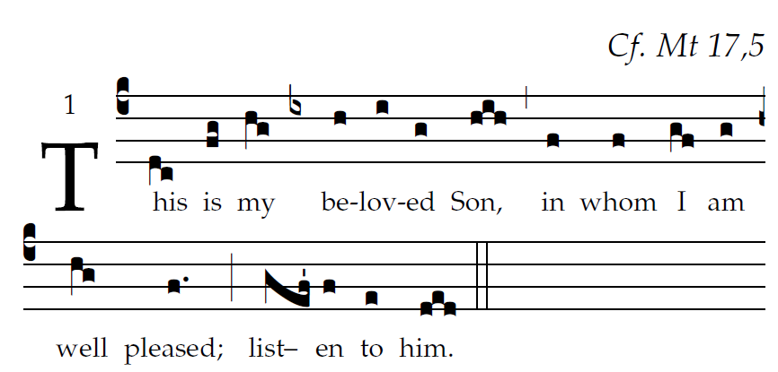
All Sing
As we have heard, so we have seen
in the city of our God,
in the city of the LORD of hosts,
which God establish - es forever.

Your merciful love, O God,
we ponder in your temple.
Your praise, O God, like your name,
reaches the ends of the earth.

HYMN “ Be Thou My Vision” #633 GP

RECESSIONAL HYMN “Christ Before Us” #586 GP
(Irish Hymn Suo Gan)

SECOND SUNDAY OF LENT

YEAR C

ENTRANCE HYMN “God of Mercy, God of Grace”
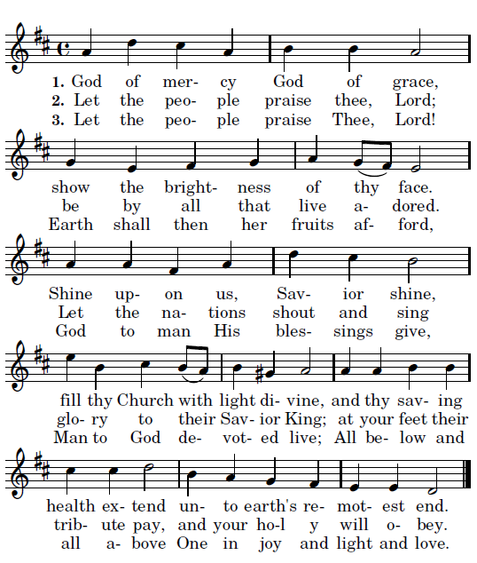

RESPONSORIAL PSALM J.G.
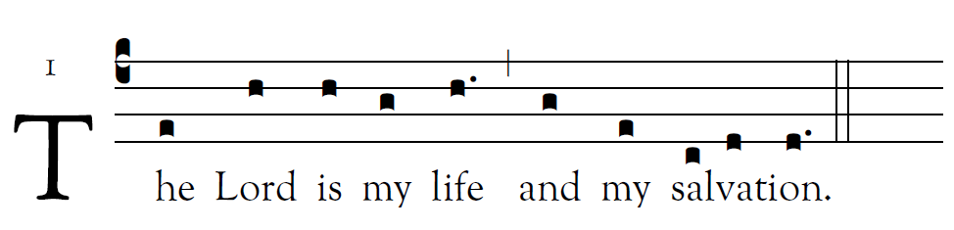

The LORD is my light and my salvation;
whom should I fear?
The LORD is my life’s refuge;
of whom should I be afraid? 
Hear, O LORD, the sound of my call;
have pity on me, and answer me.
Of you my heart speaks;
you my glance seeks.    
Your presence, O LORD, I seek.
Hide not your face from me;
do not in anger repel your servant.
You are my helper: cast me not off.    
I believe that I shall see the bounty of the LORD
in the land of the living.
Wait for the LORD with courage;
be stouthearted, and wait for the LORD. 

VERSE BEFORE THE GOSPEL
Adam Bartlett IlluminarePublications.com
From the shining cloud the Father’s voice was heard:
This is my beloved Son, listen to him. 

OFFERTORY HYMN

“O Wondrous Type! O Vision Fair!
MELODY “Jesu Dulcis Memoria”

O
h, wondrous type! Oh, vision fair
Of glory that the church may share,
Which Christ upon the mountain shows,
Where brighter than the sun he glows!

With Moses and Elijah nigh
The ‘n-carnate Lord holds converse high;
And from the cloud the Holy One
Bears record to the only Son.

With shining face and bright array
Christ wills to manifest today
What glory shall be theirs above
Who joy in God with perfect love.

And faithful hearts are raised on high
By this great vision’s mystery,
For which in joyful strains we raise
The voice of prayer, the hymn of praise

