COMMUNION ANTIPHON:
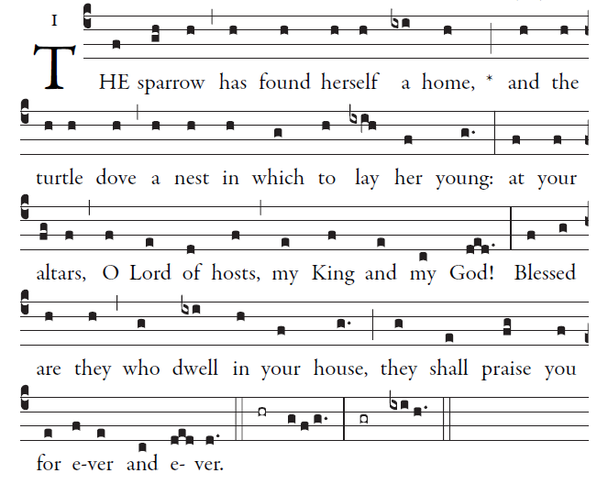 Simple English Propers Adam Bartlett © CMMA

How lovely is your dwelling place,
O Lord of hosts.
My soul is longing and yearning
for the courts of the Lord.

O Lord God of hosts, hear my prayer;
give ear, O God of Jacob.
Turn your eyes, O God, our shield;
look on the face of your anointed.

One day within your courts
is better than a thousand elsewhere.
The threshold of the house of God
I prefer to the dwellings of the wicked.

RECESSIONAL HYMN:
“ From the Depth We Cry to Thee”
THIRD SUNDAY OF LENT (year C)

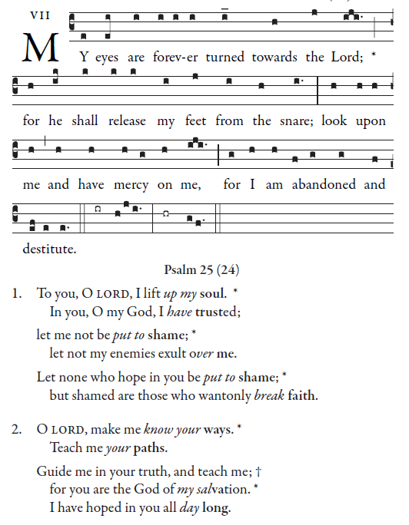

Simple English Propers Adam Bartlett © CMMA

RESPONSORIAL PSALM
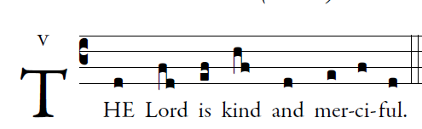
illuminarepublications.com
Bless the LORD, O my soul;
and all my being, bless his holy name.
Bless the LORD, O my soul,
and forget not all his benefits.

He pardons all your iniquities,
heals all your ills,
He redeems your life from destruction,
crowns you with kindness and compassion.

The LORD secures justice
and the rights of all the oppressed.
He has made known his ways to Moses,
and his deeds to the children of Israel.

Merciful and gracious is the LORD,
slow to anger and abounding in kindness.
For as the heavens are high above the earth,
so surpassing is his kindness toward those who fear him.

Repent, says the Lord;
the kingdom of heaven is at hand.

OFFERTORY
