RECESSIONAL HYMN

Holy Joseph, Intercessor ALLE TAGE SING UND SAGE
8.7.8.7.

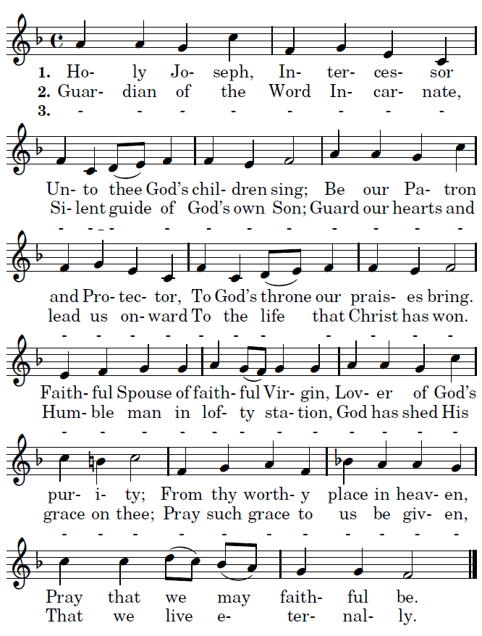

THIRD SUNDAY OF LENT (year A)
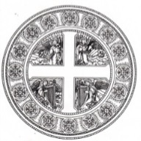

March 19, Solemnity Joseph , Husband of Mary

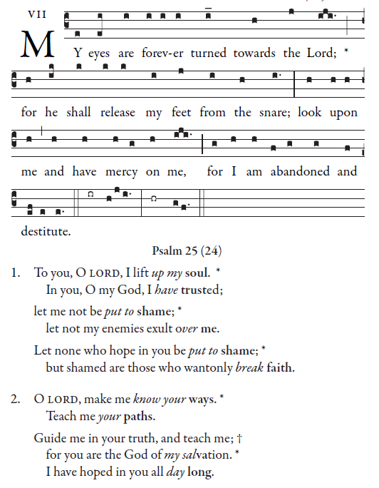

Simple English Propers Adam Bartlett © CMMA

RESPONSORIAL PSALM
R. Bednarz 2014

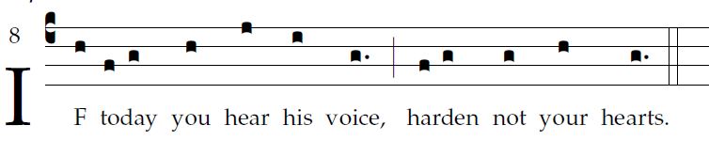
Come, let us sing joyfully to the LORD;
let us acclaim the rock of our salvation.
Let us come into his presence with thanksgiving;
let us joyfully sing psalms to him.
Come, let us bow down in worship;
let us kneel before the LORD who made us.
For he is our God,
and we are the people he shepherds, th flock he guides.

Oh, that today you would hear his voice: [5]
"Harden not your hearts as at Meribah,
as in the day of Massah in the desert,
Where your fathers tempted me;
Though they had seen my work.

OFFERTORY HYMN “Attende Domine”

COMMUNION ANTIPHON:
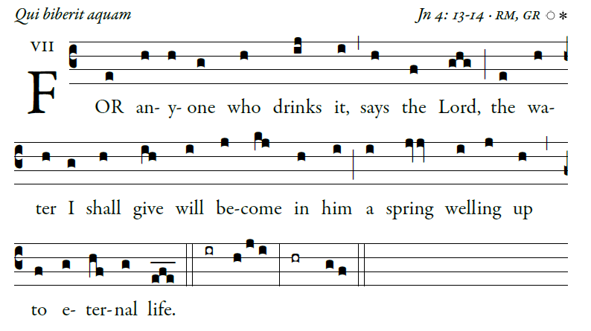

COMMUNION HYMN of THANKSGIVING
Saint Joseph, Whose Glory Fills the Church NOCTE SURGENTES

