RECESSIONAL HYMN

My Song Is Love Unknown
Samuel Crossman (1664)

M
y song is love unknown–
my Savior’s love to me;
love to the loveless shown,
that they might lovely be.
Oh, who am I, that for my sake
my Lord should take frail flesh and die?

7 Here might I stay and sing–
no story so divine!
Never was love, dear King,
never was grief like Thine.
This is my Friend, in whose sweet praise
I all my days could gladly spend.

THIRD SUNDAY OF LENT (year B)

T
o you, O LORD, I lift up my soul.
In you, O my God, I have trusted;
let me not be put to shame;
let not my enemies exult over me.

O LORD, make me know your ways.
Teach me your paths.
Guide me in your truth, and teach me;
for you are the God of my salvation.
I have hoped in you all day long.

Simple English Propers Adam Bartlett © CMMA

RESPONSORIAL PSALM

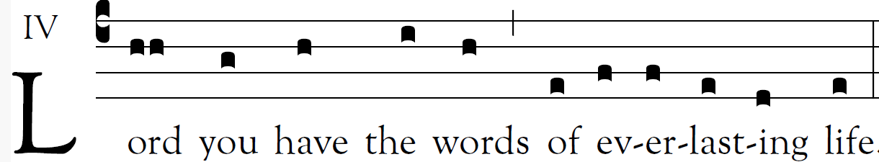

The law of the LORD is perfect,
refreshing the soul;
The decree of the LORD is trustworthy,
giving wisdom to the simple.

The precepts of the LORD are right,
rejoicing the heart;
the command of the LORD is clear,
enlightening the eye.
.
The fear of the LORD is pure,
enduring forever;
the ordinances of the LORD are true,
all of them just.
.
They are more precious than gold,
than a heap of purest gold;
sweeter also than syrup
or honey from the comb.

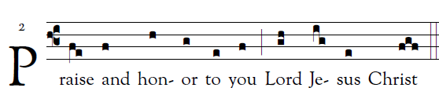

OFFERTORY HYMN “Grant to Us, O Lord ” #598

COMMUNION ANTIPHON:
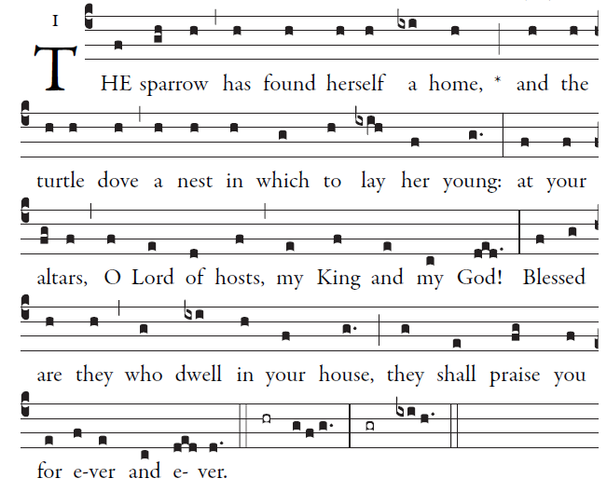
Simple English Propers Adam Bartlett © CMMA

How lovely is your dwelling place,
O Lord of hosts.
My soul is longing and yearning
for the courts of the Lord.

