COMMUNION ANTIPHON:
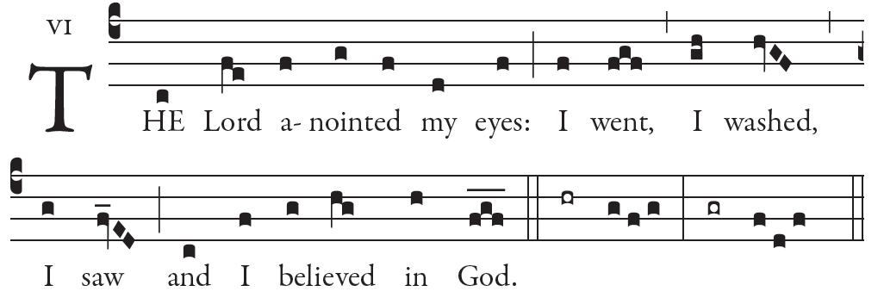
illuminare publication.com

¹The LORD is my light and my salvation;
whom shall I fear?
The LORD is the stronghold of my life;
whom should I dread?

²When those who do evil draw near
to devour my flesh,
it is they, my enemies and foes,
who stumble and fall.

⁵For there he keeps me safe in his shelter
in the day of evil.
He hides me under cover of his tent;
he sets me high upon a rock.

⁶And now my head shall be raised
above my foes who surround me,
and I shall offer within his tent
a sacrifice of joy.
I will sing and make music for the LORD.

⁷O LORD, hear my voice when I call;
have mercy and answer me.
⁸Of you my heart has spoken,
“Seek his face.”
It is your face, O LORD, that I seek;

RECESSIONAL HYMN
“From the Depths We Cry to Thee”

FOURTH SUNDAY OF LENT

year A

ENTRANCE ANTIPHON
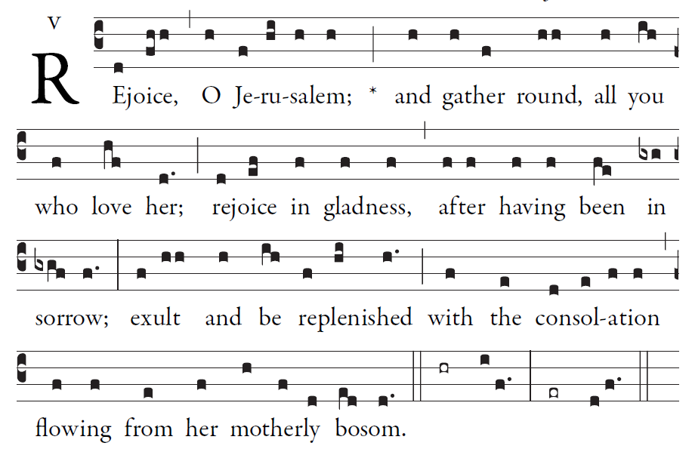
Simple English Proper © CMAA Adam Bartlet

Psalm 122 (121)
I rejoiced when they said to me,
“Let us go to the house of the Lord.”
And now our feet are standing
within your gates, O Jerusalem.

Jerusalem is built as a city
bonded as one together.
It is there that the tribes go up,
the tribes of the Lord.

For Israel’s witness it is
to praise the name of the Lord.
There were set the thrones for judgment,
the thrones of the house of David.

RESPONSORIAL PSALM

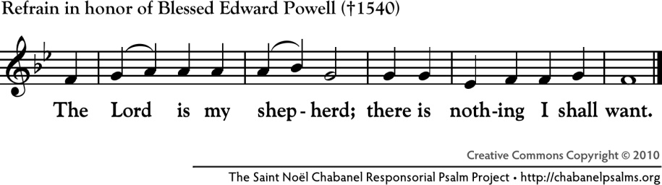

The LORD is my shepherd; I shall not want.
In verdant pastures he gives me repose;
beside restful waters he leads me;
he refreshes my soul.

He guides me in right paths for his name’s sake.
Even though I walk in the dark valley
I fear no evil; for you are at my side
with your rod and your staff that give me courage.
You spread the table before me in the sight of my foes;
you anoint my head with oil;
my cup overflows.
Only goodness and kindness follow me
all the days of my life;
and I shall dwell in the house of the LORD
for years to come.

GOSPEL ACCLAMATION R.Bednarz
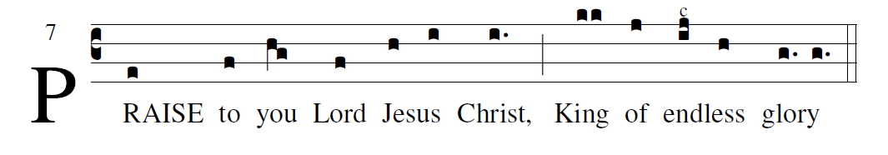
                   I am the light of the World says the Lord,
Whoever follows me will have the light of life.

OFFERTORY HYMN:

MISERICORDIAS Music 2007, Henryk Jan Botar
permission requested
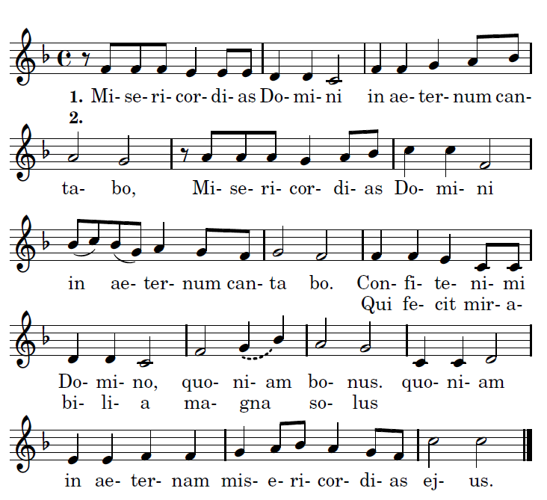

Translation

Refrain:
I will sing of the mercies of the Lord for ever.
- Praise the Lord, for he is good: for his mercy endures forever.
2. Who alone does great wonders: for his
mercy endues forever.

REJOICE

