RECESSIONAL HYMN

HEATHLANDS Henry Thomas Smart, 1866
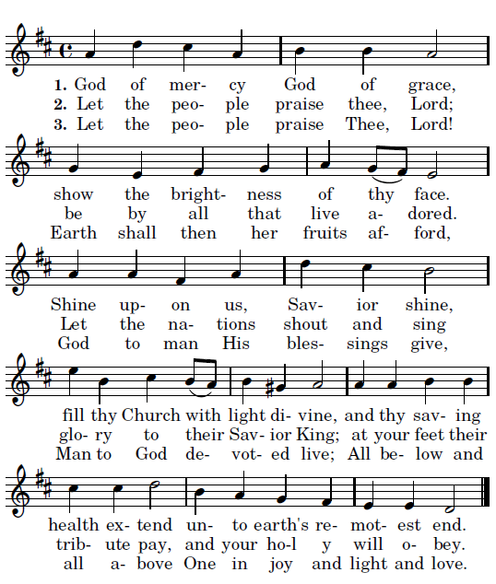

FOURTH SUNDAY OF LENT (year c)

ENTRANCE ANTIPHON
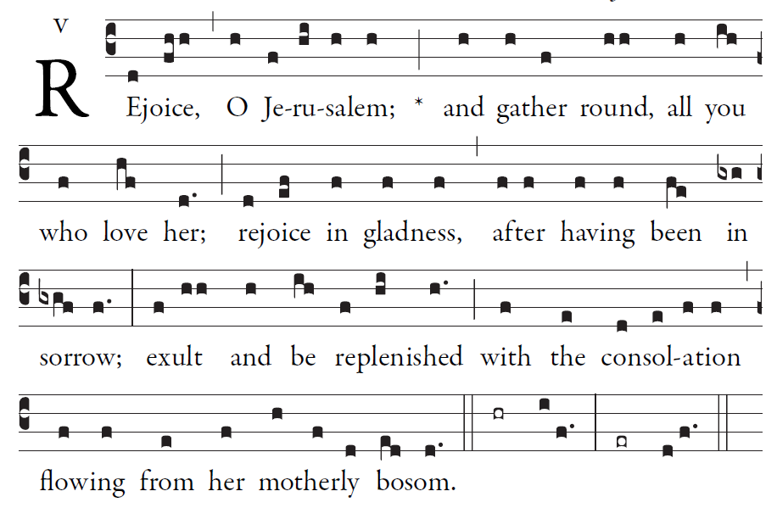
Simple English Proper © CMAA Adam Bartlet

Psalm 122 (121)
I rejoiced when they said to me,
“Let us go to the house of the Lord.”
And now our feet are standing
within your gates, O Jerusalem.

Jerusalem is built as a city
bonded as one together.
It is there that the tribes go up,
the tribes of the Lord.

For Israel’s witness it is
to praise the name of the Lord.
There were set the thrones for judgment,
the thrones of the house of David.

OFFERTORY HYMN:

MISERICORDIAS Music 2007, Henryk Jan Botar
permission requested
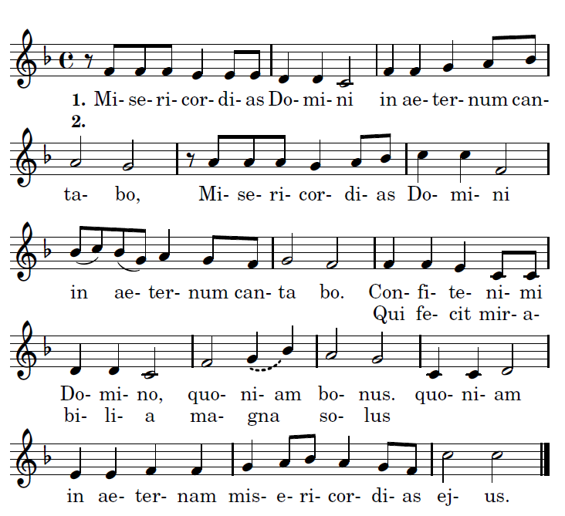

Refrain:
I will sing of the mercies of the Lord for ever.

1. Praise the Lord, for he is good: for his mercy endures forever.
2. Who alone does great wonders: for his mercy endues forever.

_

COMMUNION ANTIPHON:
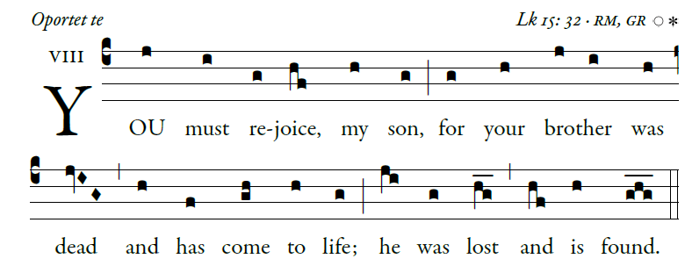
illuminare publication.com

Blessed is he whose transgression is forgiven,
whose sin is remitted.
Blessed the man to whom the LORD imputes no guilt,
in whose spirit is no guile.

I kept it secret and my frame was wasted.
I groaned all day long,
To you I have acknowledged my sin;
my guilt I did not hide.
I said, “I will confess my transgression to the LORD.”
And you have forgiven the guilt of my sin.
I will instruct you and teach you
the way you should go;
I will fix my eyes upon you.
Rejoice in the LORD; exult, you just!
Ring out your joy, all you upright of heart!

REJOICE

