v
They rise and needs will have
My dear Lord made away;
A murderer they saved,
The Prince of life they slay,
Yet cheerful He to suffering goes,
That He His foes from thence might free.

In life, no house, no home
My Lord on earth might have;
In death no friendly tomb
But what a stranger gave.
What may I say? Heav’n was His home;
But mine the tomb wherein He lay.

Here might I stay and sing,
No story so divine;
Never was love, dear King!
Never was grief like Thine.
This is my Friend, in Whose sweet praise
I all my days could gladly spend.

+ + +

RECESSIONAL HYMN

“Hail, Redeemer King Divine”
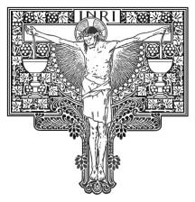

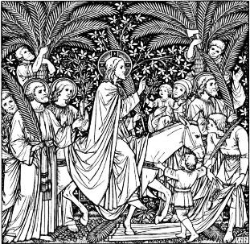
PALM SUNDAY

The entrance and blessing of Palms is
in Today’s Missal.follwed by the
Hymn: All Glory Laud and Honor.
RESPONSORIAL PSALM
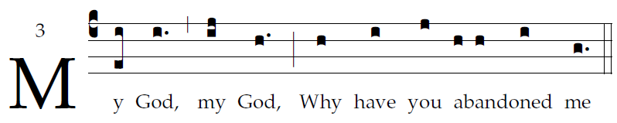

All who see me scoff at me;
they mock me with parted lips, they wag their heads:
“He relied on the LORD; let him deliver him,
let him rescue him, if he loves him.”  
Indeed, many dogs surround me,
a pack of evildoers closes in upon me;
They have pierced my hands and my feet;
I can count all my bones  
They divide my garments among them,
and for my vesture they cast lots.
But you, O LORD, be not far from me;
O my help, hasten to aid me.  
I will proclaim your name to my brethren;
in the midst of the assembly I will praise you:
“You who fear the LORD, praise him;
all you descendants of Jacob, give glory to him;
revere him, all you descendants of Israel!”  

VERSE BEFORE THE GOSPEL

OFFERTORY: from Gorzkie żale

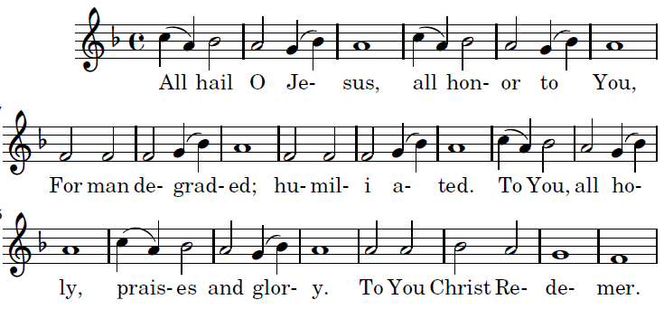

1. Jesus, sought by the maddened rabble,
like meekest of lambs driven to the slaughter
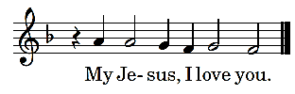


^{2.} Jesus, for thirty silver pieces
ungratefully sold by Judas the traitor.

^{3.} Jesus, down cast with sorrow and pain,
longing anxiously: death for man's salvation.  

^{4.} Jesus, in the dark olive garden
shedding bloody sweat, accepting the chalice

^{5.} Jesus, snared slyly into cruel hands
by Judas the traitor, ungrateful disciple.

^{6.} Jesus, roughly bound by drugged hire-lings:
the rope, coarse and strong tearing your flesh sorely. 

   All Hail O Jesus -

COMMUNION ANTIPHON

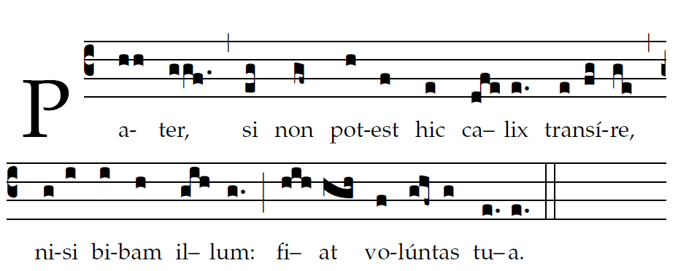
Father, if this cup cannot pass : thy will be done

COMMUNION HYMN Samuel Crossman, 1664
He came from his blest throne
Salvation to bestow;
But some my scorn, and none
The longed-for Christ would know:
But O! my Friend, my Friend indeed,
Who at my need
His life did spend.

My song is love unknown,
My Savior’s love to me;
Love to the loveless shown,
That they might lovely be.
O who am I, that for my sake
My Lord should take,
frail flesh and die.

Sometimes they strew His way,
And His sweet praises sing;
Resounding all the way
Hosannas to their King:
Then “Crucify!” is all their breath,
And for His death they thirst and cry.
Why, what hath my Lord done?
What makes this rage and spite?
He made the lame to run,
He gave the blind their sight,
Sweet injuries! Yet they at these. Themselves displease, and ’gainst Him rise. – continued –

