**COMMUNION ANTIPHON**

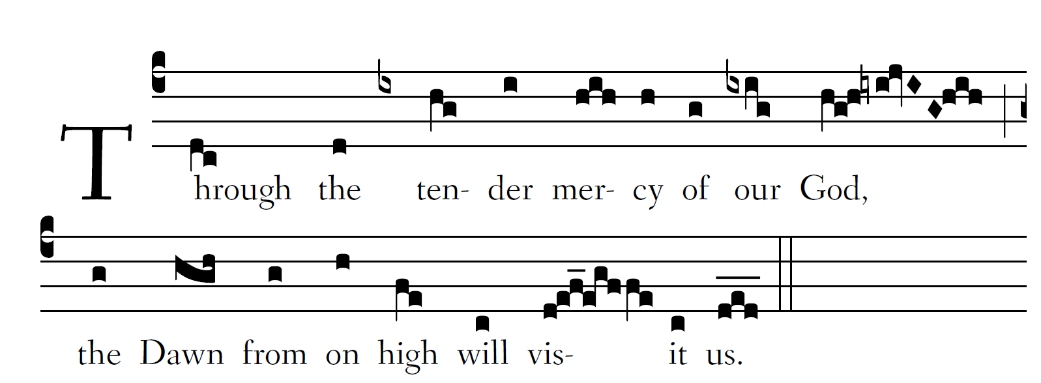

Fr.Columba Kelley @Saint Meinrad Archabbey

Blessed be the Lord, the |God of Is-ra-el,

because he has visited and wrought redemption | for his peo-ple,

and has raised up a horn of salvation | for us

in the house of Dav-|id his ser-vant.

And you, O child, |shall be called

the prophet of | the Most High ;

for you shall go before | the Lord

to pre- |pare his ways.

To give his people knowledge |of sal-va-tion

through the forgiveness | of their sins,

because of the compassionate kindness of | our God

with which the Orient from on high will |vis-it us.

To shine on those who | sit in dark-ness

and the | sha- dow of death,

to guide | our feet

into the |way of peace.

**JUBILATE DEO**

**RECESSIONAL HYMN** “ **Christ Be our Light”**



**THE NATIVITY OF SAINT JOHN THE BAPTIST**

**ENTRANCE ANTIPHON**

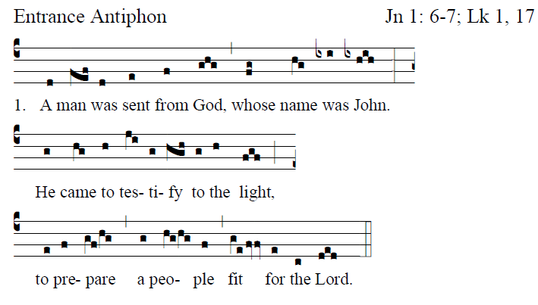

Fr.Columba Kelley @Saint Meinrad Archabbey

**It is good to give thanks to the LORD,**

**to make music to your name, O Most High,**

**to proclaim your loving mercy in the morning,**

**and your truth in the watches of the night,**

**You have gladdened me, O LORD, by your deeds;**

**How deep are your designs!**

**The senseless cannot know this,**

**and the fool cannot understand.**

**The just man shall flourish like the palm tree,**

**like a cedar of Lebanon *shall he* grow.**

**They that are planted in the house of the Lord**

**shall flourish in the courts of our God.**

RESPONSORIAL PSALM

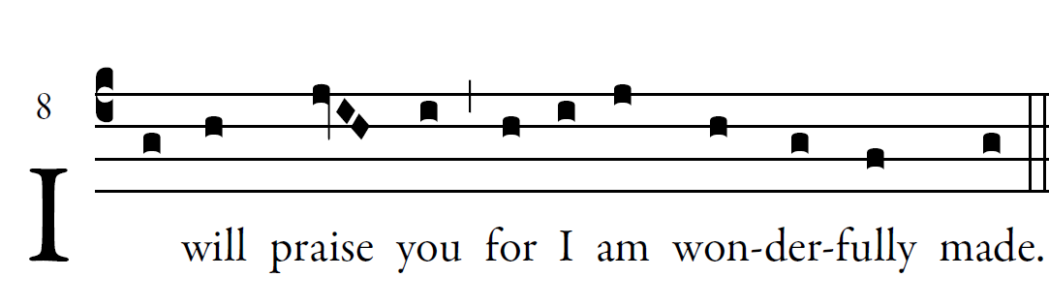Illuminarepublications.com

**O LORD, you have probed me, you know me:  
you know when I sit and when I stand;  
you understand my thoughts from afar.  
My journeys and my rest you scrutinize,  
with all my ways you are familiar.  
  
Truly you have formed my inmost being;  
you knit me in my mother's womb.  
I give you thanks that I am fearfully, wonderfully made;  
wonderful are your works.  
  
My soul also you knew full well;  
nor was my frame unknown to you  
When I was made in secret,  
when I was fashioned in the depths of the earth.**

**ALLELUIA**

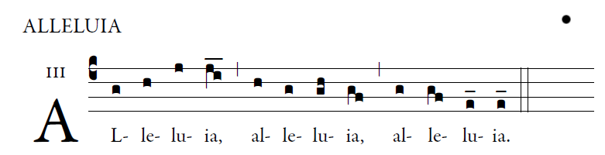

**_____________________________________________**

**OFFERTORY HYMN**

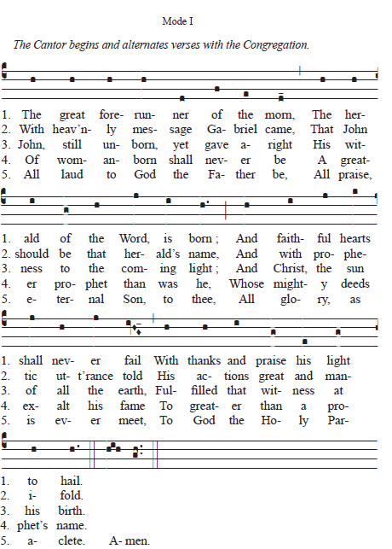

***Fr.Samauel Webber Saint Meinrad Archabbey***