TENEBRAE

       Lord open my Lips
   And my mouth will proclaim your praise.

INVITATORY 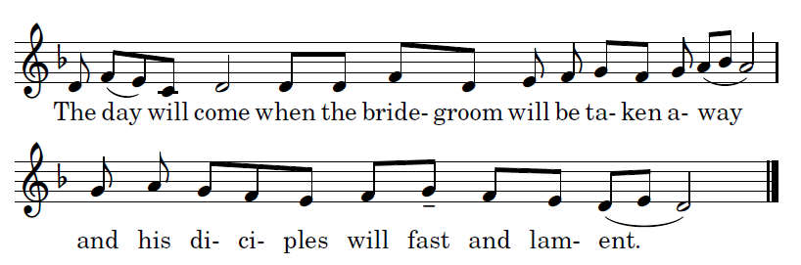

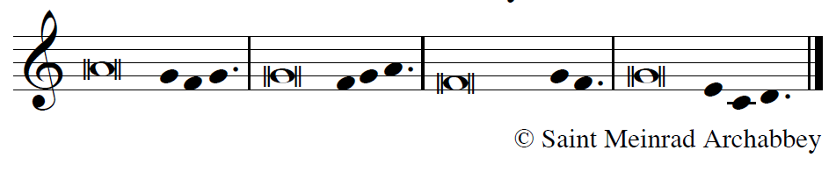
- (CANTOR) O God, take pity on us and bless us,
and let your face shine upon us,
so that your ways may be known across the world,
and all nations learn of your salvation.

- (ALL) Let the peoples praise you, O God,
Let the nations be glad and rejoice,
for you judge the peoples with fairness
and you guide the nations of the earth.              

- (CANTOR) Let the peoples praise you, O God,
let all the peoples praise you.
The earth has produced its harvest:
may the whole world revere him.                     

- (ALL BOW) Glory be to the Father and to the Son
and to the Holy Spirit,
as it was in the be- ginning,
is now, and shall be for ev - er, Amen
( the antiphon is repeated)
OFFICE OF READINGS

HYMN “Sing My Tongue the Savior’s Glory"

Antiphon 1:
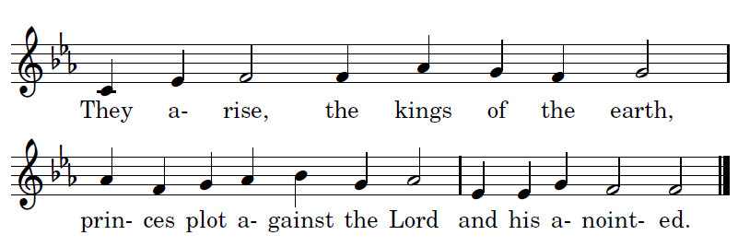

Psalm 2
The Messiah, king and conqueror
The rulers of the earth joined forces to overthrow Jesus, your anointed Son (Acts 4:27) 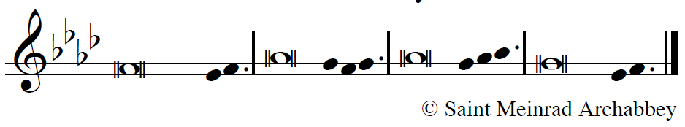

- (CANTOR) Why this tumult among the nations,
among peoples this useless murmuring?
They arise, the kings of the earth,
princes plot against the Lord and his A-nointed.

- (ALL) "Come, let us break their fetters,
come, let us cast off their yoke."
He who sits in the heavens laughs;
the Lord is laughing them to scorn.*

- (CANTOR) Then he will speak in his anger,
his rage will strike them with terror.
"It is I who have set up my king on Zion,
my holy mountain.”

- (ALL) I will announce the decree of the Lord:
The Lord said to me: "You are my Son.
It is I who have begotten you this day.
Ask and I will bequeath you the nations,

- (CANTOR) Put the ends of the earth in your possession.
With a rod of iron you will break them,
shatter them like a potter's jar."
Now, O kings, understand,

- (ALL) take warning, rulers of the earth;
serve the Lord with awe and trembling,
pay him your homage
lest he be angry and you perish;

- (CANTOR) for suddenly his anger will blaze. [2]
Blessed are they who put their trust in God.

(ALL BOWING) Glory to the Father, and to the Son,
and to the Holy Spirit:
as it was in the begin- ning, is now,
and will be for ever. / Amen.

Antiphon 1

Antiphon 2
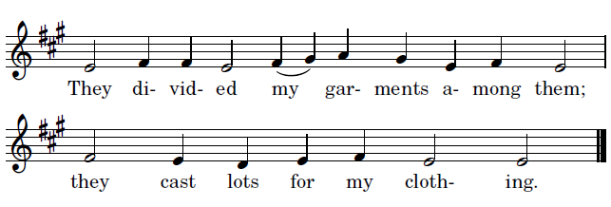

Psalm 22
God hears the suffering of his holy one
Jesus cried with a loud voice: My God, my God, why have you forsaken me? (Matthew 27:46)

- (CAN) My God, my God, why have you forsaken me?
You are far from my plea and the cry of my distress.

- (ALL) O my God, I call by day and you give no reply
I call by night and I find no peace.

- (CAN) Yet you, O God, are holy,
enthroned on the prais -es of Israel.

- (ALL) In you our fathers put their trust;
they trusted and you set them free.

- (CAN) When they cried to you, they e-scaped.
In you they trusted and nev- er in vain.

- (ALL) But I am a worm and no man,
scorned by men, despised by the people.

- (CAN) All who see me deride me.
They curl their lips, they toss their heads.

- (ALL) "He trusted in the Lord, let him save him;
let him release him if this is his friend."

- (CAN.) Yes, it was you who took me from the womb,
entrusted me to my mother's breast.

- (ALL) To you I was committed from my birth,
from my mother's womb you have been my God.

- (CAN.) Do not leave me alone in my distress;
Come close, there is none else to help.

- (ALL) Many bulls have surrounded me,
fierce bulls of Bashan close me in.

- (CAN.) Against me they open wide their jaws,
like lions, rend- ing and roaring.

- (ALL) Like water I am poured out,
disjointed are all my bones.

- (CAN.) My heart has become like wax,
it is melted within my breast.

- (ALL) Parched as burnt clay is my throat,
my tongue cleaves to my jaws.

- (CAN.) Many dogs have sur-rounded me,
a band of the wick - ed beset me.

- (ALL) They tear holes in my hands and my feet
and lay me in the dust of death

- (CAN) I can count every one of my bones.
These people stare at me and gloat;

- (ALL) they divide my cloth- ing a-mong them.
They cast lots for my robe.

- (CAN) O Lord, do not leave me alone,
my strength, make haste to help me!

- (ALL) Rescue my soul from the sword,
my life from the grip of these dogs.

- (CANTOR) Save my life from the jaws of these lions,
my poor soul from the horns of these oxen.

- (ALL) I will tell of your name to my brethren
and praise you where they are assembled. *

(CANTOR, BOW) Glory to the Father, and to the Son,
and to the Ho - ly Spirit:

(ALL) as it was in the be- ginning,
is now, and will be for ever. | A-men.

Antiphon 2

Antiphon 3
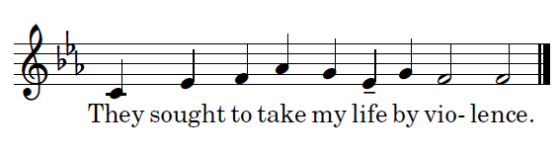
Psalm 38
A sinner in extreme danger prays earnestly to God
All his friends were standing at a distance. (Luke 23:49)

- (CANTOR) O Lord, do not rebuke me in your anger;
do not punish me, Lord, in your rage.
Your arrows have sunk deep in me;
your hand has come down upon me.

- (ALL) Through your anger all my body is sick:
through my sin, there is no health in my limbs.
My guilt towers higher than my head;
it is a weight too heavy to bear.

- (CANTOR) My wounds are foul and festering,
the result of my own folly.
I am bowed and brought to my knees.
I go mourning all the day long.

- (ALL) All my frame burns with fever;
all my bod- y is sick.
Spent and ut -terly crushed,
I cry aloud in anguish of heart.

- (CANTOR) Lord, you know all my longing:
my groans are not hid-den from you.
My heart throbs, my strength is spent;
the very light has gone from my eyes.

- (ALL) My friends avoid me like a leper;
those closest to me stand afar off.
Those who plot against my life lay snares;
those who seek my ruin speak of harm,...

- (CANTOR) But I am like the deaf who can-not hear,
like the dumb una- ble to speak.
I am like a man who hears nothing
in whose mouth is no de-fense.

- (ALL) I count on you, O Lord:
it is you, Lord God, who will answer.
I pray: Do not let them mock me,
those who triumph if my foot should slip."

- (CANTOR) For I am on the point of falling
and my pain is al- ways before me.
I confess that I am guilty
and my sin fills me with dismay.

- (ALL) My wanton enemies are numberless
and my lying foes are many.
They repay me e -vil for good
and attack me for seeking what is right.

- (CANTOR) Lord, do not forsake me!
My God, do not stay afar off!
Make haste and come to my help,
O Lord, my God, my Savior!

(ALL BOWING) Glory to the Father, and to the Son,
and to the Hol-y Spirit:
as it was in the begin- ning, is now,
and will be for ev- er. | Amen.

Antiphon 3
                They brought false evidence against me.
(ALL)  They were breathing out fury.
FIRST READING
From the letter to the Hebrews 9:11-28
By the shedding of his own blood, Christ, the high priest, entered the sanctuary once and for all
When Christ came as high priest of the good things that have come to be, passing through the greater and more perfect tabernacle not made by hands, that is, not belonging to this creation, he entered once for all into the sanctuary, not with the blood of goats and calves but with his own blood, thus obtaining eternal redemption.
For if the blood of goats and bulls and the sprinkling of a heifer's ashes can sanctify those who are defiled so that their flesh is cleansed, how much more will the blood of Christ, who through the eternal spirit offered himself unblemished to God, cleanse our consciences from dead works to worship the living God.
For this reason he is mediator of a new covenant: since a death has taken place for deliverance from transgressions under the first covenant, those who are called may receive the promised eternal inheritance. Now where there is a will, the death of the testator must be established. For a will takes effect only at death; it has no force while the testator is alive. Thus not even the first covenant was inaugurated without blood.
When every commandment had been proclaimed by Moses to all the people according to the law, he took the blood of calves and goats, together with water and crimson wool and hyssop, and sprinkled both the book itself and all the people, saying, "This is 'the blood of the covenant which God has enjoined upon you.'" In the same way, he sprinkled also the tabernacle and all the vessels of worship with blood. According to the law almost everything is purified by blood, and without the shedding of blood there is no forgiveness.
Therefore, it was necessary for the copies of the heavenly things to be purified by these rites, but the heavenly things themselves by better sacrifices than these. For Christ did not enter into a sanctuary made by hands, a copy of the true one, but heaven itself, that he might now appear before God on our behalf. Not that he might offer himself repeatedly, as the high priest enters each year into the sanctuary with blood that is not his own; if that were so, he would have had to suffer repeatedly from the foundation of the world. But now once for all he has appeared at the end of the ages to take away sin by his sacrifice. Just as it is appointed that human beings die once, and after this the judgment, so also Christ, offered once to take away the sins of many, will appear a second time, not to take away sin but to bring salvation to those who eagerly await him.

RESPONSORY See Isaiah 53:7, 12
    He was led like a lamb to the slaughter;
no complaint from his lips against the evil done to
him. He was given up to death,
 (ALL ) to give his people life.

   He surrendered himself to death
and was counted among the wicked.

 (ALL ) To give his people life.
SECOND READING
From the Catecheses by St. John Chrysostom , bishop
(Cat. 3, 13-19; SC 50, 174-177)
The power of Christ's blood
If we wish to understand the power of Christ’s blood, we should go back to the ancient account of its prefiguration in Egypt. Sacrifice a lamb without blemish, commanded Moses, and sprinkle its blood on your doors. If we were to ask him what he meant, and how the blood of an irrational beast could possibly save men endowed with reason, his answer would be that the saving power lies not in the blood itself but in the fact that it is a sign of the Lord’s blood. In those days, when the destroying angel saw the blood on the doors he did not dare to enter, so much less will the devil approach now when he sees, not that figurative blood on the doors, but the true blood on the lips of believers, the doors of the temple of Christ.
If you desire further proof of the power of this blood, remember where it came from, how it ran down from the cross, flowing from the Master’s side. The gospel records that when Christ was dead, but still hung on the cross, a soldier came and pierced his side with a lance and immediately there poured out water and blood. Now the water was a symbol of baptism and the blood of the Holy Eucharist. The soldier pierced the Lord’s side, he breached the wall of the sacred temple, and I have found the treasure and made it my own. So also with the lamb: the Jews sacrificed the victim and I have been saved by it.
There flowed from his side water and blood. Beloved, do not pass over this mystery without thought; it has yet another hidden meaning, which I will explain to you. I said that water and blood symbolized baptism and the holy Eucharist. From these two sacraments the Church is born: from baptism, the cleansing water that gives rebirth and renewal through the Holy Spirit, and from the holy Eucharist. Since the symbols of baptism and the Eucharist flowed from his side, it was from his side that Christ fashioned the Church, as he had fashioned Eve from the side of Adam. Moses gives a hint of this when he tells the story of the first man and makes him exclaim: Bone from my bones and flesh from my flesh! As God then took a rib from Adam`s side to fashion a woman, so Christ has given us blood and water from his side to fashion the Church. God took the rib when Adam was in a deep sleep, and in the same way Christ gave us the blood and water after his own death.
Do you understand, then, how Christ has united his bride to himself and what food he gives us all to eat? By one and the same food we are both brought into being and nourished. As a woman nourishes her child with her own blood and milk, so does Christ unceasingly nourish with his own blood those to whom he himself has given life.
RESPONSORY 1 Pt. 1:18-19; Eph. 2:18; 1 Jn. 1:7
    The price of your redemption
was not something of fleeting value like gold or silver,
but the costly shedding of the blood of Christ,
the lamb without blemish.
- (ALL )Through him, in the one Spirit, we can
approach the Father.

The blood of Jesus Christ washes away all our sins.
 - (ALL )Through him, in the one Spirit, we can
approach the Father.

THIRD READING
Lamentations Chapter 3 : 1-11 sung by the cantor

RESPONSORY

   O my chosen vineyard
It is I who have planted you.

    (ALL) How have you become so bitter
that you crucify me and release Barabas?

   I have hedged you in and cleared you of stones
and have built a tower.

   (ALL) How have you become so bitter
that you crucify me and release Barabas?

COLLECT

F
ather, look with love upon your people,
the love which the Lord Jesus Christ showed us
when he delivered himself to evil men
and suffered the agony of the cross,
for he lives and reigns with you and the Holy Spirit,
one God, for ever and ever.

   Let us praise the Lord.
  And give him thanks.
______________

MORNING PRAYER

HYMN O Saving Victim

O saving Victim, open wide
the gate of heaven to man below;
our foes press on from every side;
thine aid supply; thy strength bestow.
All praise and thanks to thee ascend
for evermore, blest One in Three;
O grant us life that shall not end
in our true native land with thee.

Antiphon 1: 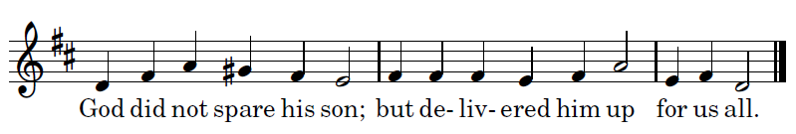

Psalm 51
O God, have mercy on me
Your inmost being must be renewed, and you must put on the new man. (Ephesians 4:23-24)
- (CANTOR) Have mercy on me, God, in your kindness.
In your compassion blot out my offense.
- (ALL) O wash me more and more from my guilt
and cleanse me from my sin.

- (CANTOR) My offenses truly I know them;
my sin is always be-fore me

- (ALL) Against you, you alone, have I sinned;
what is evil in your sight I have done.

- (CANTOR) That you may be justified when you give sentence
and be without reproach when you judge,
- (ALL) O see, in guilt I was born,
a sinner was I conceived

- (CANTOR) Indeed you love truth in the heart;
then in the secret of my heart teach me wisdom.
- (ALL) O purify me, then I shall be clean;
O wash me, I shall be whiter than snow.

- Make me hear rejoicing and gladness,
that the bones you have crushed may thrill.

- (ALL) From my sins turn away your face
and blot out all my guilt.

- (CANTOR) A pure heart create for me, O God,
put a steadfast spirit within me.

- (ALL) Do not cast me away from your presence,
nor deprive me of your ho - ly spirit.

- (CANTOR) Give me again the joy of your help;
with a spirit of fervor sus- tain me,

- (ALL) that I may teach transgressors your ways
and sinners may return to you.

- rescue me, God, my helper,
and my tongue shall ring out your goodness.

- (ALL) O Lord, open my lips
and my mouth shall declare your praise.

- (CANTOR) For in sacrifice you take no de-light,
burnt offering from me you would re-fuse,

- (ALL) my sacrifice, a con - trite spirit,
a humbled, contrite heart you will not spurn.

- (CANTOR) In your goodness, show favor to Zion:
rebuild the walls of Je-rusalem.
- (ALL) Then you will be pleased with law- ful sacrifice,
holocausts offered on your altar.

(CANTOR, BOWING) Glory to the Father, and to the Son,
and to the Ho- ly Spirit:
(ALL) as it was in the beginning, is now,
and will be for ever. Amen

Psalm Prayer:
F
ather, he who knew no sin was made sin for us, to save us and restore us to your friendship. Look upon our contrite heart and afflicted spirit and heal our troubled conscience, so that in the joy and strength of the Holy Spirit we may proclaim your praise and glory before all the nations.

Antiphon 1

Antiphon 2

Canticle - Habakkuk 3:2-4, 13a, 15-19
God comes to judge
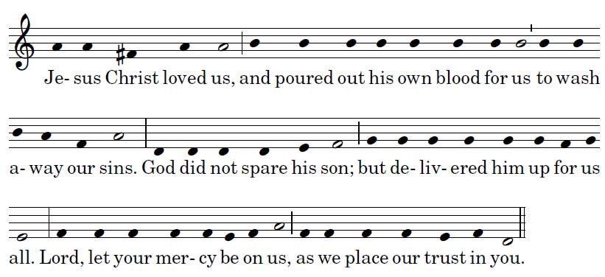
Lift up your heads, for your redemption is at hand. (Luke 21:28)

- (CANTOR) Lord, I have heard your renown,
and feared, O Lord, your work.

- (ALL) In the course of the years revive it, and make it known;
in your wrath remember com - passion!

- (CANTOR) God comes, from Teman,
the Holy One from Mount Paran.

- (ALL) Covered are the heavens with his glory,
and with his praise the earth is filled.

- (CANTOR) His splendor spreads like the light;
rays shine forth from beside him,
where his power is concealed.

- (ALL) You come forth to save your people,
to save your a-nointed one

- (CANTOR) You tread the sea with your steeds
amid the churning of the deep waters.

- (ALL) I hear, and my bod- y trembles;
at the sound, my lips quiver.

- (CANTOR) Decay invades my bones,
my legs tremble be-neath me.

- (ALL) I await the day of dis-tress
that will come upon the people who at-tack us.

- (CANTOR) For though the fig tree blos - som not
nor fruit be on the vines,

- (ALL) Though the yield of the ol-ive fail
and the terraces produce no nourishment,

- (CANTOR) Though the flocks disappear from the fold
and there be no herd in the stalls,

- (ALL) Yet will I rejoice in the Lord
and exult in my sav- ing God.

- (CANTOR) God, my Lord, is my strength;
he makes my feet swift as those of hinds
and enables me to go upon the heights.

(CANTOR, BOW) Glory to the Father, and to the Son,
and to the Ho- ly Spirit:
(ALL) as it was in the beginning, is now
and will be for ev- er. Amen

Antiphon 2

Antiphon 3.
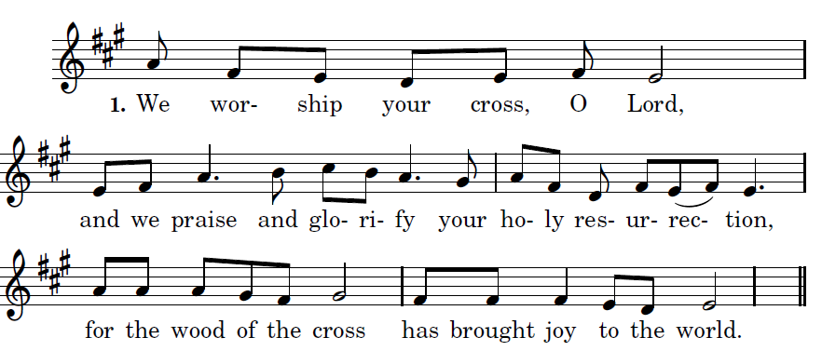

Psalm 147:12-20
The restoration of Jerusalem
Come, I will show you the bride of the Lamb (Revelation 21:9)

- (CANTOR) praise the Lord, Jerusalem!
Zion praise your God!
- (ALL) He has strengthened the bars of your gates
he has blessed the child - ren within you.
- (CANTOR) He established peace on your borders,
he feeds you with finest wheat.

- (ALL) He sends out his word to the earth
and swiftly runs his command.

- (CANTOR) He showers down snow white as wool,
he scatters hoar-frost like ashes.

- (ALL) He hurls down hail- stones like crumbs.
The waters are frozen at his touch;

- (CANTOR) he sends forth his word and it melts them:
at the breath of his mouth the waters flow.

- (ALL) He makes his word known to Jacob,
to Israel his laws and decrees.

- (CANTOR) He has not dealt thus with other nations;
he has not taught them his decrees.

(CANTOR, BOWING) Glory to the Father, and to the Son,
and to the Ho - ly Spirit:

(ALL) as it was in the be- ginning,
is now, and will be for ever. | A-men.

Psalm Prayer:
L
ord, you established peace within the borders of Jerusalem. Give the fullness of peace now to your faithful people. May peace rule us in this life and possess us in eternal life. You are about to fill us with the best of wheat: grant that what we see dimly now as in a mirror, we may come to perceive dearly in the brightness of your truth.

Antiphon 3.

READING Isaiah 52:13-15
See, my servant shall prosper;
he shall be exalted and lifted up,
and shall be very high.
Just as there were many who were astonished at him
— so marred was his appearance, beyond human semblance,
and his form beyond that of mortals —
so he shall startle many nations;
kings shall shut their mouths because of him;
for that which had not been told them they shall see,
and that which they had not heard they shall contemplate.
RESPONSORY:
   For our sake Christ was obedient, accepting even death, death on a cross.

BENEDICTUS (Canticle of Zechariah)
STAND

Antiphon: 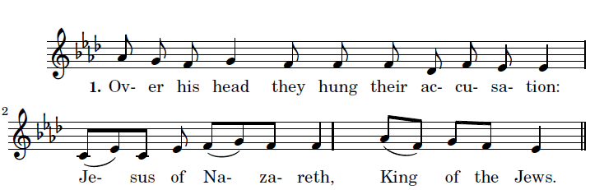
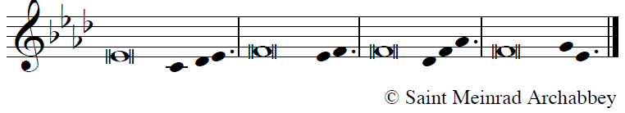
(CATNOR)
+ Blessed be the Lord, the God of Israel;
he has come to his people and set them free.
He has raised up for us a mighty savior,
born of the house of his ser - vant David.
(ALL) Through his holy prophets
he promised of old,
that he would save us from our enemies,
from the hands of all who hate us.
(CANTOR) He promised to show mercy to our fathers
and to remember his ho - ly covenant.
This was the oath he swore to our father Abraham,
to set us free from the hands of our enemies,
(ALL) [He] set us free from the hands of our enemies,
Free to worship him with - out fear,
holy and righteous in his sight
all the days of our life.
(CANTOR) You, my child, shall be called the prophet
of the Most High,
for you will go before the Lord to prepare his way,
To give his people knowledge of salvation
by the forgiveness of their sins.
(ALL) In the tender compassion of our God
the dawn from on high shall break up- on us,
To shine on those who dwell in darkness
and the shad - ow of death,
and to guide our feet into the way of peace.
(CANTOR, BOW) Glory to the Father, and to the Son,
and to the Holy Spirit:
(ALL) as it was in the beginning,
is now, and will be for ever. A-men

INTERCESSIONS: prayed silently
after this moment of silent prayer the following is sung
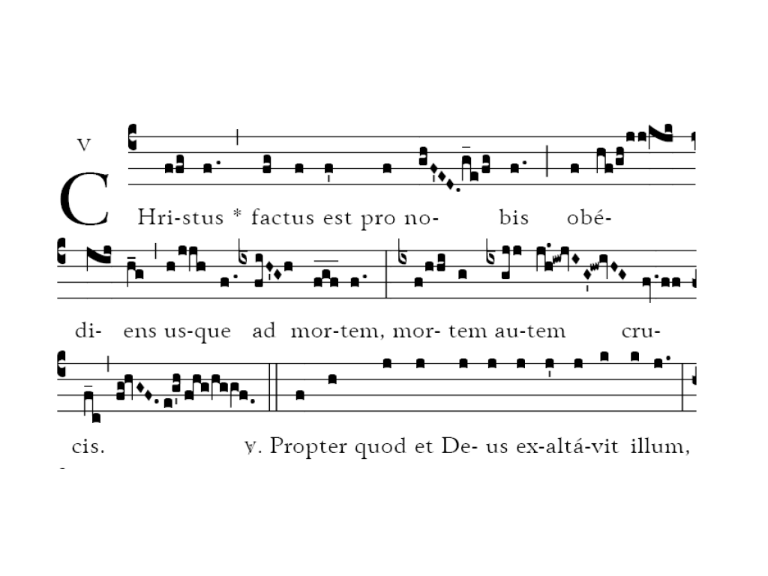

Christ became obedient for us unto death, even death on a cross.

The Our Father is said completely in silence.

Then, recto tono, on a low pitch, without ‘Let us pray’, there is added :

COLLECT

W
E beseech you, O Lord, look graciously upon this your family, for whom our Lord Jesus Christ did not hesitate to suffer betrayal into the hands of the enemy, and to suffer the torments of the Cross: who lives and reigns with you with you and the Holy Spirit, one God, for ever and ever. Amen

PRIEST + May the Lord bless us, protect us from all
evil and bring us to everlasting life.

 Amen.

KNEEL as the last lighted candle is removed.
There is made a certain amount of noise and clatter ;

and at once the lighted candle is brought forth,

and all rise, and Depart in silence
.
Psalm Prayers, Non-Biblical Readings from The Liturgy of the Hours © 1973, 1974, 1975, ICEL; excerpts from the English translation of The Roman Missal © 2010, ICEL. All rights reserved.

