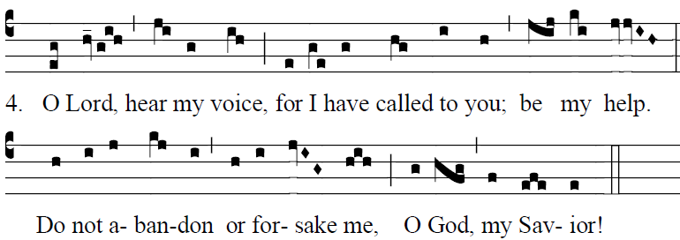

Fr. Columba Kelly © Saint Meinrad Archabbey

The LORD is my light and my salvation;
whom shall I fear?
The LORD is the stronghold of my life;
whom should I dread? 

²When those who do evil draw near
to devour my flesh,
it is they, my enemies and foes,
who stumble and fall. 

Glory be to the Father … 

