Recessional Hymn:

O SACRED HEART
by Francis Stanfield (Public Domain)

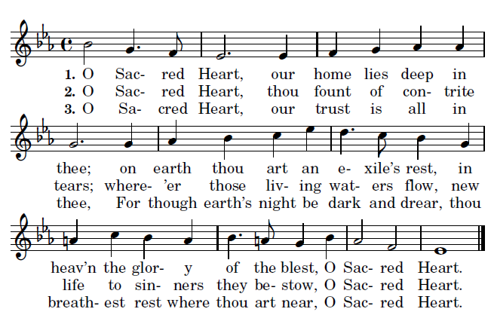
music R.R. Terr,y Westminster Hymnal
4. O Sacred Heart, when shades of death shall fall,
receive us ‘neath thy gentle care,
and save us from the tempter’s snare,
O Sacred Heart.
5. O Sacred Heart, lead exiled children home,
where we may ever rest near thee,
in peace and joy eternally,
O Sacred Heart.

proper antiphon from Illuminarepublications.com

13th Sunday in Ordinary Time

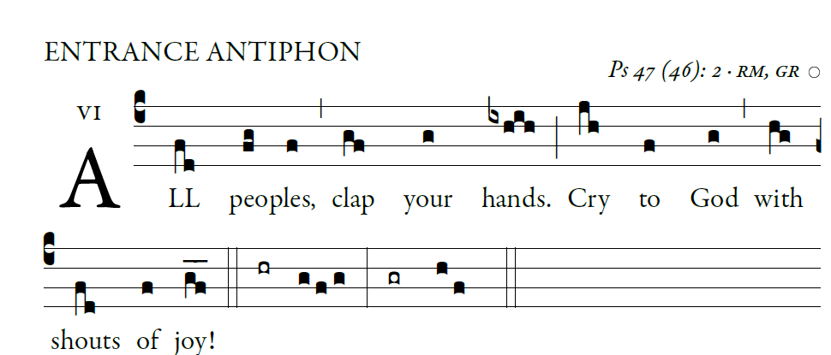
Entrance Antiphon

Psalm 28 (27)

For the LORD, the Most High, is awesome,
the great king over all the earth.
He humbles peoples under us
and nations under our feet.

Our heritage he chose for us,
the pride of Jacob whom he loves.
God goes up with shouts of joy.
The LORD goes up with trumpet blast.

Sing praise for God; sing praise!
Sing praise to our king; sing praise!
God is king of all the earth.
Sing praise with all your skill.
God reigns over the nations.
God sits upon his holy throne.

Kyrie and Gloria (MISSA SIMPLEX booklet)

Responsorial Psalm (year B)

I will extol you, O LORD, for you drew me clear
and did not let my enemies rejoice over me.
O LORD, you brought me up from the netherworld;
you preserved me from among those going down into the pit.

Sing praise to the LORD, you his faithful ones,
and give thanks to his holy name.
For his anger lasts but a moment;
a lifetime, his good will.
At nightfall, weeping enters in,
but with the dawn, rejoicing.

Hear, O LORD, and have pity on me;
O LORD, be my helper.
You changed my mourning into dancing;
O LORD, my God, forever will I give you thanks.

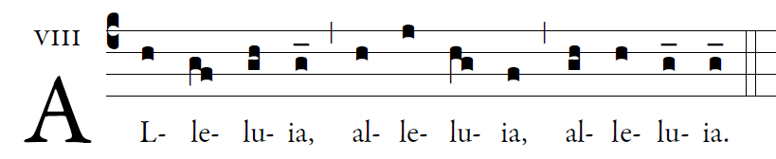

Our Savior Jesus Christ destroyed death
and brought us life through the gospel.

Offertory Hymn:

PRAISE MY SOUL THE KING OF HEAVEN

Holy & Lamb of God: MISSA SIMPLEX booklet

Communion Antiphon

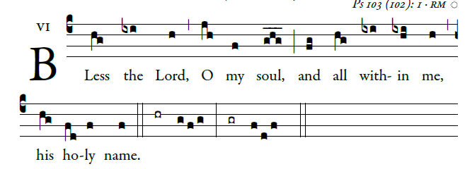

Bless the LORD, O my soul,
and all within me, his holy name.
²Bless the LORD, O my soul,
and never forget all his benefits.

³It is the LORD who forgives all your sins,
who heals every one of your ills,
⁴who redeems your life from the grave,
who crowns you with mercy and compassion,
⁵who fills your life with good things,
renewing your youth like an eagle’s.

⁶The LORD does just deeds,
gives full justice to all who are oppressed.
⁷He made known his ways to Moses,
and his deeds to the children of Israel.

⁸The LORD is compassionate and gracious,
slow to anger and rich in mercy.
⁹He will not always find fault;

