15th Sunday

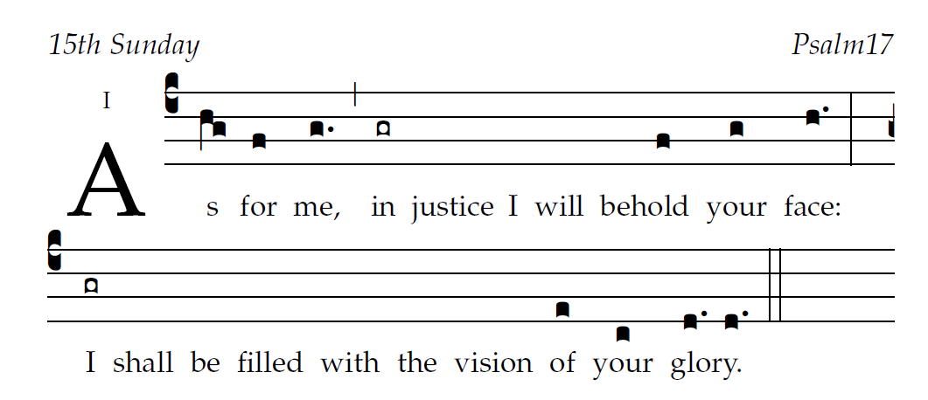

Entrance Antiphon

|  |  |
| --- | --- |
| 1O LORD, hear a cause *that is* just;  pay heed *to my* cry.  Turn your ear to *my* prayer:  no deceit is *on my* lips. | 6To you I call; for you will surely heed *me, O* God. [5]  Turn your ear to me; *hear my* words.  7Display your mer-  *ciful* love.  By your right hand you deliver *from their* foes  those who put their *trust in* you. |
| 2From you may my just-*ice come* forth.  Your eyes discern *what is* upright.  3Search my heart and visit me *by* night.  Test me by fire, and you will find no *wrong in* me. | 8Guard me as the apple *of your* eye. [6]  Hide me in the shadow *of your* wings  9from the violent attack *of the* wicked.  My foes encircle me with dead- *ly in*-tent.  15As for me, in justice I shall behold *your* face;  when I awake I shall be filled  with the vision *of your* presence. |



user-notes: 15th Sunday ;

commentary: Psalm17 ;

annotation: I;

centering-scheme: english;

%fontsize: 12;

%spacing: vichi;

%font: palatino;

%width: 4;

%height: 11;

%%

(c4) As(hg) for(f) me,(g.) (,) in(gr) justice() I() will() behold( /f) your(g) face:(h.) (:) (z) I(gr) shall() be() filled() with() the() vision() of(e) your(c) {glo}ry.(d./ d.) (::)