COMMUNION ANTIPHON

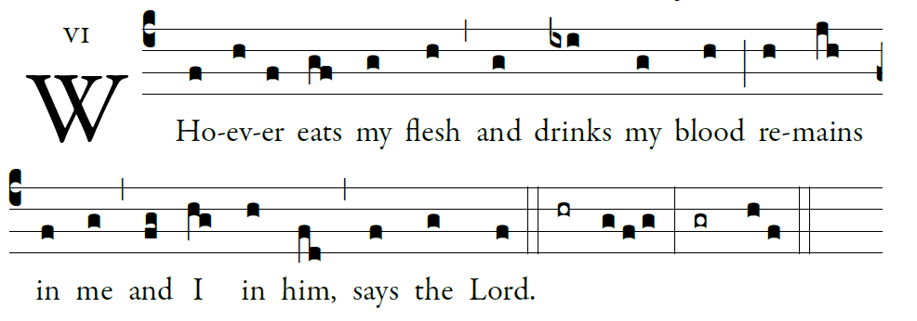
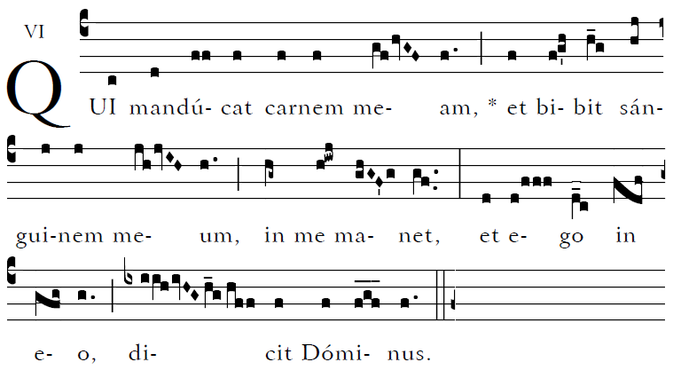

Blessed are those whose way is blameless,
who walk in the law of the LORD!
²Blessed are those who keep his decrees!
With all their hearts they seek him.

³They never do anything evil,
but walk in his ways.
⁴You have laid down your precepts
to be carefully kept.

RECESSIONAL HYMN

“Be Thou My Vision ”

15th Sunday in Ordinary Time YEAR A

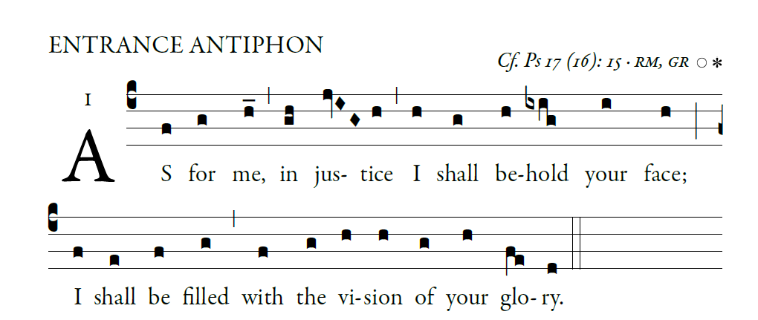

O LORD, hear a cause that is just;
pay heed to my cry.
Turn your ear to my prayer:
no deceit is on my lips.

From you may my just-ice come forth.
Your eyes discern what is upright.
Search my heart and visit me by night.
Test me by fire, and you will find no wrong
in me.

I kept my steps firmly in your paths.
My feet have never faltered.
To you I call; for you will surely heed me,
O God.
Turn your ear to me; hear my words.

antiphons from ILLUMINAREPUBLICTIONS.COM

GLORY TO GOD R.B.2014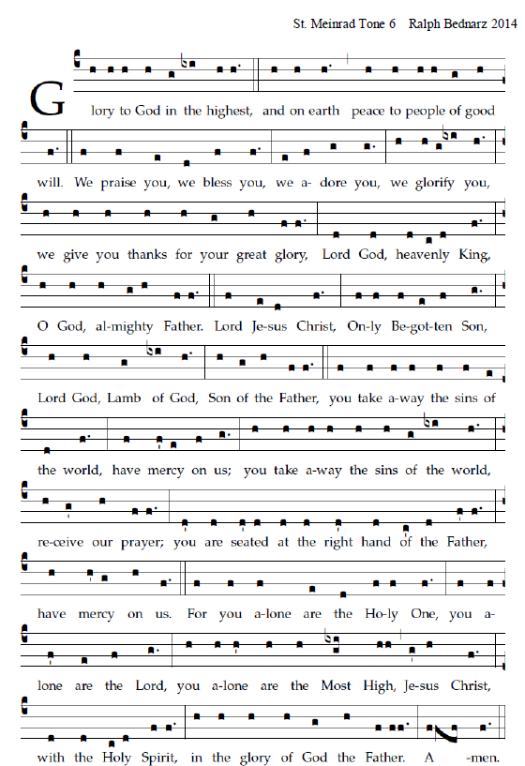

RESPONSORIAL PSALM in Today’s Missal

ALLELUIA
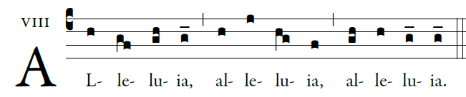

               The seed is the word of God, Christ is the sower,
All who come to him will have life forever.

OFFERTORY HYMN “Jesus Joy of Loving Hearts”
JESU DULCIS MEMORIA

Jesus, Thou Joy of loving hearts,
Thou Fount of life, Thou Light of men,
From the best bliss that earth imparts,
We turn unfilled to Thee again.

Thy truth unchanged hath ever stood;
Thou sav-est those that on Thee call;
To them that seek Thee, Thou art good,
To them that find Thee, all in all!
Thy truth unchanged hath ever stood;
Thou savest those that on Thee call;
To them that seek Thee Thou art good,
To them that find Thee all in all.
O Jesus, ever with us stay,
Make all our moments calm and bright;
Chase the dark night of sin away,
Shed over the world Thy holy light.

