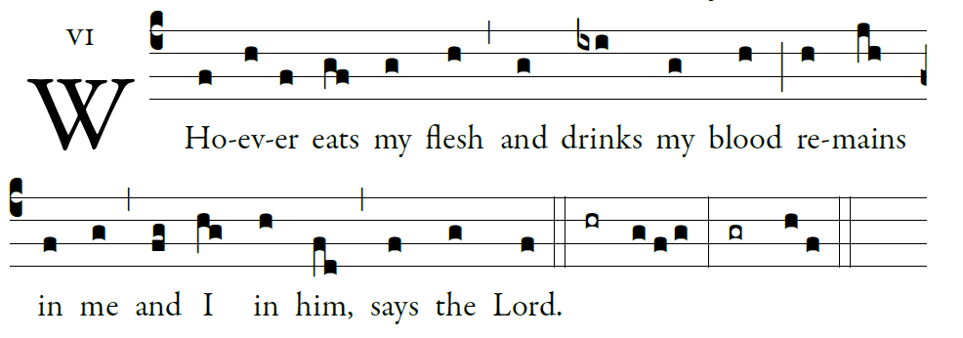
Communion

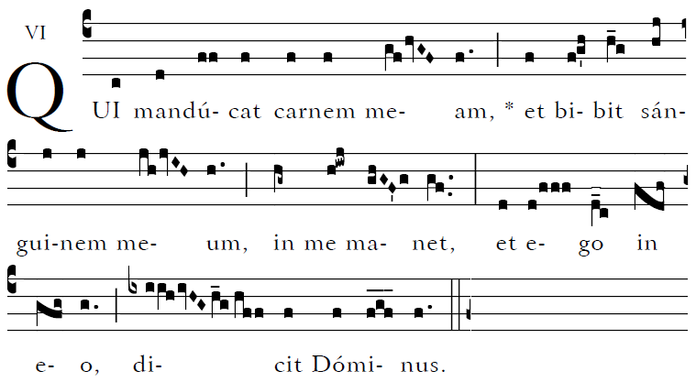

Blessed are those whose way is blameless,
who walk in the law of the LORD!
²Blessed are those who keep his decrees!
With all their hearts they seek him.

³They never do anything evil,
but walk in his ways.
⁴You have laid down your precepts
to be carefully kept.

Recessional Hymn

“Church of God Elect and Glorious”

15th Sunday in Ordinary Time

Kyrie 853 Gloria 854, Sanctus, 855, Agnus Dei 859

Entrance Antiphon

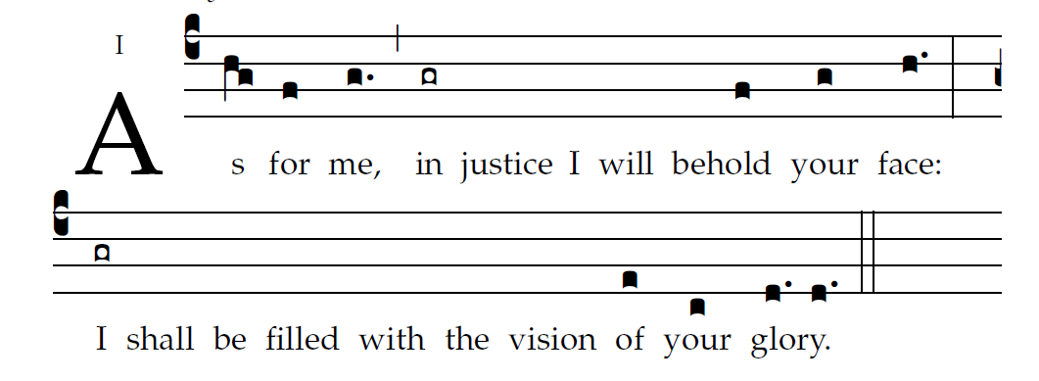

¹O LORD, hear a cause that is just;
pay heed to my cry.
Turn your ear to my prayer:
no deceit is on my lips.

From you may my just-ice come forth.
Your eyes discern what is upright.
³Search my heart and visit me by night.
Test me by fire, and you will find no wrong in me.

²From you may my just-ice come forth.
Your eyes discern what is upright.
³Search my heart and visit me by night.
Test me by fire, and you will find no wrong in me
Responsorial Psalm

I will hear what God proclaims;
the LORD —for he proclaims peace.
Near indeed is his salvation to those who fear him,
glory dwelling in our land.

Kindness and truth shall meet;
justice and peace shall kiss.
Truth shall spring out of the earth,
and justice shall look down from heaven.

The LORD himself will give his benefits;
our land shall yield its increase.
Justice shall walk before him,
and prepare the way of his steps.

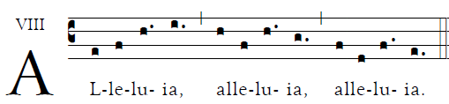

May the Father of Our Lord Jesus Christ
enlighten the eyes of our hearts,
that we may know what is the hope
that belongs to our call

Offertory Hymn
Adoro Te Devote (English text)

Responsorial psalm and Communion antiphon are from ILLUMINAREPUBLICTIONS.COM AdamBartlett

