COMMUNION ANTIPHON

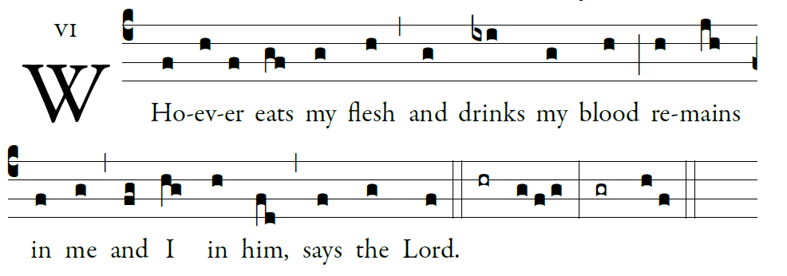
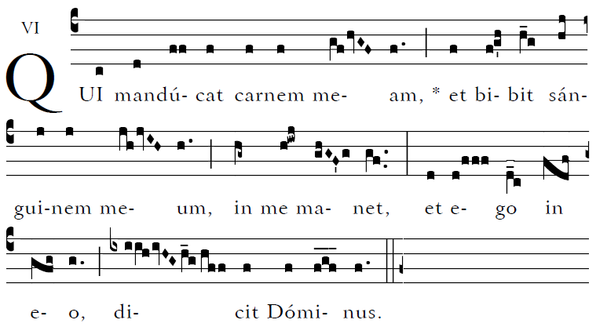

Blessed are those whose way is blameless,
who walk in the law of the LORD!
²Blessed are those who keep his decrees!
With all their hearts they seek him.

³They never do anything evil,
but walk in his ways.
⁴You have laid down your precepts
to be carefully kept.

RECESSIONAL HYMN

“All is Well with My Soul”

15th Sunday in Ordinary Time YEAR C

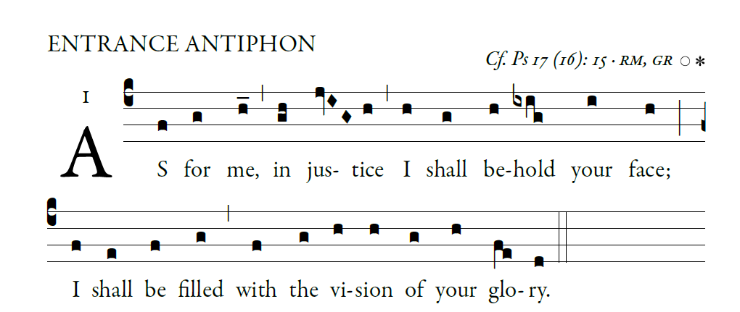

O LORD, hear a cause that is just;
pay heed to my cry.
Turn your ear to my prayer:
no deceit is on my lips.

From you may my just-ice come forth.
Your eyes discern what is upright.
Search my heart and visit me by night.
Test me by fire, and you will find no wrong
in me.

I kept my steps firmly in your paths.
My feet have never faltered.
To you I call; for you will surely heed me,
O God.
Turn your ear to me; hear my words.

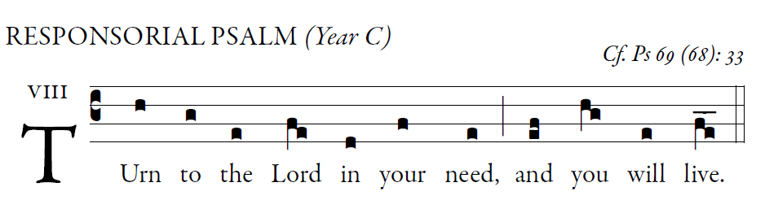

I pray to you, O LORD,
for the time of your favor, O God!
In your great kindness answer me
with your constant help.
Answer me, O LORD, for bounteous is your kindness:
in your great mercy turn toward me.

I am afflicted and in pain;
let your saving help, O God, protect me.
I will praise the name of God in song,
and I will glorify him with thanksgiving.

"See, you lowly ones, and be glad;
you who seek God, may your hearts revive!
For the LORD hears the poor,
and his own who are in bonds he spurns not."

For God will save Zion
and rebuild the cities of Judah.
The descendants of his servants shall inherit it,
and those who love his name shall inhabit it.

ALLELUIA
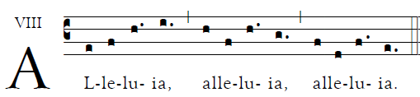

Your words, Lord, are Spirit and life;
you have the words of everlasting life.

OFFERTORY HYMN

Adoro Te Devote (English text)

Responsorial psalm and antiphons are from ILLUMINAREPUBLICTIONS.COM AdamBartlett

