COMMUNION ANTIPHON

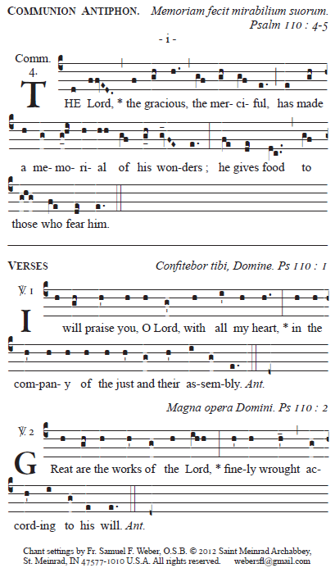

RECESSIONAL HYMN

“Sent Forth by God’s Blessing”

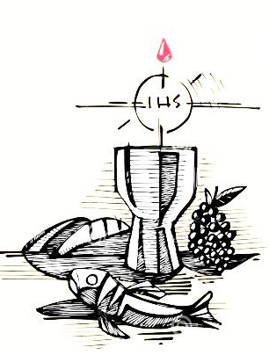
16th Sunday in Ordinary Time YEAR B

ENTRANCE ANTIPHON

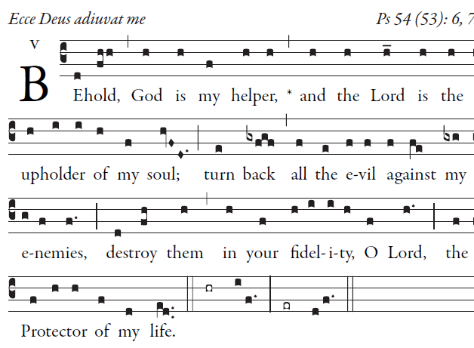

O God, save me by your name;
by your power, defend my cause.
⁴O God, hear my prayer;
give ear to the words of my mouth.

⁵For the proud have risen against me,
and the ruthless seek my life.
They have no regard for God.

Entrance antiphon, Simple English Propers©CMAA creative commons
Responsorial psalm , Offertory and Communion antiphons and antiphons are from ILLUMINAREPUBLICTIONS.COM AdamBartlett
©Creative Commo

RESPONSORIAL PSALM

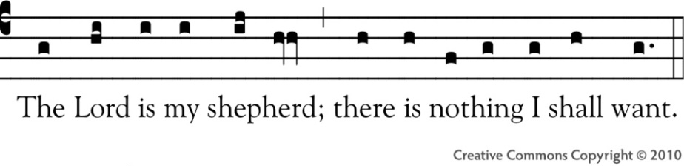

The LORD is my shepherd; I shall not want.
In verdant pastures he gives me repose;
beside restful waters he leads me;
he refreshes my soul.
He guides me in right paths
for his name's sake.
Even though I walk in the dark valley
I fear no evil; for you are at my side
with your rod and your staff
that give me courage.
You spread the table before me
in the sight of my foes;
you anoint my head with oil;
my cup overflows.
Only goodness and kindness follow me
all the days of my life;
and I shall dwell in the house of the LORD
for years to come.

ALLELUIA

My sheep hear my voice says, the Lord
I know them, and they follow me.

OFFERTORY ANTIPHON
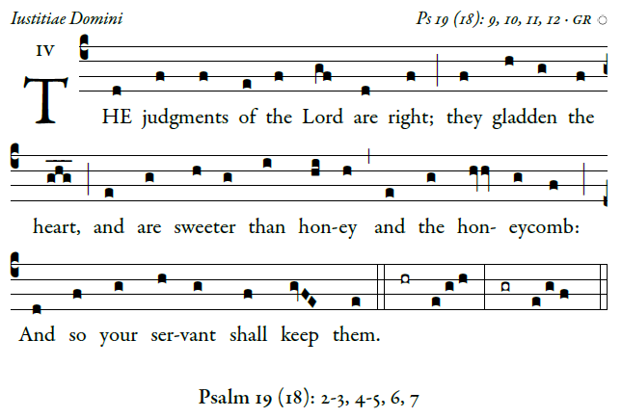
The heavens declare the glory of God,
and the firmament proclaims the work of his hands.
³Day unto day conveys the message,
and night unto night imparts the knowledge.

⁴No speech, no word, whose voice goes unheeded;
⁵their sound goes forth through all the earth,
their message to the utmost bounds of the world.

