COMMUNION ANTIPHON
Fr. Columba Kelly St .Meinrad Archabbey
Blessings from the LORD shall he receive,
and right reward from the God who saves him.
⁶Such are the people who seek him,
who seek the face of the God of Jacob.

O gates, lift high your heads;
grow higher, ancient doors.
Let him enter, the king of glory!

⁸Who is this king of glory?
The LORD, the mighty, the valiant;
the LORD, the valiant in war.

O gates, lift high your heads;
grow higher, ancient doors.
Let him enter, the king of glory!
¹⁰Who is this king of glory?
He, the LORD of hosts,
he is the king of glory.

RECESSIONAL HYMN

“Church of God Elect and Glorious” verses 3&4

16th Sunday in Ordinary Time

Kyrie : Today’s Missal page 9 Gloria page 10
Sanctus, page 88 Agnus Dei 96

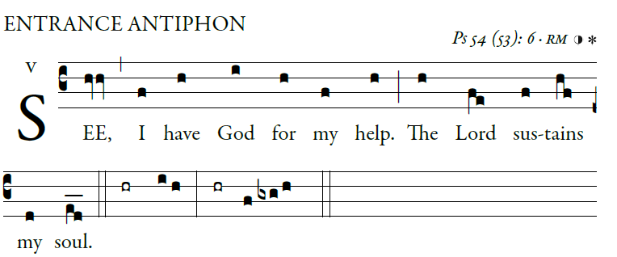 [ I will sacrifice to you with willing heart,
from illuminarepublication.com
ENTRANCE ANTIPHON
and praise your name, for it is good:]
O God, save me by your name;
by your power, defend my cause.
⁴O God, hear my prayer;
give ear to the words of my mouth.

⁵For the proud have risen against me,
and the ruthless seek my life.
They have no regard for God.
⁶See, I have God for my help.

The LORD sustains my soul.
⁷Let evil recoil on my foes.
In your faithfulness, bring them to an end.
⁹for it has rescued me from all distress,
and my eyes have gazed upon my foes.

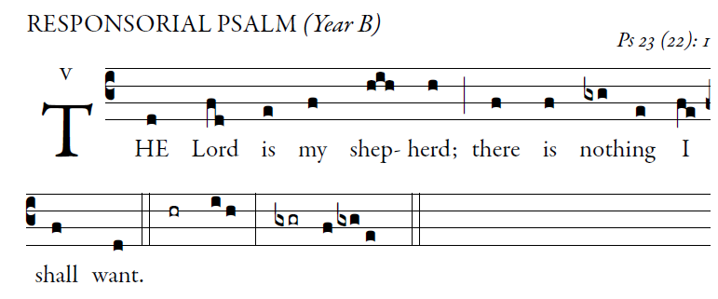
from illuminarepublication.com

The LORD is my shepherd; I shall not want.
In verdant pastures he gives me repose;
beside restful waters he leads me;
he refreshes my soul. 
He guides me in right paths
for his name’s sake.
Even though I walk in the dark valley
I fear no evil; for you are at my side
with your rod and your staff
that give me courage. 
You spread the table before me
in the sight of my foes;
you anoint my head with oil;
my cup overflows. 
Only goodness and kindness follow me
all the days of my life;
and I shall dwell in the house of the LORD
for years to come. 
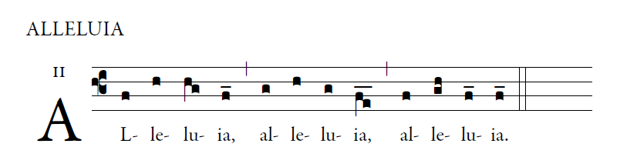

My sheep hear my voice says, the Lord;
I know them and they follow me. 
OFFERTORY ANTIPHON
from illuminarepublication.com

The heavens declare the glory of God,
and the firmament proclaims the work of his hands.
³Day unto day conveys the message,
and night unto night imparts the knowledge.

⁴No speech, no word, whose voice goes unheeded;
⁵their sound goes forth through all the earth,
their message to the utmost bounds of the world.

