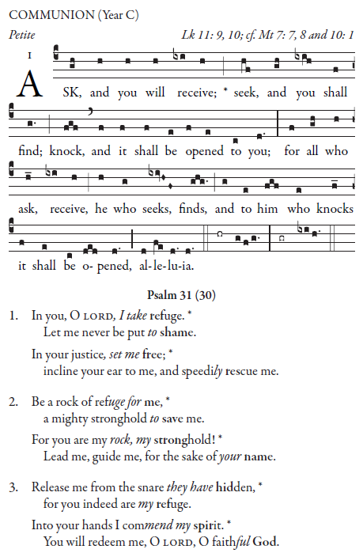

RECESSIONAL HYMN
Now Thank We All Our God

17 th Sunday in Ordinary Time

ENTRANCE ANTIPHON

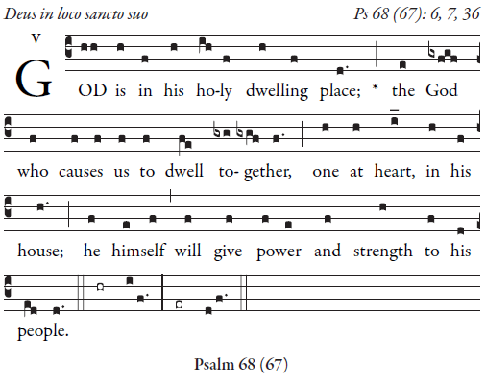

Let God arise; let his foes be scattered.
Let those who hate him flee from his presence.
³As smoke is driven away, so drive them away;
like wax that melts before the fire,  

so the wicked shall perish at the presence of God.
But the just shall rejoice at the presence of God;
they shall exult with glad rejoicing.
⁵O sing to God; make music to his name. 

Glory be to the Father … 

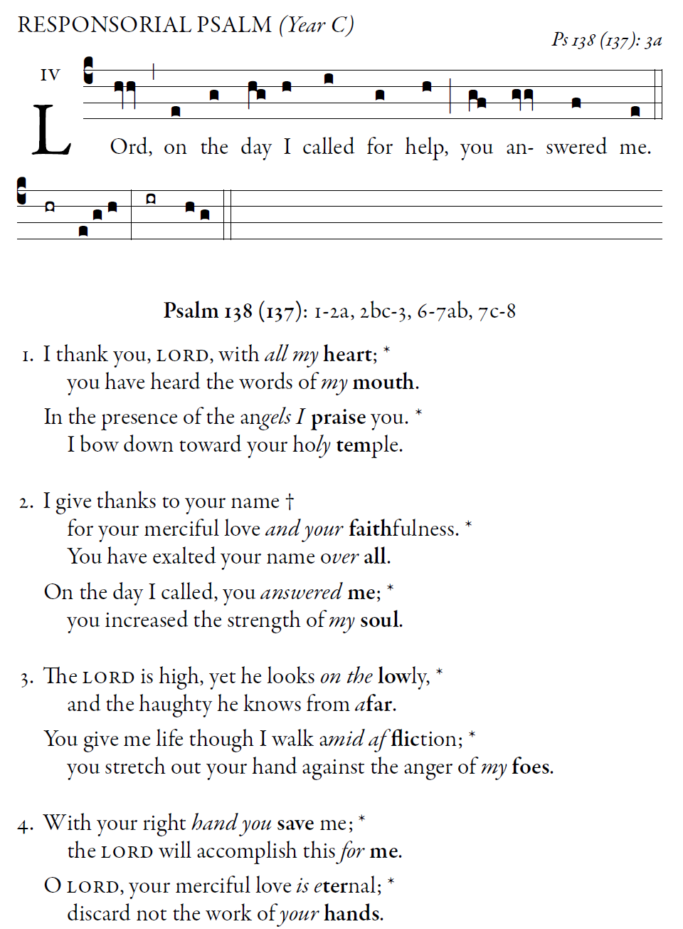illuminarepublications.com

