COMMUNION ANTIPHON

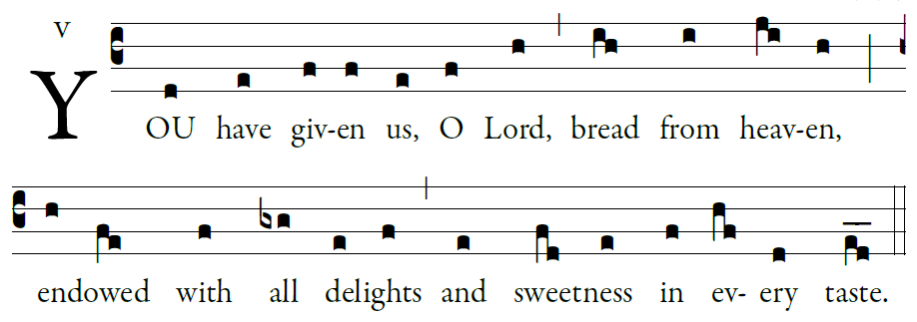
Illuminarepublications.com
^{Psalm 78}
¹Give ear, my people, to my teaching;
incline your ear to the words of my mouth.
²I will open my mouth in a parable
and utter hidden lessons of the past.

³The things we have heard and understood,
the things our fathers have told us,
⁴these we will not hide from their children
but will tell them to the next generation:
the glories of the LORD and his might,
and the marvelous deeds he has done.

Yet he commanded the clouds above,
and opened the gates of heaven.
²⁴He rained down manna to eat,
and gave them bread from heaven.

²⁵Man ate the bread of angels.
He sent them abundance of food;

RECESSIONAL HYMN

“O God Our Help in Ages Past”

18th SUNDAY in ORDINARY TIME
(year C)

Lord Have Mercy, Glory to god, Holy and Lamb of God
from the Missa Simplex booklet

ENTRANCE ANTIPHON
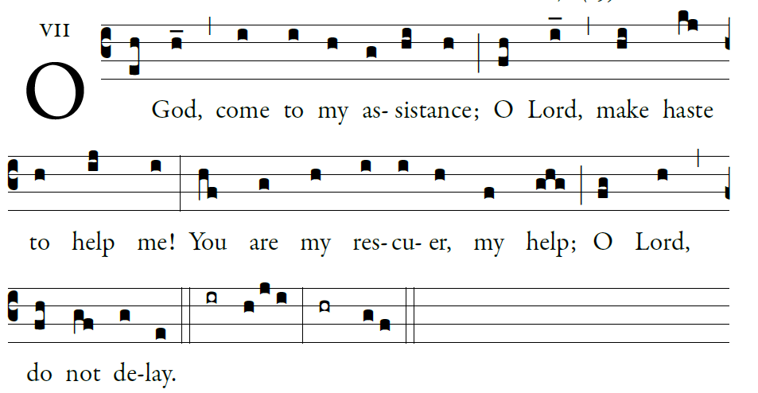

Illuminarepublications.com

O let them turn back in confusion,
who delight in my harm;
let them retreat, covered with shame,
who jeer at me and mock.

O let there be rejoicing and gladness
for all who seek you.
Let them say forever, “God is great,”
who love your saving help.

As for me, wretched and poor,
hasten to me, O God.
You are my rescuer, my help;
O LORD, do not delay

RESPONSORIAL PSALM
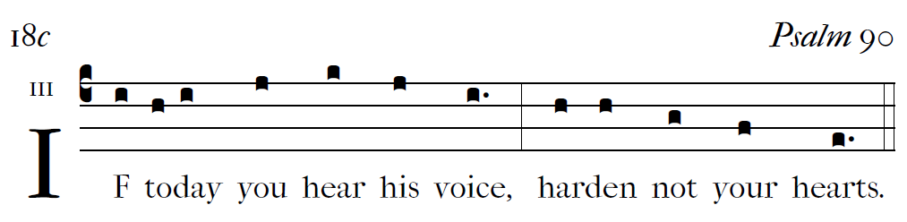
R Bednarz 2013, Psalm 95
Psalm 90
You turn man back to dust,
saying, “Return, O children of men.”
For a thousand years in your sight
are as yesterday, now that it is past,
or as a watch of the night.

You make an end of them in their sleep;
the next morning they are like the changing grass,
Which at dawn springs up anew,
but by evening wilts and fades.

Teach us to number our days aright,
that we may gain wisdom of heart.
Return, O LORD! How long?
Have pity on your servants!

Fill us at daybreak with your kindness,
that we may shout for joy and gladness all our days.
And may the gracious care of the LORD our God be ours;
prosper the work of our hands for us!
Prosper the work of our hands!

GOSPEL ALLELUIA
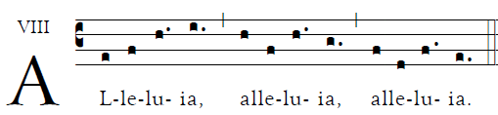
 Blessed are the poor in spirit, for theirs is the kingdom of God

OFFERTROY ANTIPHON :

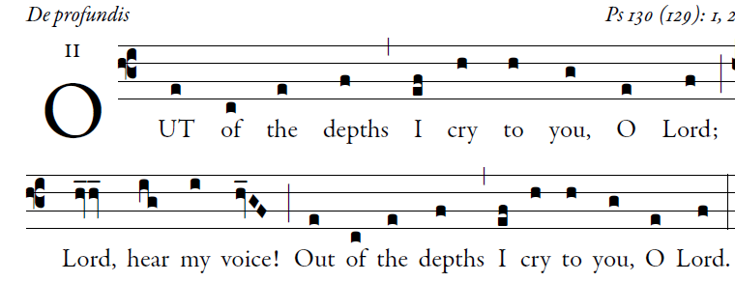
Illuminarepublications.com

O let your ears be attentive
to the sound of my pleadings.
If you, O LORD, should mark iniquities,
LORD, who could stand?

But with you is found forgiveness,
that you may be revered.
I long for you, O LORD,
my soul longs for his word.

My soul hopes in the LORD
more than watchmen for daybreak.
More than watchmen for daybreak,
let Israel hope for the LORD.

For with the LORD there is mercy,
in him is plentiful redemption.
It is he who will redeem Israel

