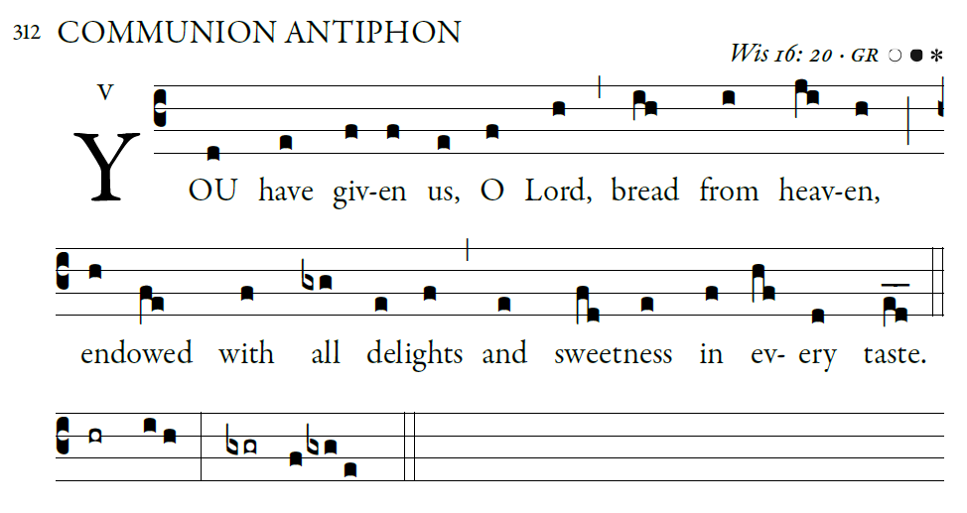
Illuminarepublications.com

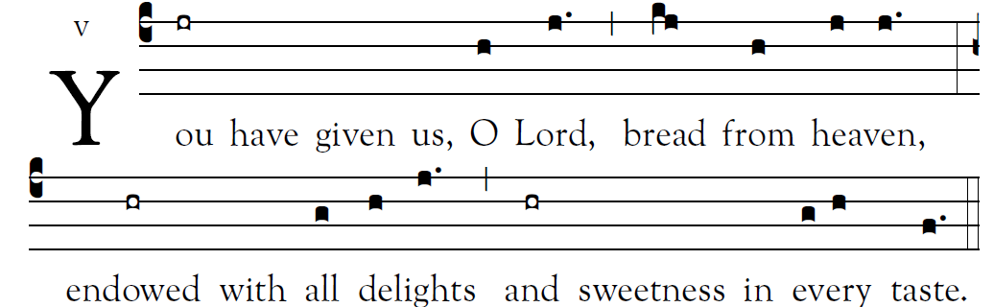

St. Meinrad Psalm Tone ©Saint Mainrad Archabbey

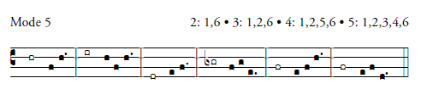

Psalm 78

¹Give ear, my people, to my teaching;
incline your ear to the words of my mouth.
²I will open my mouth in a parable
and utter hidden lessons of the past.

³The things we have heard and understood,
the things our fathers have told us,
⁴these we will not hide from their children
but will tell them to the next generation:
the glories of the LORD and his might,
and the marvelous deeds he has done.

Yet he commanded the clouds above,
and opened the gates of heaven.
²⁴He rained down manna to eat,
and gave them bread from heaven.

²⁵Man ate the bread of angels.
He sent them abundance of food;

He rained flesh upon them like dust,
winged fowl like the sands of the sea.
²⁸He let it fall in the midst of their camp,
and all around their tents.
²⁹So they ate and had their fill,
what they craved, he gave them.

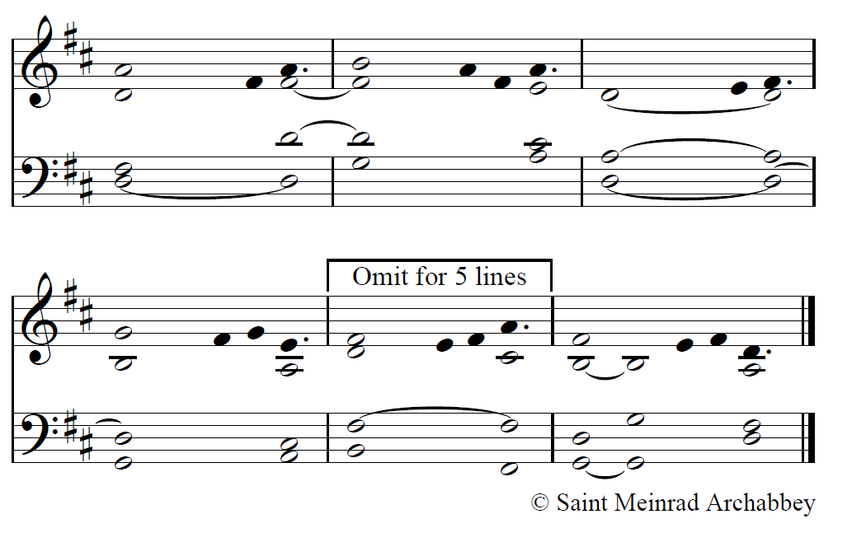
Scripture texts in this work are taken from the New American Bible, revised edition © 2010, 1991, 1986, 1970 Confraternity of Christian Doctrine, Washington, D.C. and are used by permission of the copyright owner. All Rights Reserved. No part of the New American Bible may be reproduced in any form without permission in writing from the copyright owner

user-notes:18 Communion ;
commentary:Wis 16: 20 ;
annotation: v ;
centering-scheme: english;
%fontsize: 12;
%spacing: vichi;
%font: OFLSortsMillGoudy;
%width: 4.5;
%height: 11;
%%
(c4)You(jr) have() given() us,() O(h) Lord,(j.) (,) bread(kj) from(h) {hea}ven,(j/ j.) (:)
endowed(hr) with() all(g) {de}lights(h/ j.) (,) and(hr) sweetness() in() {ev}ery(g/ h ) taste.(f.) (::)

