19th Sunday in Ordinary Time (YEAR A)

Lord have Mercy, Glory to God , Holy, Acclamation,
Amen and Alleluia from the MISSA SIMPLEX booklet.

ENTRANCE ANTIPHON illuminarepublications .com and R Bednarz
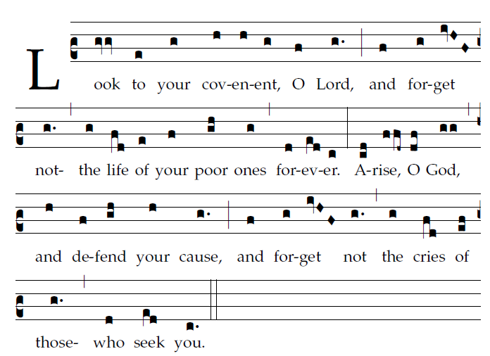

Why, O God, have you cast us off forever?
Why does your anger blaze at the sheep of your pasture?
Remember your flock which you claimed long ago,
the tribe you redeemed to be your own possession,
Turn your steps to these places that are utterly ruined!
The enemy has laid waste the whole of the holy place.
Your foes have made uproar in the midst of your assembly;
they have set up their emblems as tokens there.

RESPONSORIAL PSALM: found in Today’s Missal

OFFERTORY HYMN

SOUL OF MY SAVIOR
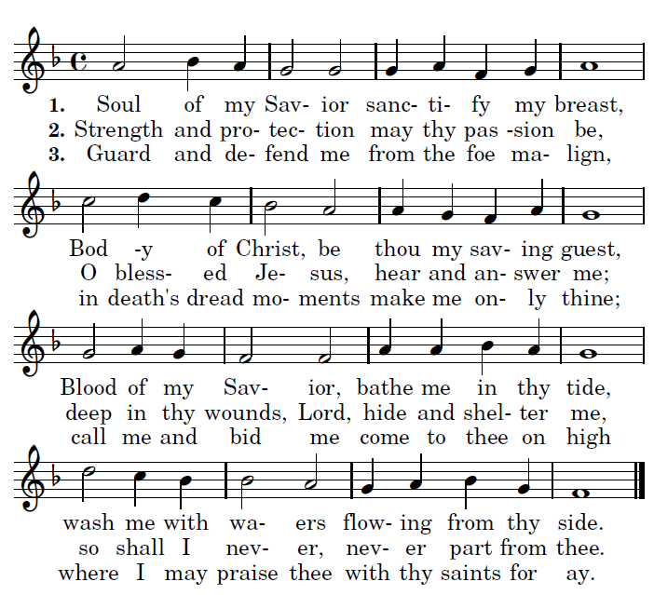

COMMUNION ANTIPHON

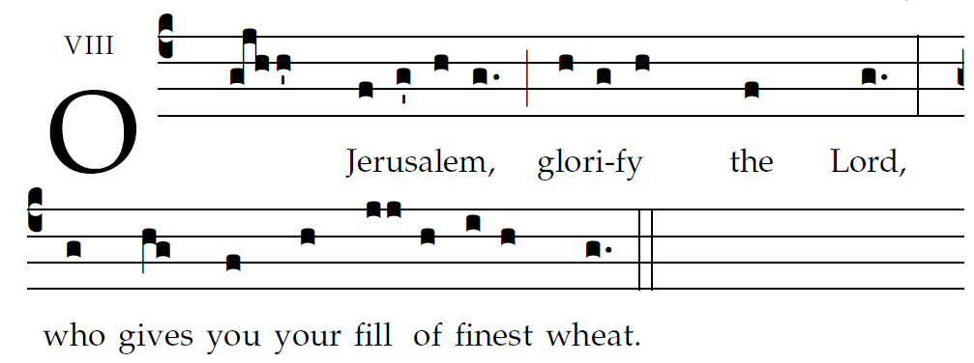
R.Bednarz 2013, 2014, 2015

O Jerusalem, glorify the LORD!
O Sion, praise your God!
He has strengthened the bars of your gates;
he has blessed your children within you.

He established peace on your borders;
he gives you your fill of finest wheat.
He sends out his word to the earth,
and swiftly runs his command.

He showers down snow like wool;
he scatters hoarfrost like ashes.
He hurls down hailstones like crumbs;
before such cold, who can stand?

¹He sends forth his word and it melts them;
at the blowing of his breath the waters flow.

RECESSIONAL HYMN “ All is Well with My Soul“
in the Music Issue Hymnal

