COMMUNION ANTIPHON

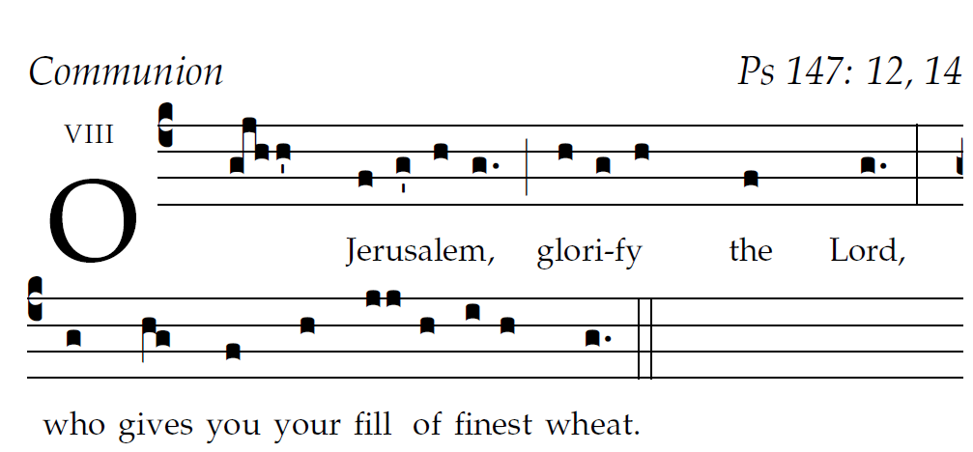
R.Bednarz 2013, 2014, 2015

O Jerusalem, glorify the LORD!
O Sion, praise your God!
He has strengthened the bars of your gates;
he has blessed your children within you.

He established peace on your borders;
he gives you your fill of finest wheat.
He sends out his word to the earth,
and swiftly runs his command.

He showers down snow like wool;
he scatters hoarfrost like ashes.
He hurls down hailstones like crumbs;
before such cold, who can stand?

¹He sends forth his word and it melts them;
at the blowing of his breath the waters flow.

RECESSIONAL HYMN “ Be Not Afraid “

19th Sunday in Ordinary Time (YEAR C)

Lord have Mercy, Glory to God , Holy, Acclamation,
Amen and Alleluia from the MISSA SIMPLEX booklet.

ENTRANCE ANTIPHON illuminarepublications .com and R Bednarz
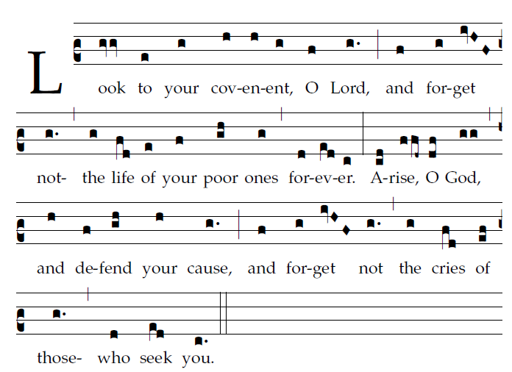

Why, O God, have you cast us off forever?
Why does your anger blaze at the sheep of your pasture?
Remember your flock which you claimed long ago,
the tribe you redeemed to be your own possession,
Turn your steps to these places that are utterly ruined!
The enemy has laid waste the whole of the holy place.
Your foes have made uproar in
the midst of your assembly;
they have set up their emblems as tokens there.
Arise, O God, and defend your cause!
Remember how the senseless revile you all the day.
²³Do not forget the clamor of your foes,
the unceasing uproar of those who defy you.

RESPONSORIAL PSALM

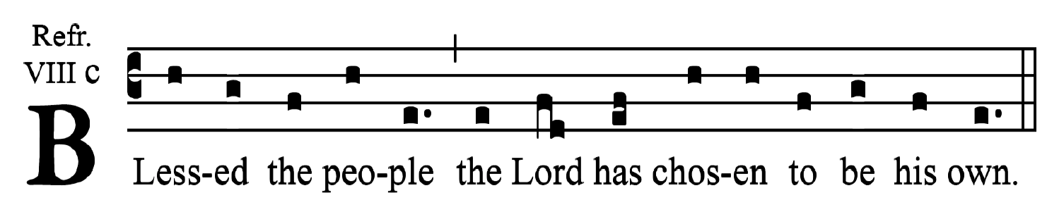
Fr. Samuel Webber
Exult, you just, in the LORD;
praise from the upright is fitting.
Blessed the nation whose God is the LORD,
the people he has chosen for his own inheritance.
See, the eyes of the LORD are upon those who fear him,
upon those who hope for his kindness,
To deliver them from death
and preserve them in spite of famine.
Our soul waits for the LORD,
who is our help and our shield.
May your kindness, O LORD, be upon us
who have put our hope in you.

ALLELUIA
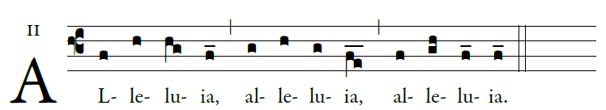

Stay awake and be ready! For you do not know
on what day your Lord will come. 

OFFERTORY HYMN

SOUL OF MY SAVIOR
