RECESSIONAL HYMN

“I Am the Bread of Life”

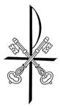

“We have come to believe and to know that you are the Holy One of God."

21st Sunday of Ordinary Time YEAR B

ENTRANCE ANTIPHON
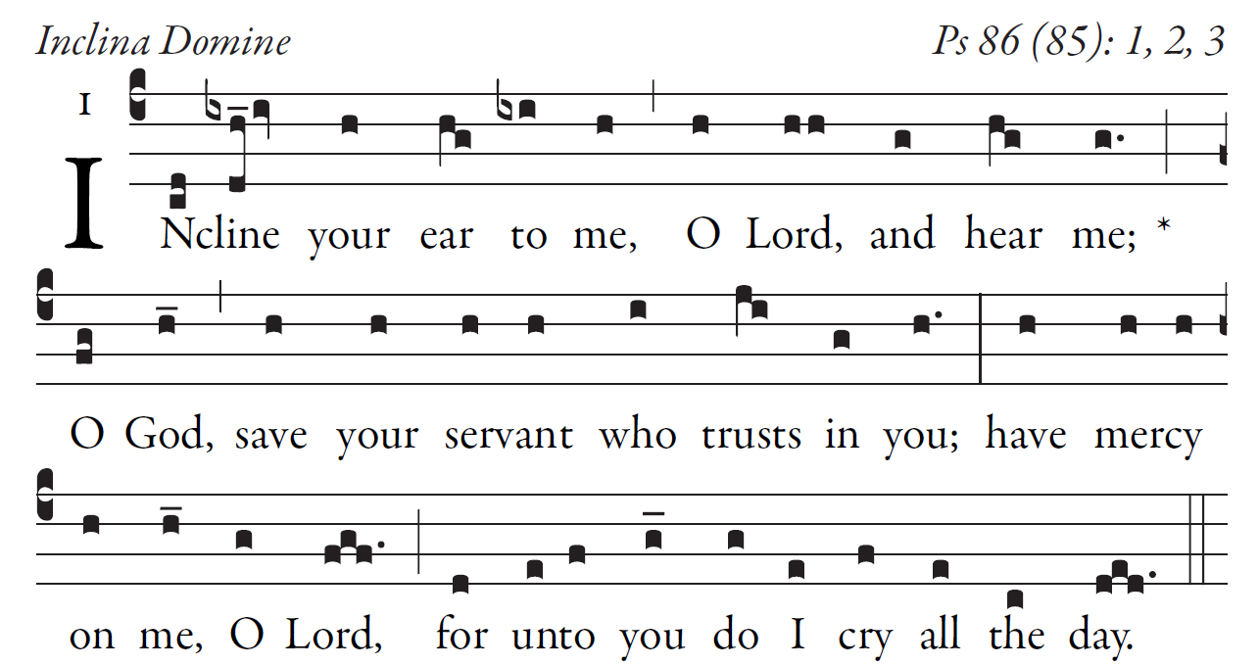

Gladden the soul of your servant,
for I lift up my soul to you, O LORD.
O LORD, you are good and forgiving,
full of mercy to all who call to you.

Give ear, O LORD, to my prayer,
and attend to my voice in supplication.
In the day of distress, I will call to you,
and surely you will answer me.

LITURGY OF THE WORD
Psalm and readings in Today’s Missal

OFFERTORY: “ Gift of Finest Wheat ”

COMMUNION ANTIPHON 1
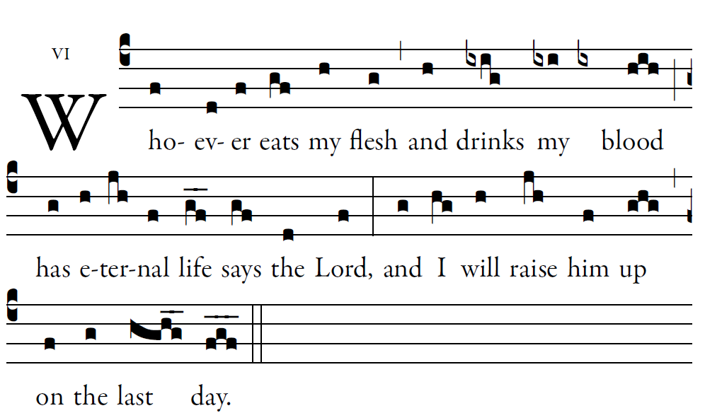
© St. Meinrad Archabbey, Fr Columba Kelly
Psalm 119:1-8

Blessed are those whose way is blameless,
who walk in the law of the LORD!
²Blessed are those who keep his decrees!
With all their hearts they seek him

I treasure your word in my heart,
lest I sin against you.
Blest are you, O LORD;
teach me your statutes

COMMUNION ANTIPHON 2
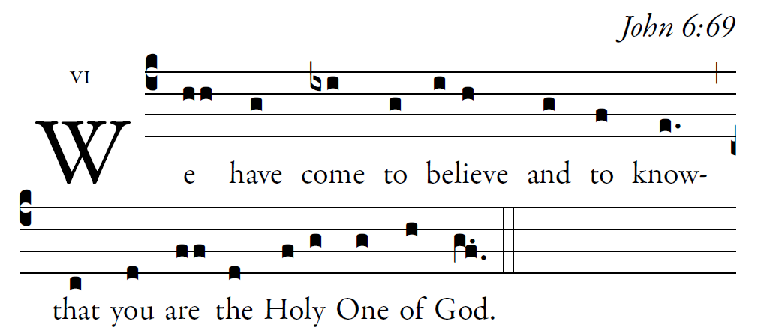
R. Bednarz 2015

Remember your word to your servant,
by which you made me hope.
This is my comfort in sorrow:
that your promise gives me life.

The law from your mouth means more to me
than large quantities of silver and gold.
How sweet is your promise to my tongue,
more than honey in the mouth.
Your word is a lamp for my feet,
and a light for my path.

Glory be to the Father…

