MEMEMORIAL ACCLAMATION
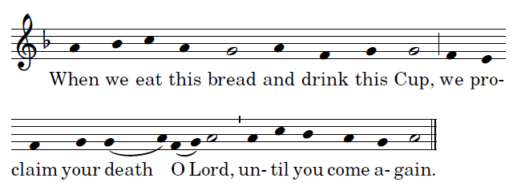

LAMB OF GOD
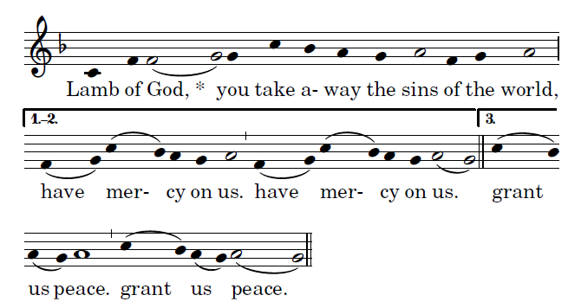
Ordinary of the Mass by Richard Clark, Used with permisision

COMMUNION ANTIPHON
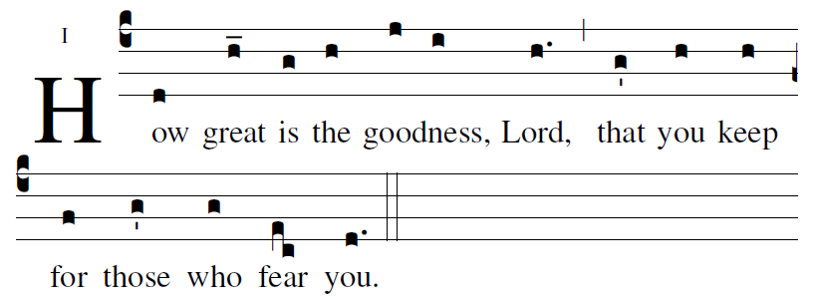
Ralph Bednarz 2014

RECESSIONAL HYMN: “ Christ, Be Our Light”

22nd SUNDAY in ORDINARY TIME

ENTRANCE ANTIPHON
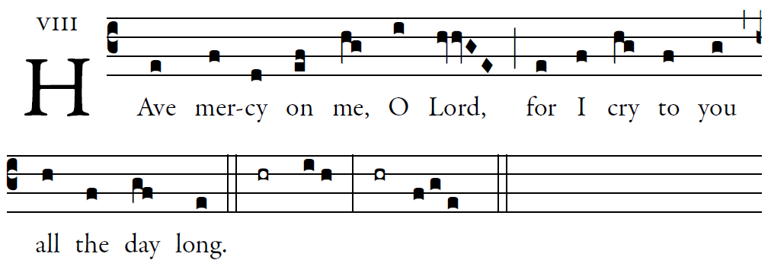
© 2012-2014 Adam Bartlett, licensed under a Creative Commons Attribution

How lovely is your dwelling place,
O Lord of hosts.
my soul is longing and yearning
for the courts of the Lord.

LORD HAVE MERCY
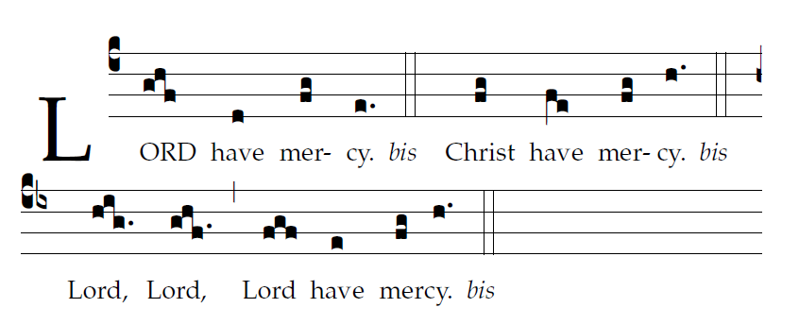

GLORIA

RESPONSORIAL PSALM
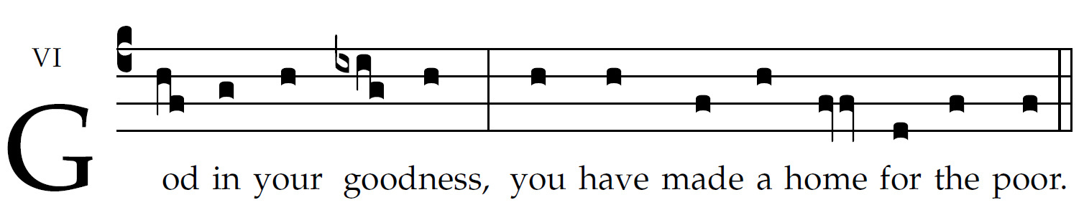
© 2012-2014 Adam Bartlett, licensed under a Creative Commons Attribution
he just rejoice and exult before God;
they are glad and rejoice.
Sing to God, chant praise to his name;
whose name is the LORD.
The father of orphans and the defender of widows
is God in his holy dwelling.
God gives a home to the forsaken;
he leads forth prisoners to prosperity.
A bountiful rain you showered down, O God, upon your inheritance;
you restored the land when it languished;
your flock settled in it;
in your goodness, O God, you provided it for the needy.
ALLELUIA
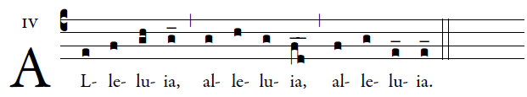

OFFERTORY “ Humbly, Lord, We Worship You”

SANCTUS
