COMMUNION ANTIPHON

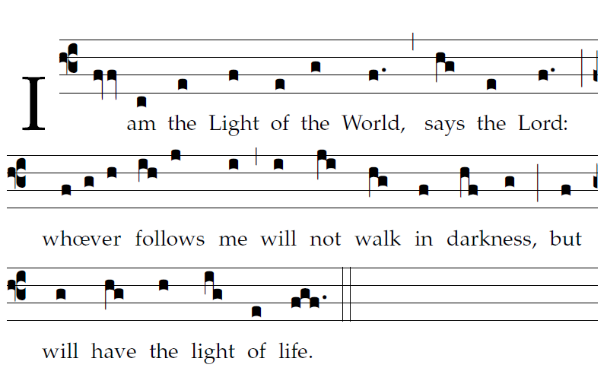 Fr Columba Kelly ©Saint Meinrad Archabbey
Your mercy, LORD, reaches to heaven,
your truth to the clouds.
⁷Your justice is like God’s mountains;
like the great deep, your justice.

Both man and beast you save, O LORD.
⁸How precious is your mercy, O God!
The children of men seek shelter
in the shadow of your wings.

⁹They feast on the riches of your house;
you give them drink from the stream of your delight.
¹⁰For with you is the fountain of life,
and in your light we see light.

RECESSIONAL HYMN

“Abide with Me” verses 2 and4

23rd Sunday of Ordinary Time
YEAR B

ENTRANCE ANTIPHON
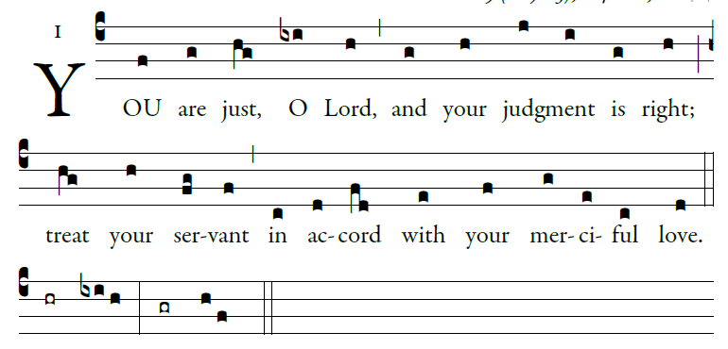

illulminarepublication.com
I call with all my heart;
LORD, answer me.
I will observe your statutes.
I call upon you; save me,
and I will keep your decrees.

I rise before dawn and cry for help;
I have hoped in your word.
My eyes awaken before dawn,
to ponder your promise.

In your mercy, hear my voice, O LORD;
give me life by your decrees.
Those who pursue me with malice draw near;
they are far from your law.

RESPONSORIAL PSALM

illulminarepublication.com

The God of Jacob keeps faith forever,
secures justice for the oppressed,
gives food to the hungry.
The LORD sets captives free.
The LORD gives sight to the blind;
the LORD raises up those who were bowed down.
The LORD loves the just;
the LORD protects strangers.
The fatherless and the widow the LORD sustains,
but the way of the wicked he thwarts.
The LORD shall reign forever;
your God, O Zion, through all generations. Alleluia.

ALLELUIA
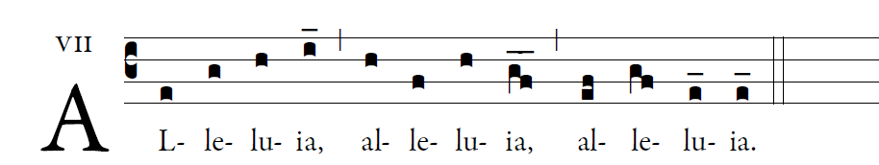
illulminarepublication.com
Jesus proclaimed the Gospel of the kingdom
and cured every disease among the people.

OFFERTORY

“When Morning Gilds the Skies ”
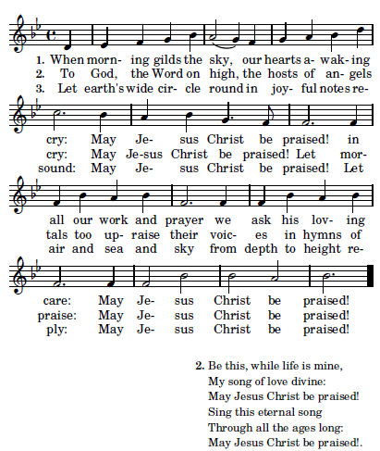

Be this, while life is mine,
My song of love divine:
May Jesus Christ be praised!
Sing this eternal song
Through all the ages long:
May Jesus Christ be praised!

