COMMUNION HYMN

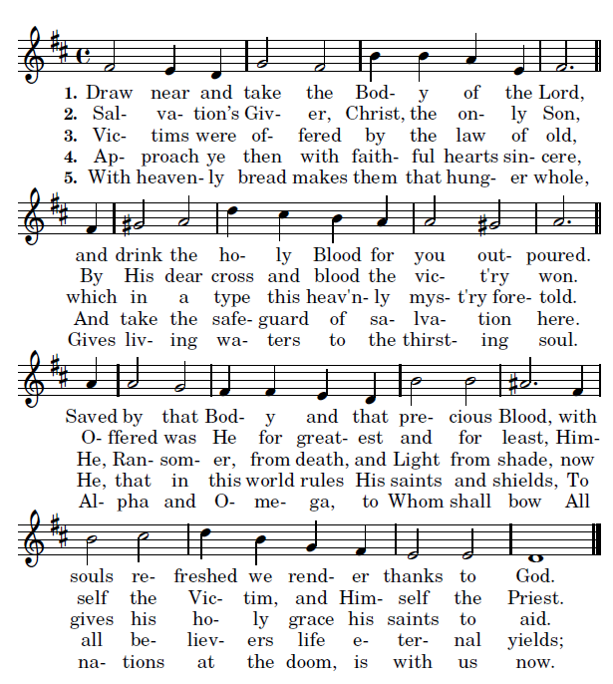

RECESSIONAL HYMN

“All Praise and Glad Thanksgiving”

25th SUNDAY IN ORDINARY TIME

ENTRANCE ANTIPHON

Psalm 78

Give ear, my people, to my teaching;
incline your ear to the words of my mouth.
I will open my mouth in a parable
and utter hidden lessons of the past.
The things we have heard and understood,
the things our fathers have told us,

these we will not hide from their children
but will tell them to the next generation:
the glories of the LORD and his might,
and the marvelous deeds he has done.

Glory be to the Father…

Entrance and offertory antiphon s © 2012-2014 Adam Bartlett, licensed under a Creative Commons www. Illuminarepublications.com

LITURGY OF THE WORD

ALLELUIA

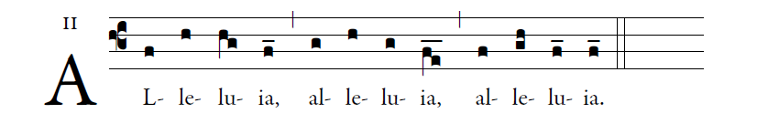

    Though our Lord Jesus Christ was rich, he became poor,
so that by his poverty you might become rich.

OFFERTORY ANTIPHON

I thank you, LORD, with all my heart;
you have heard the words of my mouth.
In the presence of the angels I praise you.
I bow down toward your holy temple.

I give thanks to your name
for your merciful love and your faithfulness.
You have exalted your name over all.
On the day I called, you answered me;
you increased the strength of my soul.

All earth’s kings shall thank you, O LORD,
when they hear the words of your mouth.
They shall sing of the ways of the LORD,
“How great is the glory of the LORD!”

The LORD is high, yet he looks on the lowly,
and the haughty he knows from afar.

+

