COMMUNION ANTIPHON

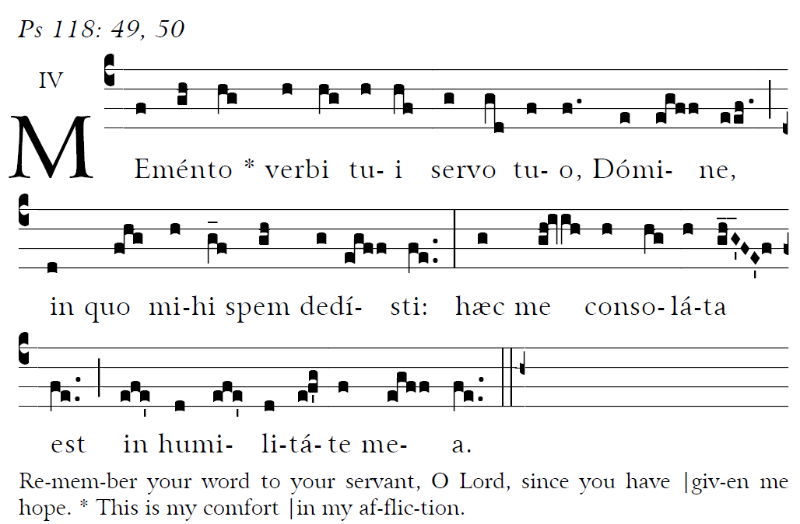

Blessed are those whose way is blameless,
who walk in the law of the LORD!
²Blessed are those who keep his decrees!
With all their hearts they seek him.

My soul holds fast to the dust;
revive me by your word.
²My soul pines away with grief;
by your word raise me up.

COMMUNION HYMN “ Jesus Remember Me”

RECESSIONAL HYMN
“ Blest Are They”

26th Sunday in Ordinary Time YEAR C

A
ll that you have done to us, O Lord, you have done with true judgement, for we have sinned against you and not obeyed your commandments. But give glory to your name and deal with us according to your mercy.

ENTRANCE HYMN
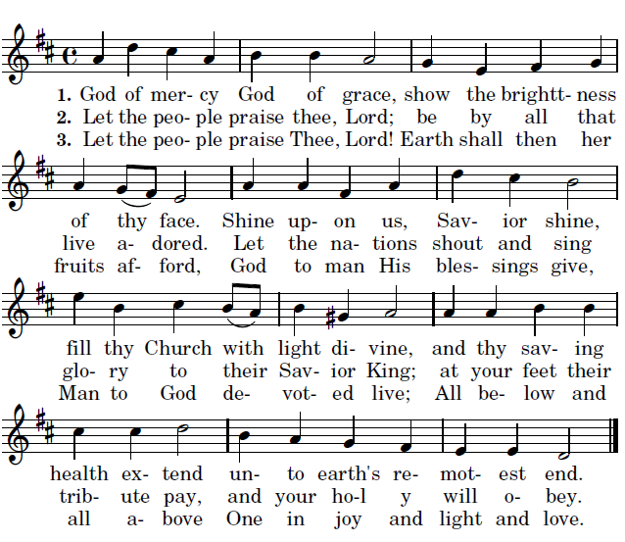

LITURGY OF THE WORD
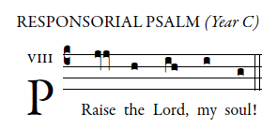

Blessed he who keeps faith forever,
secures justice for the oppressed,
gives food to the hungry.
The LORD sets captives free.
The LORD gives sight to the blind.
The LORD raises up those who were bowed down;
the LORD loves the just.
The LORD protects strangers.
The fatherless and the widow he sustains,
but the way of the wicked he thwarts.
The LORD shall reign forever;
your God, O Zion, through all generations. Alleluia.

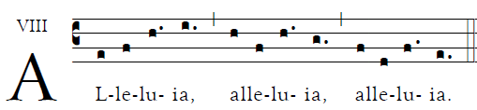

                    Though our Lord Jesus Christ was rich, he became poor, so that by his poverty you might become rich..
Responsorial Psalm from Illuminare publications.com. Offertory antiphon © 2012-2014 Adam Bartlett, licensed under a Creative Commons Licens www. Illuminarepublications.com Communion antiphon 1.Fr. C Kelly St Meinrad Archabbey. Memento verbi from the Gradual Romanum

OFFERTORY ANTIPHON

On the poplars that grew there
we hung up our harps.
³For it was there that they asked us,
our captors, for songs,
our oppressors, for joy.
“Sing to us,” they said,
“one of Sion’s songs.”

⁴O how could we sing
the song of the LORD
on foreign soil?
⁵If I forget you, Jerusalem,
let my right hand wither!

⁶O let my tongue
cleave to my palate
if I remember you not,
if I prize not Jerusalem
as the first of my joys!

