28th SUNDAY IN ORDINARY TIME

Liturgy of the Word and Music for the ordinary of Mass are found within the order of the Mass in “TODAYS MISSAL”

Adam Bartlett © illluminarepublications.com
Out of the depths I cry to you, O LORD;
²LORD, hear my voice!
O let your ears be attentive
to the sound of my pleadings.

⁵I long for you, O LORD,
my soul longs for his word.
⁶My soul hopes in the LORD
more than watchmen for daybreak.

OFFERTORY HYMN “ Ave Maria” Music Issue

COMMUNION ANTIPHON

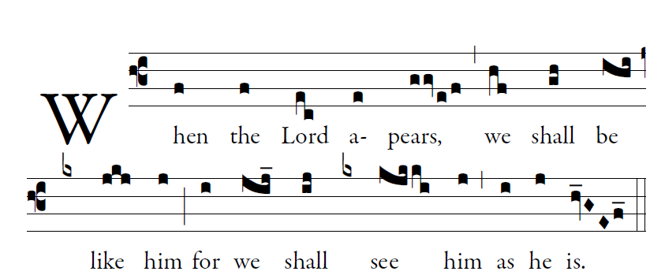
Fr. C Kelly @St. Mainrad Archabbey
PSALM 63

O God, you are my God; at dawn I seek you;
for you my soul is thirsting.
For you my flesh is pining,
like a dry, weary land without water.
³I have come before you in the sanctuary,
to behold your strength and your glory.

⁴Your loving mercy is better than life;
my lips will speak your praise.
⁵I will bless you all my life;
in your name I will lift up my hands.
⁶My soul shall be filled as with a banquet;
with joyful lips, my mouth shall praise you.

COMMUNION HYMN : “ Taste and See”

RECESSIONAL HYMN “Salve Regina”

