COMMUNION ANTIPHON

Fr. C Kelly @St. Mainrad Archabbey
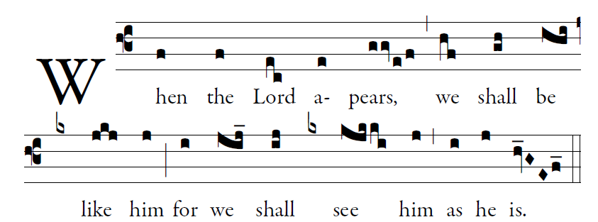
PSALM 63

O God, you are my God; at dawn I seek you;
for you my soul is thirsting.
For you my flesh is pining,
like a dry, weary land without water.
³I have come before you in the sanctuary,
to behold your strength and your glory.

⁴Your loving mercy is better than life;
my lips will speak your praise.
⁵I will bless you all my life;
in your name I will lift up my hands.
⁶My soul shall be filled as with a banquet;
with joyful lips, my mouth shall praise

RECESSIONAL HYMN
“ Salve Regina”

28th SUNDAY IN ORDINARY TIME (YEAR A)

© illluminarepublications.com

Psalm 130
Out of the depths I cry to you, O LORD;
LORD, hear my voice!
O let your ears be attentive
to the sound of my pleadings.

I long for you, O LORD,
my soul longs for his word.
My soul hopes in the LORD
more than watchmen for daybreak.

Glory be to the Father…

ALLELUIA
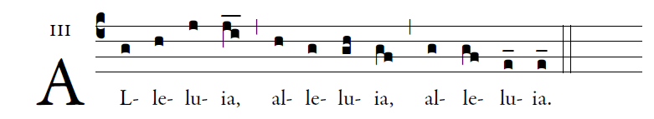

May the Father of our Lord Jesus Christ
Enlighten the eyes of our hearts,
So that we may know what is the hope
That belongs to our call.

Show unto us the blessed fruit of thy womb, Jesus

OFERTORY HYMN

Fatima’s Ave Maria
