OFFERTORY HYMN “ Ave Maria” Music Issue

Sub Tuum (schola)
We fly to thy patronage, O holy Mother of God; despise not our petitions in our necessities, but deliver us always from all dangers, O glorious and blessed Virgin. Amen.

COMMUNION ANTIPHON

Fr. C Kelly @St. Mainrad Archabbey
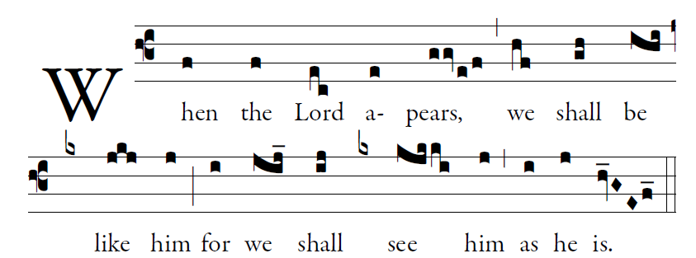
PSALM 63
O God, you are my God; at dawn I seek you;
for you my soul is thirsting.
For you my flesh is pining,
like a dry, weary land without water.
³I have come before you in the sanctuary,
to behold your strength and your glory.

RECESSIONAL HYMN

Lead Kindly Light

Lead kindly Light amid the gloom of evening.
Lord lead me on. Lord, lead me on.
On through the night! On to your radiance.
Lead, kindly Light. Lead, kindly Light.
The night is dark, and I am far from home.
Direct my feet; I do not ask to see,
The distant scene; one step enough for me
So lead me onward Lord and hear my plea.
St. John Henry Newman

28th SUNDAY IN ORDINARY TIME (YEAR C)

Adam Bartlett © illluminarepublications.com

Psalm 130
Out of the depths I cry to you, O LORD;
²LORD, hear my voice!
O let your ears be attentive
to the sound of my pleadings.

⁵I long for you, O LORD,
my soul longs for his word.
⁶My soul hopes in the LORD
more than watchmen for daybreak.

Glory be to the Father…

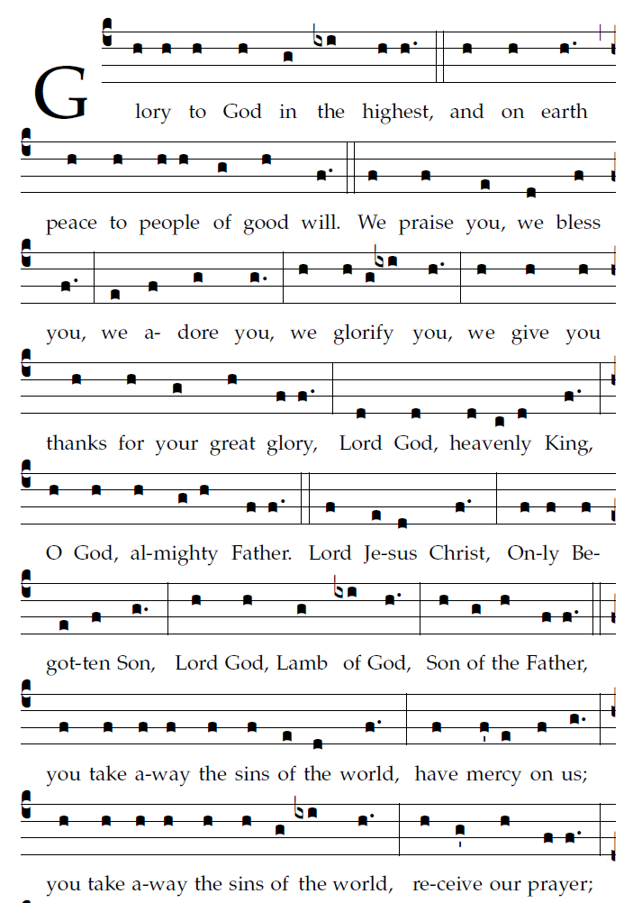

R. Bednarz 2016

RESPONSORIAL PSALM
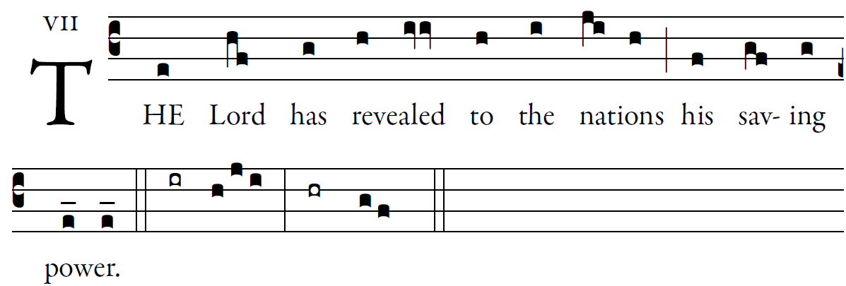
©Illuminare publications

Sing to the LORD a new song,
for he has done wondrous deeds;
His right hand has won victor-y for him,
his holy arm.

The LORD has made his salvation known:
in the sight of the nations he has revealed his justice.
He has remembered his kindness and his faithfulness
toward the house of Israel.

All the ends of the earth have seen
the salvation by our God.
Sing joyfully to the LORD, all you lands;
break into song; sing praise.

