RECESSIONAL HYMN

Immaculate Mary!
Our hearts are on fire,
that title so wondrous
fills all our desire.
Ave, ave, ave Maria!
Ave, ave, ave Maria!
We pray for God’s glory,
the Lord’s kingdom come!
We pray for his vicar,
our father, and Rome.
Ave, ave, ave Maria!
Ave, ave, ave Maria!
We pray for our mother
the church upon earth,
and bless, sweetest lady,
the land of our birth.
Ave, ave, ave Maria!
Ave, ave, ave Maria!
For poor, sick, afflicted
thy mercy we crave;
and comfort the dying
thou light of the grave.
Ave, ave, ave Maria!
Ave, ave, ave Maria!

29th SUNDAY IN ORDINARY TIME

ENTRANCE HYMN “Hail Redeemer King Divine”

RESPONSORIAL PSALM
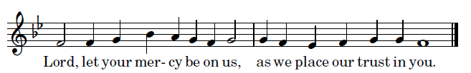
Chabanel Psalms Royce Nickel

Upright is the word of the LORD,
and all his works are trustworthy.
He loves justice and right;
of the kindness of the LORD the earth is full.
See, the eyes of the LORD are upon those who fear him,
upon those who hope for his kindness,
To deliver them from death
and preserve them in spite of famine.
Our soul waits for the LORD,
who is our help and our shield.
May your kindness, O LORD, be upon us
who have put our hope in you.
ALLELUIA
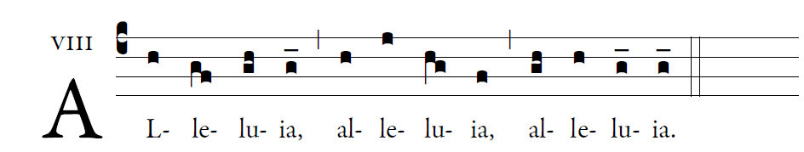
The Son of Man came to serve
and to give life as a ransom for many

OFFERTORY

͡©illminarepublications.com

Blessed are those whose way is blameless,
who walk in the law of the LORD!
Blessed are those who keep his decrees!
With all their hearts they seek him.

They never do anything evil,
but walk in his ways.
You have laid down your precepts
to be carefully kept.

COMMUNION ANTIPHON

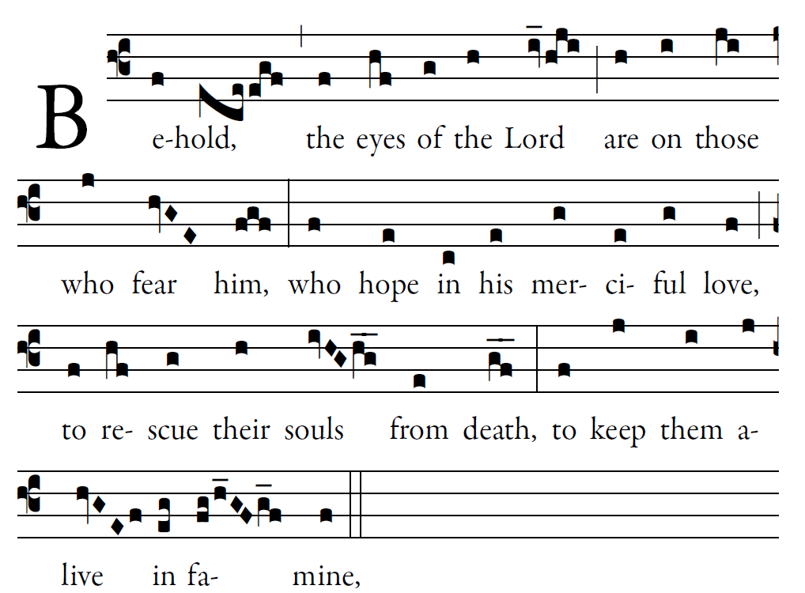
Fr. Columba Kelly ©St. Mainrad Archabbey

Blessed is he whose transgression is forgiven,
whose sin is remitted.
Blessed the man to whom the LORD imputes no guilt,
in whose spirit is no guile.

So let each faithful one pray to you
in the time of need.
The floods of water may reach high,
but such a one they shall not reach.

You are a hiding place for me;
you keep me safe from distress;
you surround me with cries of deliverance.
I will instruct you and teach you the way you should go;
I will fix my eyes up-on you.

COMMUNION HYMN
“Let All Mortal Flesh Keep Silence

