RECESSIONAL HYMN:

Immaculate Mary!
Our hearts are on fire,
that title so wondrous
fills all our desire.
Ave, ave, ave Maria!
Ave, ave, ave Maria!
We pray for God’s glory,
the Lord’s kingdom come!
We pray for his vicar,
our father, and Rome.
Ave, ave, ave Maria!
Ave, ave, ave Maria!
We pray for our mother
the church upon earth,
and bless, sweetest lady,
the land of our birth.
Ave, ave, ave Maria!
Ave, ave, ave Maria!
For poor, sick, afflicted
thy mercy we crave;
and comfort the dying
thou light of the grave.
Ave, ave, ave Maria!
Ave, ave, ave Maria!

30th SUNDAY IN ORDINARY TIME
YEAR C

ENTRANCE ANTIPHON
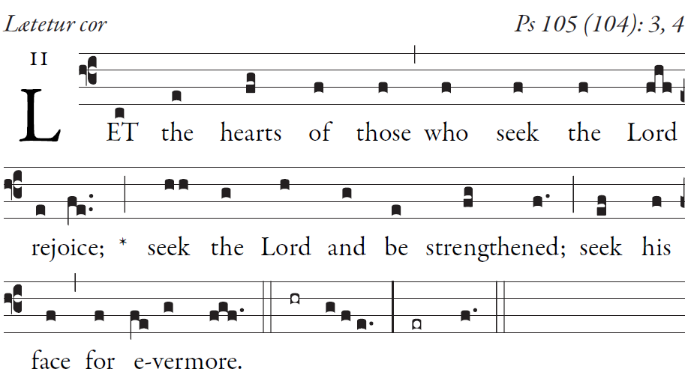
SIMPLE ENGLISH PROPER, ANDAM BARTLET ©CMAA

Give thanks to the LORD; proclaim his name.
Make known his deeds among the peoples.

O sing to him, sing his praise;
tell all his wonderful works!
Glory in his holy name;
let the hearts that seek the LORD rejoice.

Turn to the LORD and his strength;
constantly seek his face.
Remember the wonders he has done,
his marvels and his words of judgment

RESPONSORIAL PSALM

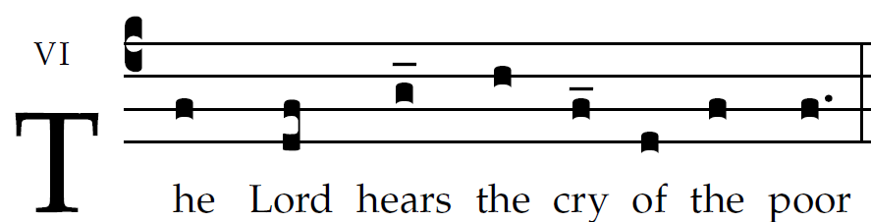

I will bless the LORD at all times;
his praise shall be ever in my mouth.
Let my soul glory in the LORD;
the lowly will hear me and be glad.
The LORD confronts the evildoers,
to destroy remembrance of them from the earth.
When the just cry out, the Lord hears them,
and from all their distress he rescues them.
The LORD is close to the brokenhearted;
and those who are crushed in spirit he saves.
The LORD redeems the lives of his servants;
no one incurs guilt who takes refuge in him.
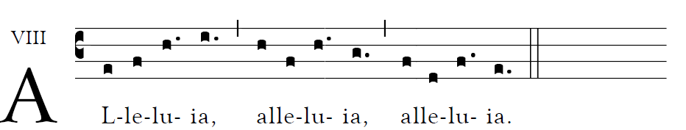
God was reconciling the world to himself in Christ,
And entrusting to us the message of salvation.

OFFERTORY: “Humbly, Lord, we worship You”

COMMUNION ANTIPHON

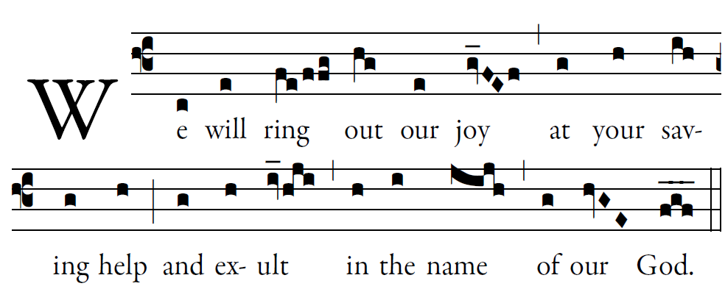
Fr .Columba Kelly © Saint Meinrad Archabbey

May the LORD answer you in time of trial;
may the name of Jacob’s God protect you.
May he send you help from the holy place,
and give you support from Sion.

May he remember all your offerings,
and receive your sacrifice with favor.
May he give you your heart’s desire,
and fulfill every one of your plans

Now I know the LORD saves his anointed,
and answers from his holy heaven
with the mighty victory of his hand.

Some put their trust in chariots or horses,
but we in the name of the LORD, our God

