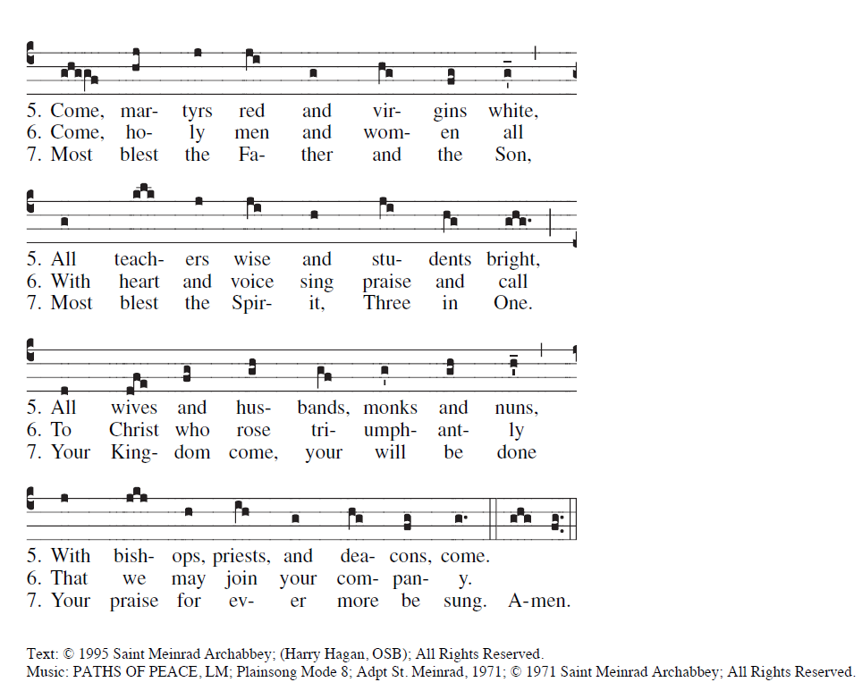

RECESSIONAL HYMN

“To Jesus Christ Our Sovereign King”

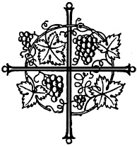

31st SUNDAY IN ORDINARY TIME YEAR A

ENTRANCE ANTIPHON

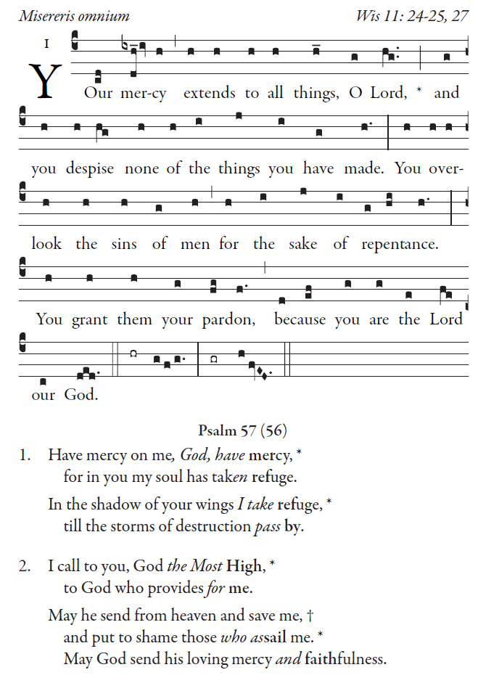
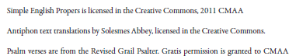

OFFERTORY HYMN
“Humbly,Lord We Worship You” Today’s Missal

COMMUNION ANTIPHON

Fr. Columba Kelly ©St. Mainrad Archabbey
PSALM16(15)

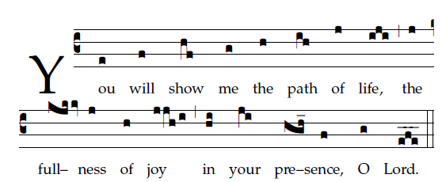
PSALM 16(15)
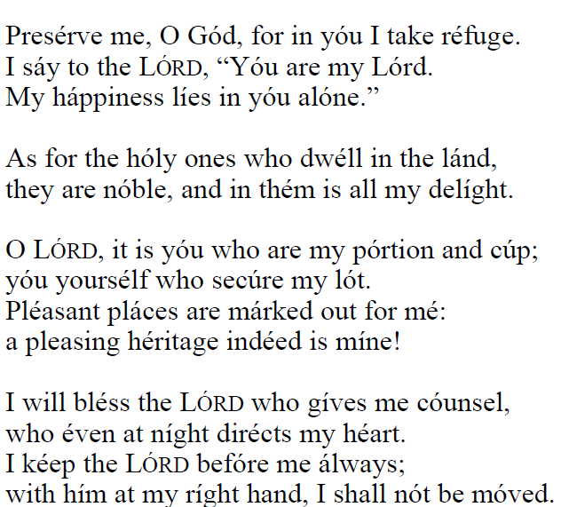.

COMMUNION HYMN
Salutis aeternae dator L.M.

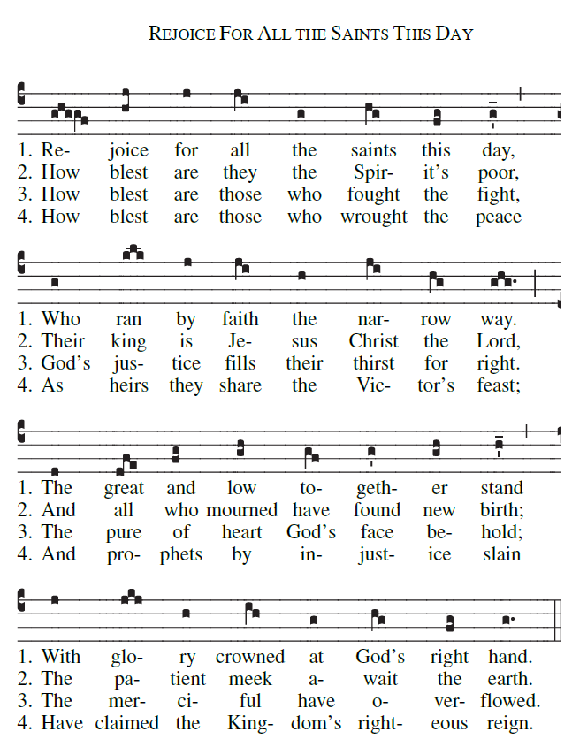
continued

