COMMUNION ANTIPHON
©illumiarepublications.com

RECESSIONAL HYMN
“We are the Light of the World.”

Fourth Sunday
in Ordinary Time YEAR A

ENTRANCE ANTIPHON

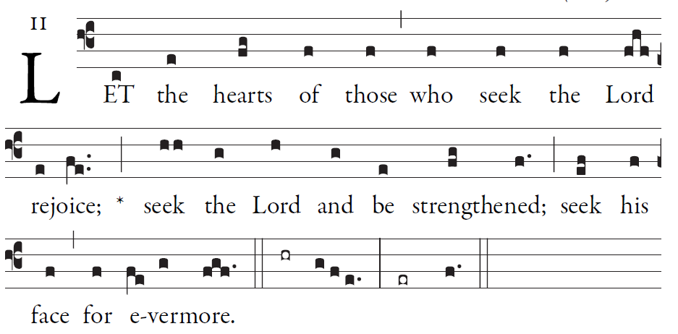
Simple English Ppropers ©CMAA Adam Bartlet
Simple English Propers is licensed in the Creative Commons, 2011 CMAA
Psalm 105

Give thanks to the LORD; proclaim his name.
Make known his deeds among the peoples.

O sing to him, sing his praise;
tell all his wonderful works!
Glory in his holy name;
let the hearts that seek the LORD rejoice.

Turn to the LORD and his strength;
constantly seek his face.
⁵Remember the wonders he has done,
his marvels and his words of judgment.

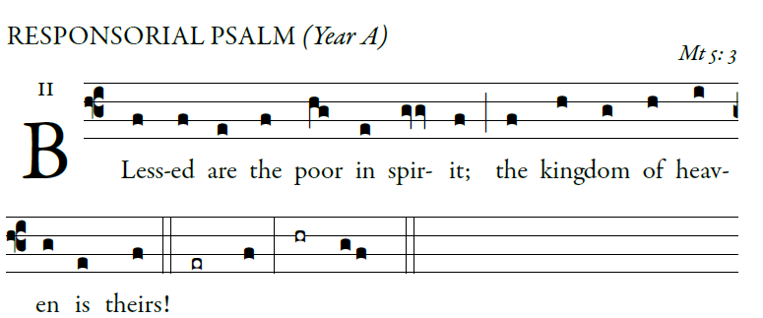
©illuminarepublications.com
The LORD keeps faith forever,
secures justice for the oppressed,
gives food to the hungry.
The LORD sets captives free. 
The LORD gives sight to the blind;
the LORD raises up those who were bowed down.
The LORD loves the just;
the LORD protects strangers. 
The fatherless and the widow the LORD sustains,
but the way of the wicked he thwarts.
The LORD shall reign forever;
your God, O Zion, through all generations. Alleluia.  
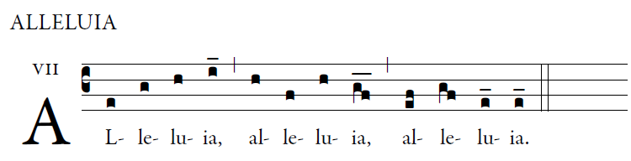

TheRejoice and be glad;
Your reward will be great in heaven.

OFFERTORY HYMN

“Rejoice and be glad, your reward will be great in heaven”
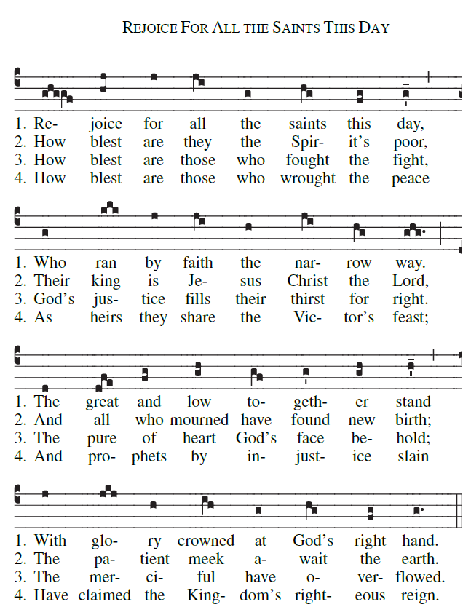

5. Come, martyrs red and virgins white,
All teachers wise and studenst bright,,
All wives and husbands, monks and nuns,
With bishops, priests and deacons come.

