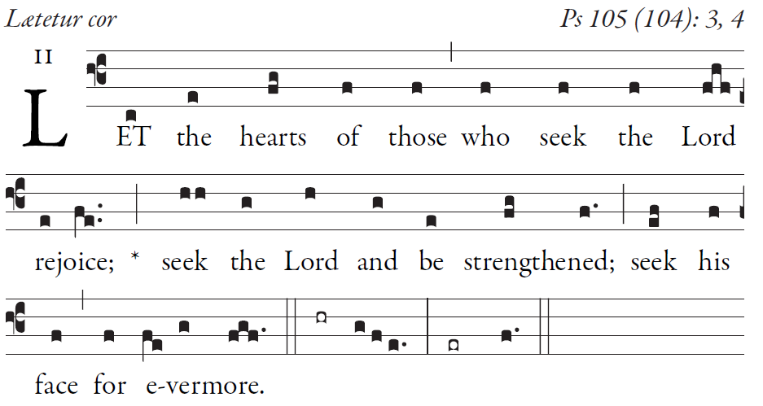

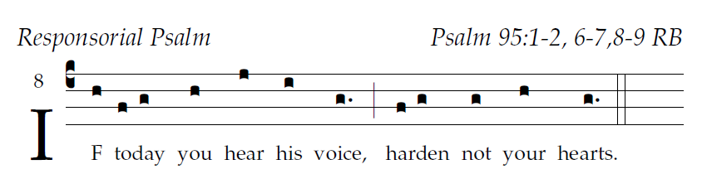

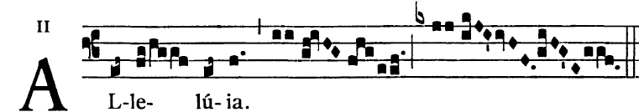

Offertory Hymn:
“O God Beyond All Praising” #544

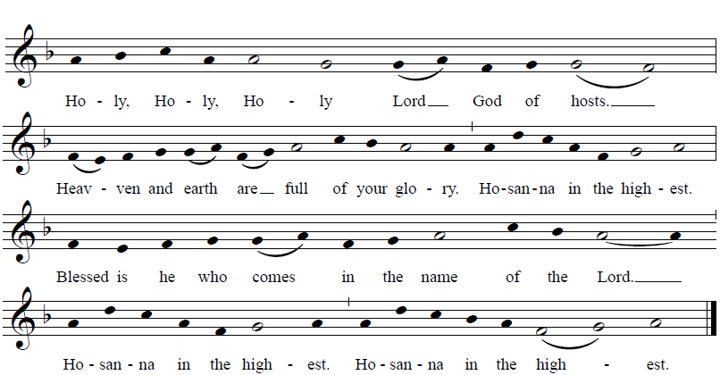

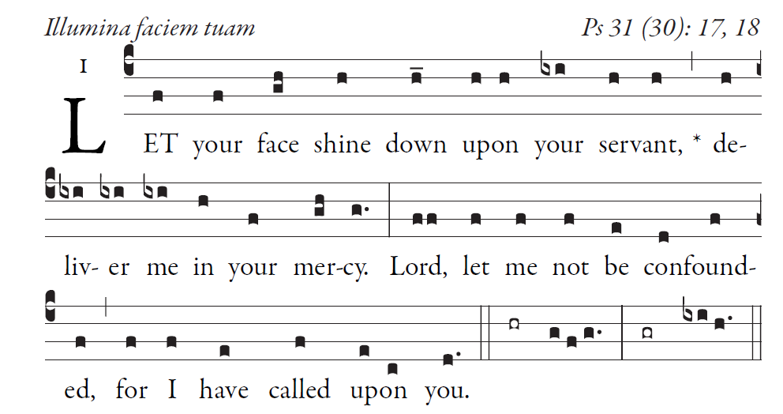
Recessional Hymn:

Praise My Soul the King of Heaven #568

