*Lamb of God / Agnus Dei*



**



COMMUNION ANTIPHON ©SAINT MEINRAD ARCHABBEY used with perimission

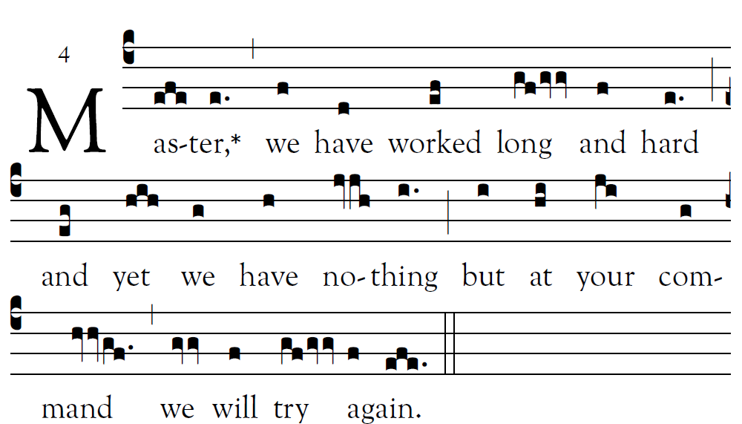

**Let your deed be seen by your servants,**

**and your glorious power by their children.**

**Let the favor of the LORD our God be upon us;**

**give success to the work of our hands.**

**O give success to the work of our hands**.

RECESSIONAL HYMN: “Be Not Afraid”



**Fifth Sunday**

**in Ordinary Time (year C)**

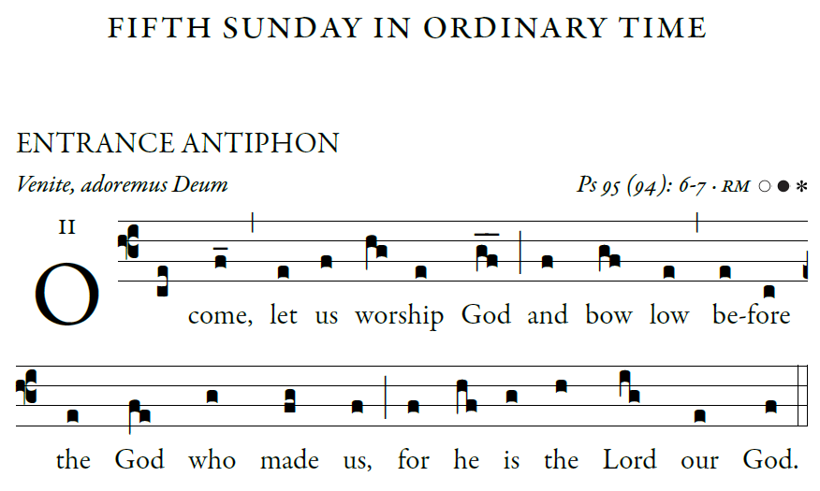

**Come, let us ring out our joy to *the LORD;***

**hail the *rock who saves us.***

**Let us come into his presence, *giving thanks;***

**let us hail him with a song *of praise.***

*All* 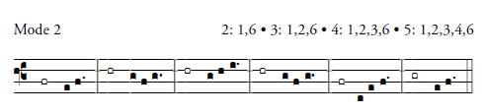

**A mighty God is *the LORD,***

**a great king a- *bove all gods.***

**In his hands are the depths *of the earth;***

**the heights of the mountains *are his.***

**To him belongs the sea, for *he made it,***

**and the dry land that he shaped by *his hands****.*

©Illuminare publications Adam Bartlet

RESPONSORIAL PSALM

©illuminarepublications.com

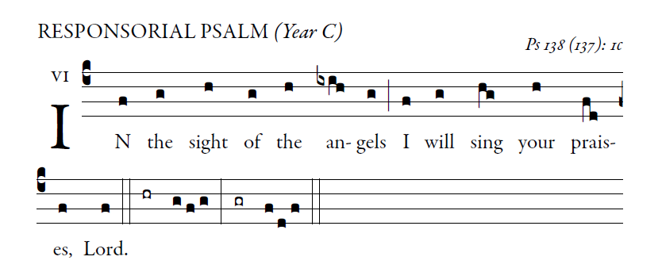

**I will give thanks to you, O LORD, with all my heart,**

**for you have heard the words of my mouth;**

**in the presence of the angels I will sing your praise;**

**I will worship at your holy temple**

**and give thanks to your name.**

**Because of your kindness and your truth;**

**for you have made great above all things**

**your name and your promise.**

**When I called, you answered me;**

**you built up strength within me.**

**All the kings of the earth shall give thanks to you, O LORD,**

**when they hear the words of your mouth;**

**and they shall sing of the ways of the LORD:**

**“Great is the glory of the LORD.”**

**Your right hand saves me.**

**The LORD will complete what he has done for me;**

**your kindness, O LORD, endures for-ever;**

**forsake not the work of your hands.**

ALLELUIA

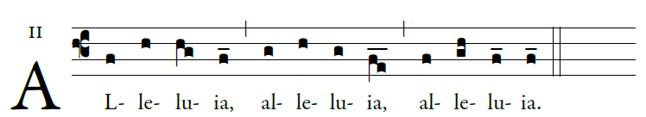

   Come after Me

and I will make you fishers of men.

OFFERTORY

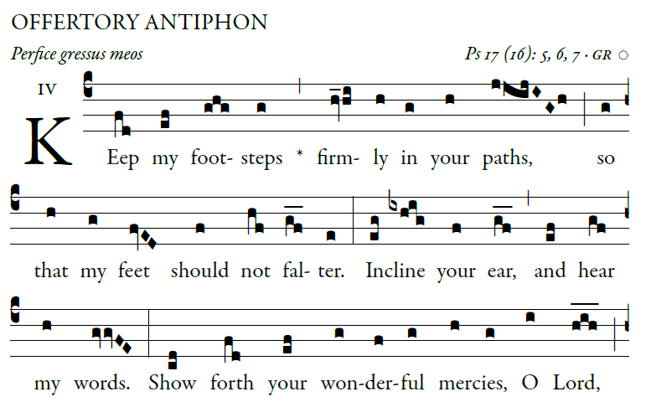

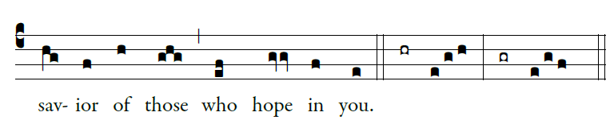

*©illuminarepublications.com*