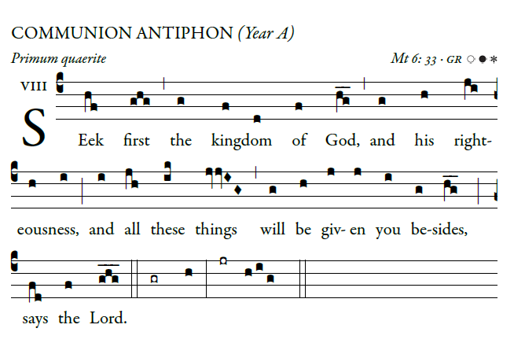
©Illuminarepublication.com

Do not fret because of the wicked;
do not envy those who do evil,
Trust in the lord and do good;
then you will dwell in the land and safely pasture.

The Lord takes note of the days of the blameless;
their heritage will last forever.
They shall not be put to shame in evil days;
in time of famine they shall have their fill.
By the lord are the steps made firm
of one in whose path He delights.

RECESSIONAL HYMN

“All Creatures of Our God and King” #536

Weekly music programs are available at
www.gregorianchant.weebly.com

Eighth Sunday
in Ordinary Time (year A)

ENTRANCE HYMN
_
“Praise My Soul the King of Heaven”

#546 Music Issue

KYRIE #902 MI (optional)

GLORIA: Mass of St Francis Cabrini #903 MI

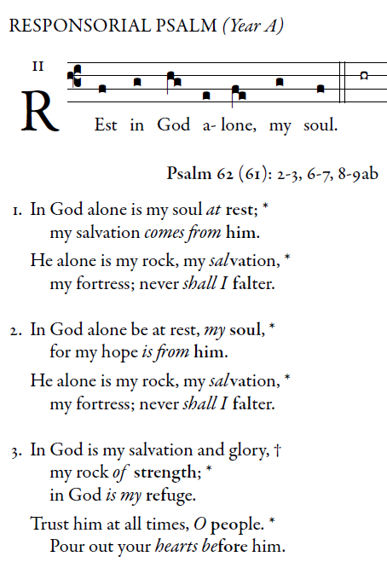
©Illuminarepublication.com

ALLELUIA

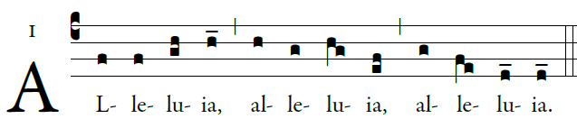

The word of God is Living and effective;
Discerning reflections and thoughts of the heart.

OFFERTORY ANTIPHON
R.Bednarz 2014
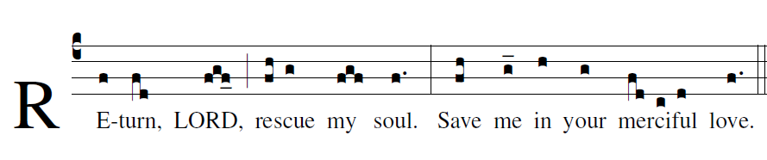

O LORD, do not rebuke me in your anger; [5]
reprove me not in your rage.
Have mercy on me, LORD, for I languish.
LORD, heal me; my bones are shaking,
and my soul is greatly shaken.

Gradual Romanum
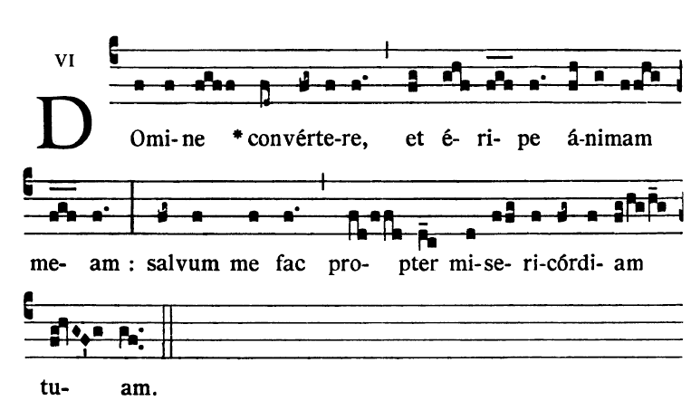
Leave me, all who do evil, [6]
for the LORD heeds the sound of my weeping.
The LORD has heard my plea;
the LORD will receive my prayer.
All my foes will be shamed and greatly shaken,
suddenly put to shame.

Mass of St. Francis Cabrini : #906 - #911 MI
Holy, Acclamation, Amen, Lamb of God.

