FIRST SUNDAY OF ADVENT: COMMUNION

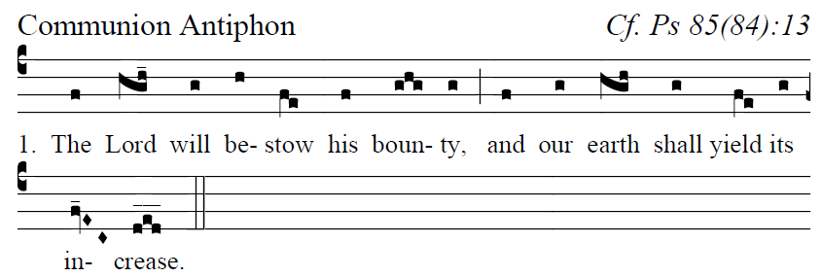
Fr. Columba Kelly© Saint Meinrad Archabbey
Psalm85 (84): 2-3, 4-5, 7-8, 10, 11-12

Psalm 85

²O LORD, you have favored your land,
and brought back the captives of Jacob.
³You forgave the guilt of your people,
and covered all their sins.

⁴You averted all your rage;
you turned back the heat of your anger.
⁵Bring us back, O God, our savior!
Put an end to your grievance against us.

⁷Will you not restore again our life,
that your people may rejoice in you?
⁸Let us see, O LORD, your mercy,
and grant us your salvation.

¹⁰His salvation is near for those who fear him,
and his glory will dwell in our land.
¹¹Merciful love and faithfulness have met;
justice and peace have kissed.
¹²Faithfulness shall spring from the earth,
and justice look down from heaven.

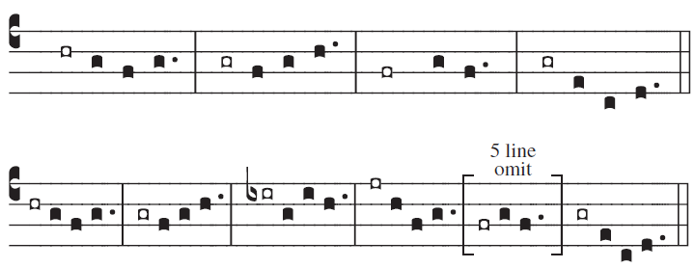

commentary: Baruch 5:5 ;
user-notes: Second Sunday of Advent Communion ;
annotation: ii;
centering-scheme: english;
%spacing: vichi;
%font: times;
%width: 4;
%height: 11;
%%
(f3)Je(h)- {ru}salem,(hg f h) (;) {a}rise(e/ fh) and(h) stand(i_) up-(h)on(i) the(j) heights(i.) (:)and(hr) behold() the() joy() that() comes() to(g) you(h_) from(-ge) God.(f.) (::)

