COMMUNION ANTIPHON
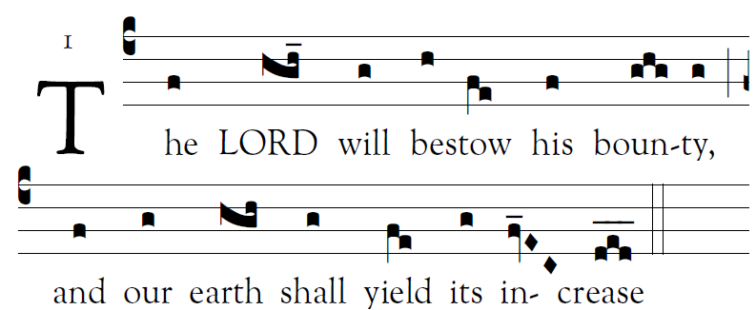
Fr. Columba Kelly© Saint Meinrad Archabbey
Psalm85 (84): 2-3, 4-5, 7-8, 10, 11-12

1. O Lord, you have favored your land,
and brought back the captives of Jacob.
You forgave the guilt of your people,
and covered all their sins.

2. You averted all your rage;
you turned back the heat of your anger.
Bring us back, O God, our savior!
Put an end to your grievance against us.

3. Will you not restore again our life,
that your people may rejoice in you?
Let us see, O lord, your mercy,
and grant us your salvation.

4. His salvation is near for those who fear him,
and his glory will dwell in our land.
5. Merciful love and faithfulness have met;
justice and peace have kissed.
Faithfulness shall spring from the earth,
and justice look down from heaven.

RECESSIONAL HYMN

“Comfort, Comfort, O my People”

FIRST SUNDAY OF ADVENT
.

© 2012, 2013 Adam Bartlett, licensed under a Creative Commons Attribution-NonCommercial-NoDerivs 3.0 Unported License.
Excerpts from the English translation of The Roman Missal © 2010, International Commission on English in the Liturgy Corporation. All rights reserved.
Excerpts from the Lectionary for Mass for Use in the Dioceses of the United States of America, second typical edition © 2001, 1998, 1997, 1986, 1970 Confraternity of Christian Doctrine, Inc., Washington, DC.. Communion antiphon by Fr. Columba Kelly , Saint Meinrad Archabbey

ENTRANCE ANTIPHON
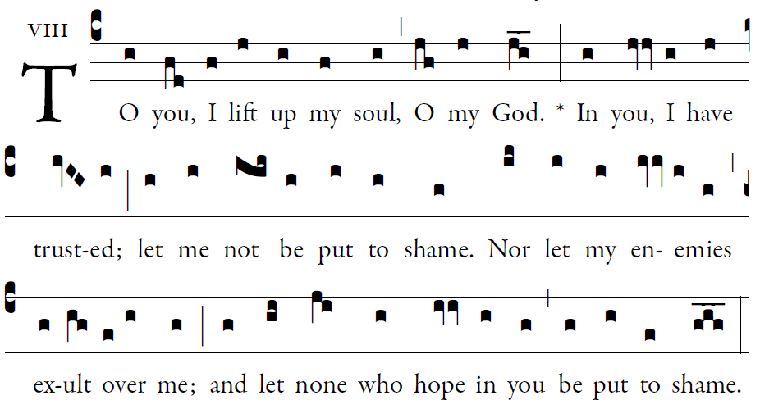

O LORD, make me know your ways. [5]
Teach me your paths.
Guide me in your truth, and teach me;
for you are the God of my salvation.
I have hoped in you all day long.

Remember your compassion, O LORD, [5]
and your merciful love,
for they are from of old.
In your merciful love remember me,
because of your goodness, O lord.

Ordinary of the Mass : Orbis Factor Mass XI
Yellow program

RESPONSORIAL PSALM ( YEAR C)

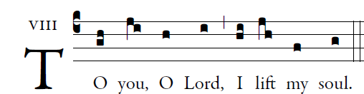

Your ways, O LORD, make known to me;
teach me your paths,
Guide me in your truth and teach me,
for you are God my savior,
and for you I wait all the day.
Good and upright is the LORD;
thus he shows sinners the way.
He guides the humble to justice,
and teaches the humble his way.
All the paths of the LORD are kindness and constancy
toward those who keep his covenant and his decrees.
The friendship of the LORD is with those who fear him,
and his covenant, for their instruction.

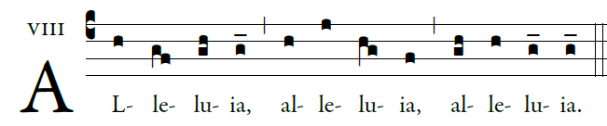

Show us, Lord, your love;
and grant us your salvation.

OFFERTORY HYMN:

“O Come, O Come Emanuel”

