THE DIVINE PRAISES
1.Blessed be | __ God*.
3.Blessed be Jesus Christ, true God and | true man
5.Blessed be His Most | Sa-cred Heart.
7.Blessed be Jesus in the Most Holy  Sacrament of the | Al - tar.
9.Blessed be the great Mother of God,  Mary most | hol - y.
11.Blessed be her glorious As- | sump - tion
13.Blessed be Saint Joseph, her most | chaste spouse

Blessed be | His Hol- | y Name.
2. Blessed be His  4.Blessed be the name | his ho-  of Je- | ly name  sus.
6.Blessed be His | most pre- | cious blood.
8.Blessed be the Holy Spirit, the | Con - sol- | er.
10.Blessed be her holy and Immaculate | Con –cep- | tion.
12.Blessed be the name of Mary,Virgin | and Moth- | er.
14.Blessed be God in His angels | and in | His saints.

Closing Hymn
“Jesus, Remember me, When you come into your Kigndom”

Eucharistic Adoration

Entrance Hymn
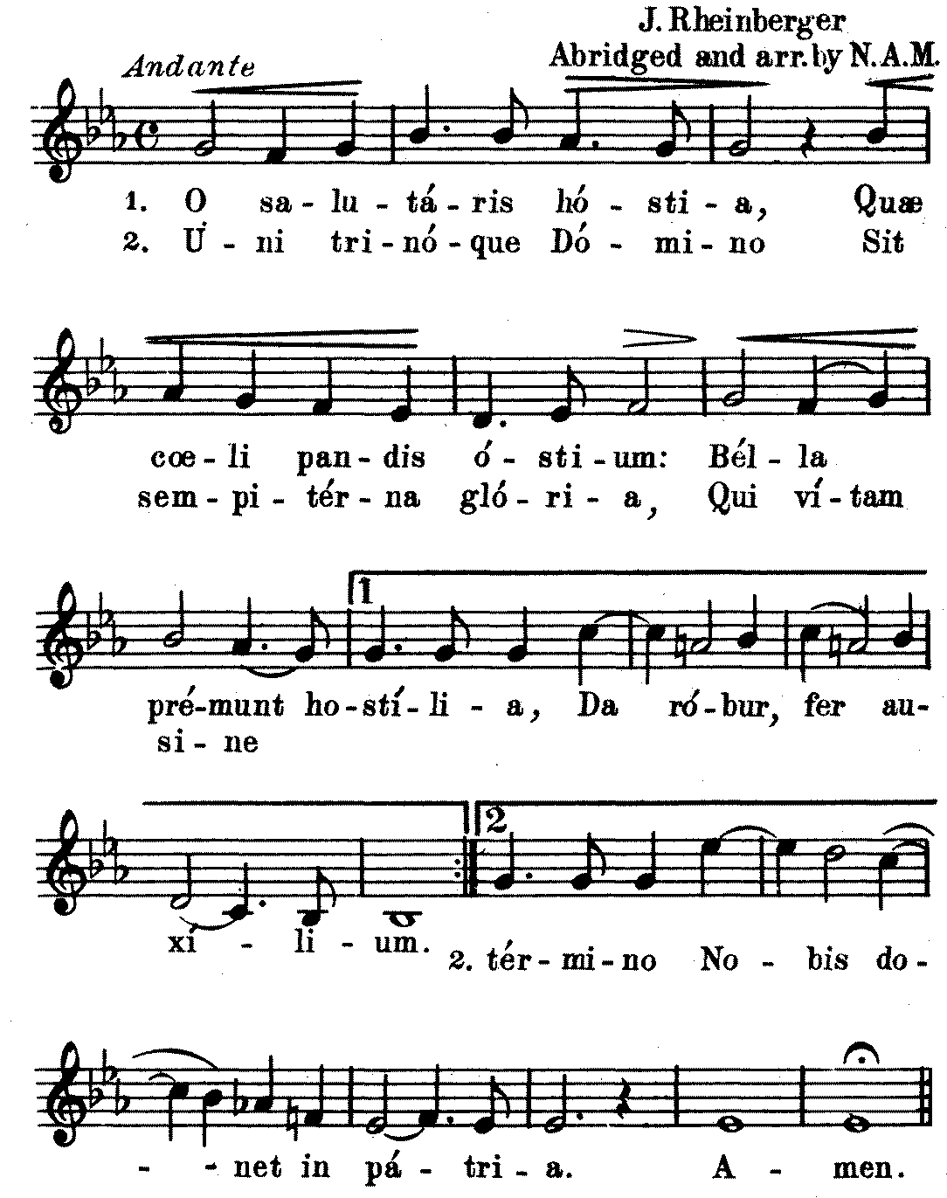

HYMN
“ Hold Me in Life” #595 Glory and Praise Hymnal
(Blue book)

Silence

HYMN
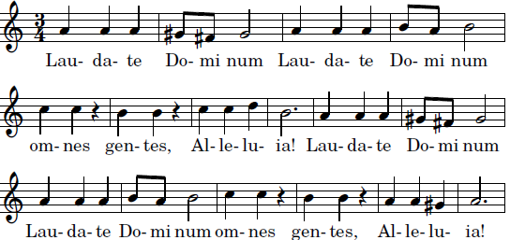

Silence

Alleluia before the Gospel
 II 1 The Spirit of the Lord is upon me,
Because he has annóinted me,
to bring glad tidings to the poor.      

Gospel

Benediction
Th. Dubois
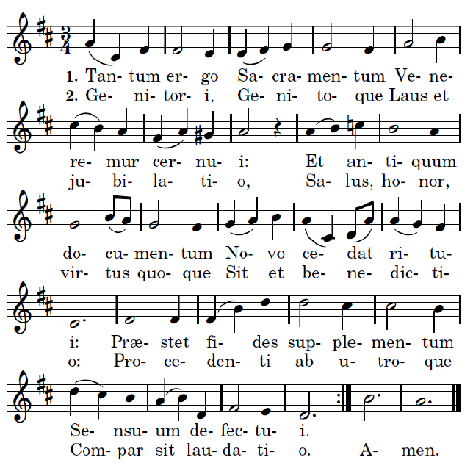

= You have given them bread from heaven.
+ Having within it all Sweet-ness

