RECESSIONAL HYMN

God of Mercy God of Grace
for the Jubilee year of Mercy

HEATHLAND
Henry Lyte
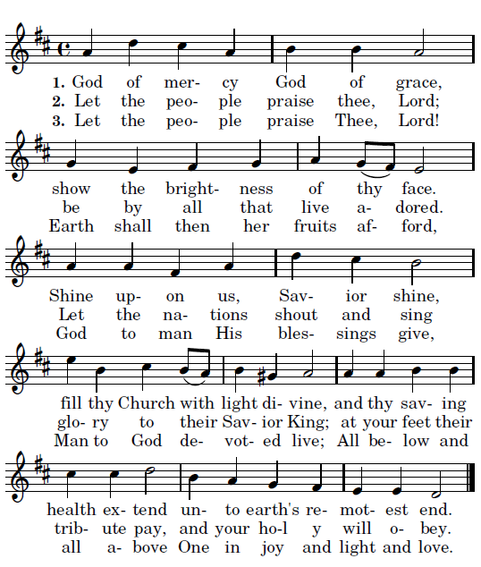

REJOICE

THIRD SUNDAY of ADVENT
.

ENTRANCE ANTIPHON ©CMMA Adam Bartlett

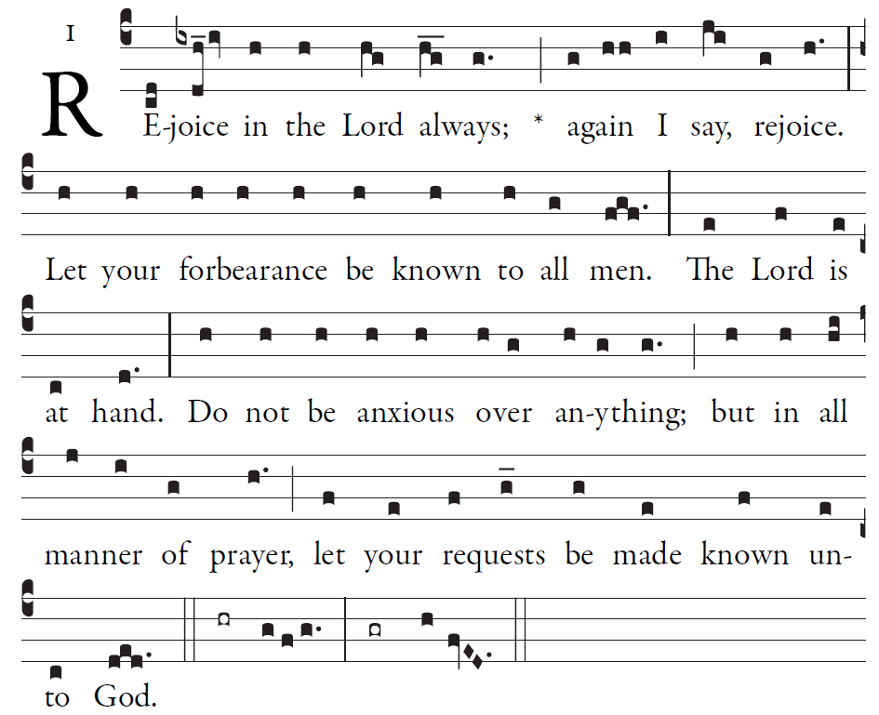

O LORD, you have favored your land,
and brought back the captives of Jacob.
Will you not restore again our life,
that your people may rejoice in you?

Bring us back, O God, our savior!
Put an end to your grievance against us.
Will you be angry with us forever?
Will your anger last from age to age?

Ordinary of the Mass : Orbis Factor Mass XI
Yellow program
OFFERTORY ANTIPHON

©CMMA Adam Bartlett

You forgave the guilt of your people,
and covered all their sins.
You averted all your rage;
you turned back the heat of your anger.

Bring us back, O God, our savior!
Put an end to your grievance against us.
Will you be angry with us forever?
Will your anger last from age to age?

REJOICE

COMMUNION ANTIPHON
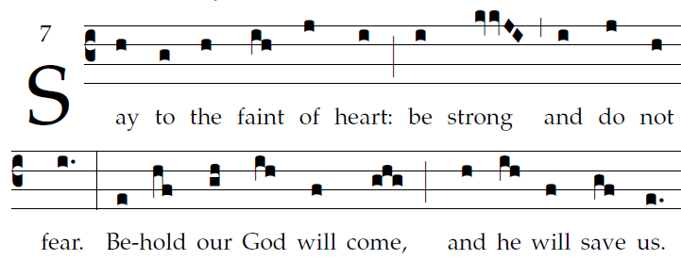
Fr. Coluba Kelly © Saint Meinrad Archabbey
ISAIAH 35
The wilderness and the parched land will exult;
the Arabah will rejoice and bloom;
Like the crocus it shall bloom abundantly,
and rejoice with joyful song.

The glory of Lebanon will be given to it,
the splendor of Carmel and Sharon;
They will see the glory of the LORD,
the splendor of our God.

Strengthen hands that are feeble,
make firm knees that are weak,
Then the lame shall leap like a stag,
and the mute tongue sing for joy.

For waters will burst forth in the wilderness, [6]
and streams in the Arabah.
The burning sands will become pools,
and the thirsty ground, springs of water;
The abode where jackals crouch
will be a marsh for the reed and papyrus.

A highway will be there,
called the holy way;
No one unclean may pass over it,
but it will be for his people;
no traveler, not even fools, shall go astray on it.

